INEQUALITIES

1.0 Definitions

You have been previously instructed that numbers have the effect that of being greater than another, or that one number is less than another. Such statements are referred to as inequalities. For example, 2 > -1 and 5 < 7 are inequalities.

Since a statement of inequality between two numbers implies that the numbers may be arranged in order of magnitude on a number scale, it follows that inequalities in the algebraic sense must deal with real numbers only. This restriction must be understood throughout algebra. The statement X - 1 = 4 describes the number x completely; x must have the value 5. The statement X - 1 > 4 describes X in a less definite fashion; X may have any value greater than 5. [The symbols > and < always point toward the smaller number.]

The symbols ≥ and ≤ to mean "is greater than or equal to" and "is less than or equal to," respectively. For example, every real number, say N, obeys the inequality N² > 0.

2.0 Operations With Inequalities

The methods used in handling inequalities are in many ways similar to those used in dealing with equations. The following Principles are all proved by the use of the fundamental fact that if

a > b,

then, a - b = p is a positive number, and conversely.

2.1 Principle 1. The addition of the same real number to, or the subtraction of the same real number from, both members of an inequality leaves the direction (sense) of the inequality unaltered.

Illustrations: If we start with the inequality 6 > 2, we may find 11 > 7 by adding 5 to both members. Similarly, -1 > -5 is obtained by subtracting 7 from both members.

2.2 Principle 2. The multiplication or division of both members of an inequality by the same positive number leaves the sense of the inequality unaltered.

Illustrations: If we start with the inequality 6 > 2, (5) * 6 > (5) * 2 is 30 > 10. Similarly, 6/(2) > 2/(2) is 3 > 1.

2.3 Principle 3. If both members of an inequality are multiplied or divided by a negative number, a new inequality of opposite direction (sense) is obtained.

Illustrations: From the inequality 3 < 5, we find 6 < 10 by multiplying both members by 2. Also, we may obtain - 6 > -10 by multiplying both members by - 2.

2.4 Principle 4. If all the members of two inequalities of the same sense are positive and the corresponding members of the inequalities are multiplied together, an inequality of the same direction (sense) is obtained.

Illustration: From the inequalities 5 > 2 and 4 > 3 we may conclude 20 > 6.
3.0 Unconditional Inequalities

Many important properties of numbers may be expressed in the form of inequalities. A proposed unconditional inequality may frequently be shown to be valid by a process of analysis as follows:

  - Assume the inequality to be valid.
  - Apply any of the principles above may be necessary in order to deduce from the assumed statement another inequality which is known to be valid.
  - Reverse the steps in (2), making certain that each step is justified, in order to obtain the proposed inequality. A student who is familiar with the principles of logic will realize that step (3) is essential; the demonstration cannot stop with step (2).

Example: Prove that the sum of any positive number and its reciprocal cannot be less than 2, that is,

a +1/a ≥ 2, if a>0.

Analysis: Assume the validity of the proposed inequality. Since a > 0, we may multiply both sides of a + 1/a ≥ 2 by a to obtain

a² + 1 ≥ 2a. [Principle (2)]

Next, subtract 2a from both sides to get

a² - 2a + 1 ≥ 0, [Principle (1)]

or
(a-1)² ≥ 0.

4.0 Conditional Inequalities

Here, we shall confine the following discussion entirely to conditional inequalities involving one letter. An inequality is said to be solved when the range of values of the letter which makes the inequality valid is found. This range of values is called the solution of the inequality. For example, the inequality

2x – 1 > x + 4

may be solved by adding 1 to both sides and subtracting x from both sides to obtain

x > 5.

The range of values of x greater than 5 is the solution of the inequality. This range may be indicated as

In sections 5.0 and 6.0 two methods of solution of conditional inequalities, namely, the algebraic method and the graphical method will be demonstrated.

5.0 The Algebraic Solution Of Inequalities

5.1 An inequality that contains the unknown to the first degree only is called a linear inequality. Linear inequalities and inequalities that may be reduced to this type are easily solved by algebraic manipulation as in the preceding section.

Example: Find the range of values for which 5x + 6 > 8x + 12.

Solution:

5.1.1 Subtract 8x from both members -3x + 6 > +12.
5.1.2 Add -6 to both members -3x > 6.
5.1.3 Divide both sides by -3 and reverse the direction (sense) according to Principle (3).
x < -2.
This range for the answer is:

5.2 An inequality that contains the unknown greater than the first degree is called a polynomial inequality. If f(x) is a quadratic function ax² + bx + c, the inequality may be solved by the method of completing the square. Essentially, this method is based on the fact that x² > n² (where n >0) is valid if, and only if, │x│ > n; that is, x > n, or x < -n. (See (a) below)

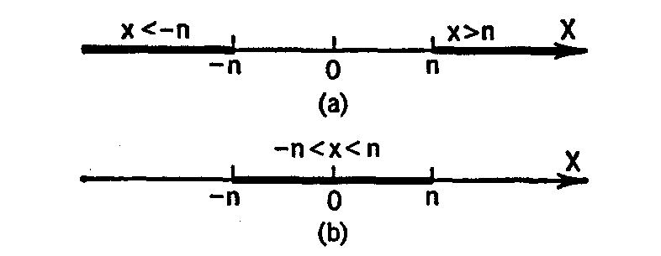

By contrast, the inequality x² < n² (where n< n) is valid if, and only if, │x│ < n; that is, both x > -n, or x < n are to be satisfied. Written as a combined function –n < x < n, that is read "x lies between –n and n." (See (b) above)

Example. Solve the inequality x² + 4x + 3 ≥ 0.

Solution:

    - Subtract 3 from both members x² + 4x ≥ -3.
    - In order to have a perfect trinomial square on the left, we add 4 to both sides. This addition yields

x² + 4x + 4 ≥ 1, or (x + 2)² ≥ 1.

As noted in 5.2 above, you see that we must have x +2 ≥1 or x + 2 ≤ -1, that is, x ≥ -1 or x ≤ -3.

This range is displayed below

6.0 Graphical Solution of Inequalities

The graphical solution of inequalities such as f(x) > 0 or f(x) < 0 consists of two steps, as follows:

  - Draw the graph of the function f(x).
  - Keeping in mind that f(x) > 0 [that is, f(x) is positive] when its graph lies above the X axis, and f(x) < 0 [f(x) is negative] when its graph lies below the X axis, read the range of values of x for which the given inequality is valid.

An inequality may frequently be reduced to one of the preceding forms, where f(x) is a factored polynomial. The schematic sketch such a polynomial below may then be used to read off the solution of the inequality.

Example. Solve the inequality (x + 1) (x - 2) (x - 3) < 0 by the graphical method.

Solution: Let f (x) = (x + 1) (x - 2) (x - 3).

The schematic graph of f(x) is given in above. Since it is required to have f(x) < 0, we read off the ranges of values of x for which the curve lies below the X axis. These ranges are x < -1 or 2 < x < 3.

