1.0 Definitions and Notifications

A. Definitions

(1) Arithmetic is the systematic study of fundamental operations with real numbers and of the use of these operations in solving practical problems.

(2) Real numbers are:

- Natural numbers (also called the Arabic numbers or positive integers) are the symbols arrived at by counting such as 1, 2, 3, 4, ..., where the three dots mean "and so on."

- Rational numbers are real numbers that can be expressed in the form p/q where p and q are integers (q can be 1).

- Irrational numbers are real numbers which cannot be expressed in the form p/q where p and q are integers.

(3) Four fundamental operations of arithmetic are:

a) The addition (See 2.A. below).
b) The subtraction (See 2.B below).
c) The multiplication (See 2.C, below).
d) The division (See 2.D. below).

B. Symbols of Relationship

The following symbols define the relationship of two numbers:

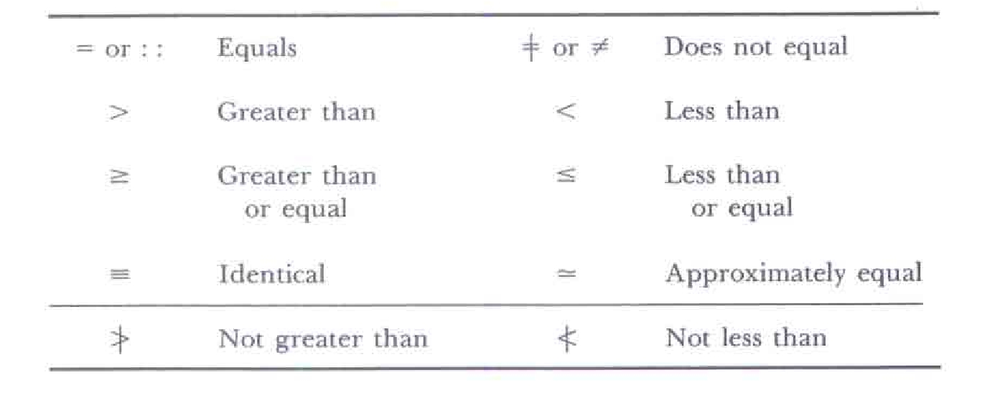
C. Symbols of Aggregation

The symbols of grouping (aggregation) are:

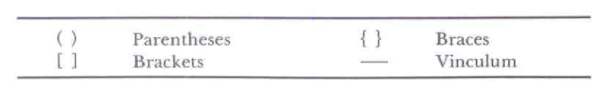
(D) Signs of Operations

The signs of operations are:

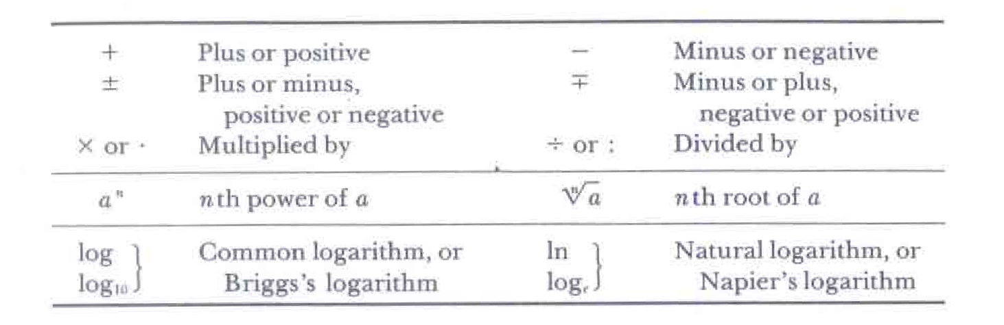

2.0 Four Fundamental Operations

A. Addition

(1) Addition is the operation of finding the sum of two or more numbers. Example: 2+3+4 = 9

where 9 is the sum and 2, 3, 4 are the terms of the sum.

(2) Order of terms in addition may be changed without affecting the sum (commutative law). Examples:

2+3+4 = 9 3+4+2 = 9 4+2+3 = 9

(3) Grouping of terms in addition may be changed without affecting the sum (associative law). Examples:

(2+3)+4 = 5+4 = 9 2+(3+4) = 2 + 7 = 9

B. Subtraction

(1) Subtraction is the operation of finding the difference of two numbers. Example: 9-4 = 5

where 5 is the difference, 9 is the minuend, and 4 is the subtrahend.

(2) Difference of two equal numbers is zero. Example: 9-9 = 0

C. Multiplication

(1) Multiplication is the operation of finding the product of two or more numbers. Example: 2 x 3 x 4 = 24

where 24 is the product and 2, 3, 4 are the factors of the product.

(2) Order of factors in multiplication may be changed without affecting the product (commutative law). Examples:

2x3x4 = 24 3x4x2 = 24 4x2x3 = 24

(3) Grouping of factors in multiplication may be changed without affecting the product (associative law). Examples:

(2x3)x4 = 6x4 = 24 2x(3x4) = 2 x 12 = 24

D. Division

(1) Division is the operation of finding the quotient of two numbers. Example: 24÷8 = 3

where 3 is the quotient, 24 is the dividend, and 8 is the divisor.

(2) Quotient of two equal numbers is 1. Example: 24 ÷ 24 = 1

E. Even, Odd, and Prime Numbers

(1) Even number is an integer divisible by 2. Example: 2, 4, 6, .. are even numbers.

(2) Odd number is an integer not divisible by 2. Example: 1, 3, 5,... are odd numbers.

(3) Prime number is an integer divisible only by 1 and itself. Example: 2, 3, 5, 7, . . . are prime numbers.

F. Factoring

(1) Every nonprime number greater than 1 can be expressed as a product of prime numbers. (Fundamental Theorem of Arithmetic) Examples:

30 = 2 x 3 x 5 60 = 2 x 2 x 3 x 5

(2) Highest common factor (HCF) of a given set of numbers is the largest number that is a factor of all the numbers. Example:

24 = 2 x 2 x 2 x 3
60 = 2 x 2 x 3 x 5
84 = 2 x 2 x 3 x 7

HCF = 2 x 2 x 3 = 12

where HCF is the product of the prime factors that are common to all the numbers of the set.

(3) Lowest common multiple (LCM) of a given set of numbers is the smallest number that has each of the given numbers as a factor. Example:

24 = 2 x 2 x 2 x 3
60 = 2 x 2 x 3 x 5
84 = 2 x 2 x 3 x 7
LCM = 2 x 2 x 2 x 3 x 5 x 7 = 840

where LCM is the product of all the different prime factors of the given numbers, each taken the greatest number of times that it occurs in one of the numbers. ( The LCM is also known as the least common denominator.)

3.0 Signed Numbers

A. Graphical Representation

(1) Real numbers may be represented by points on a straight line as shown in the Fig. below, where the distance between two adjacent points is constant and equals 1.

(2) Positive numbers + 1, +2, + 3, ... are then associated with the points on the right side of the origin designated by 0 (zero).

(3) Negative numbers - 1 , - 2, - 3, ... are then associated with the points on the left side of the origin.

(4) Positive and negative numbers are called the signed numbers. Zero has no sign, and all unsigned numbers are assumed to be positive numbers.

(5) Absolute value of a number is its numerical value regardless of sign and is designated by two vertical lines surrounding the signed number. Examples: ⏐+5⏐= 5 ⏐-5⏐= 5 ⏐+5⏐ = ⏐-5⏐

which means the absolute value of a positive number equals the absolute value of the negative number and vice versa.

B. Addition and Subtraction

(1) Sum of two numbers of like signs equals the sum of their absolute values prefixed by their sign. Examples:

(+3) + (+5) = +8 (-3) + (-5) = -8

(2) Sum of two numbers of unlike signs equals the difference of their absolute values prefixed by the sign of the number having the larger absolute value. Examples:

(+3) + (-5) = -2 (-3) + (+5) = +2

(3) Difference of the signed numbers equals their sum in which the sign of subtrahend was reversed. Examples:

(+12) - (+3) = (+ 12) + (-3) = +9

(+12) - (-3) = (+12) + (+3) = +15

(-12) - (+3) = (-12) + (-3) = -15

(-12) - (-3) = (-12) + (+3) = -15

C. Multiplication and Division

(1) Product of two numbers of like signs equals the positive product of their absolute values. Examples:

(+12) x (+3) = +(12 X 3) = +36 (-12) x (-3) = +(12 x 3) = +36

(2) Product of two numbers of unlike signs equals the negative product of their absolute values. Examples:

(+12) x (-3) = -(12 x 3) = -36 (-12) x (+3) + -(12 x 3) = -36

(3) Quotient of two numbers of like signs equals the positive quotient of their absolute values. Examples:

(+12) ÷ (+3) = +(12 ÷ 3) = +4 (-12) ÷ (- 3) = + (12 ÷ 3) = +4

(4) Quotient of two numbers of unlike signs equals the negative quotient of their absolute values. Examples:

(+12) ÷ (-3) = -(12 ÷ 3) = -4 (-12) ÷(+3) = -(12 ÷ 3) = -4

4.0 Operations With Zero

A. Addition and Subtraction

(1) Sum of any number N and zero equals N. Examples:

5 + 0 = 5 0 + 5 = 5

- Difference of any number N and zero equals N. Examples:

5 - 0 = 5 but 0 - 5 = -5

(2) Multiplication and Division

- Product of any number N and zero equals zero. Examples:

5 x 0 = 0 0 x 5 = 0

(2) Quotient of any number N and zero is meaningless, but a quotient of zero and N is zero. Example:

0 ÷ 5 = 0

5.0 Simple Fractions

A. Definitions

(1) A Fraction is an indicated division. The part of the fraction above the vinculum (bar) is called the numerator N and the part of the fraction below the vinculum is called the denominator D. Example:

N/D = fraction D

(2) Proper and improper fraction. When N < D (N is less than D), the fraction is termed a proper fraction. When N > D (N is greater than D), the fraction is termed an improper fraction. Examples:

2/5 = proper fraction 5/2 = improper fraction

(3) When N and D are integers, the fraction is termed a simple fraction. When N or D or both are fractions, the fraction is termed a complex fraction. A sum of an integer and a fraction is a mixed number.

B. Principles Used in Operations

(1) Enlarging a fraction by multiplying both its numerator and its denominator by the same number (except zero) does not change the value of the fraction. Example:

4 = 4 x 2 = 8
6 6 x 2 12

(2) Reduction of a fraction by dividing both its numerator and its denominator by the same number (except zero) does not change the value of the fraction. Example:

4 = 4 ÷ 2 = 2
6 6 ÷ 2 3

(3) Change in sign of both numerator and denominator of a fraction does not change the sign of the fraction. Examples:

-2 = 2 -2 = 2 = - 2
-3 3 3 -3 3

(4) Change in sign of either numerator or denominator of a fraction changes the sign of the fraction. Examples:

2 ≠ -2 -2 = 2 = -2
3 3 3 -3 3

(5) Lowest common denominator (LCD) of two or more fractions is the lowest common multiple (LCM) [See. 2.0 F. (3)] of their denominators. Example:

LCD of 1/3, 3/6, 7/9 is 18 and their transformation to this denominator is accomplished by rule (1) of this section as

1 = 1 x 6 = 6 3 = 3x3 = 9 7 = 7 x 2 = 14
3 3 x 6 18 6 6x3 18 9 9 x 2 18

C. Addition and Subtraction

- Fractions of common denominators can be added or subtracted.

(2) Sum or difference of two fractions with a common denominator equals a fraction whose numerator is the sum or difference of their numerators and the denominator is their common denominator. Examples:

6 + 9 = 6 + 9 = 15 = 5 6 9 = 6-9 _ 3 = -1
18 18 18 18 6 18 18 18 18 6

(3) Sum or difference of two fractions of different denominators is found by transforming the given fractions to their lowest common denominator. Examples:

2 ÷ 4 = 2 x 5 ÷ 4 x 3 = 10 +12 = 22
3 5 3 x 5 5 x 5 15 15

2 - 4 = 2 x 5 - 4 x 3 = 10 -12 = 2
3 5 3 x 5 5 x 5 15 15

(4) Sum or difference of an Integer and a fraction is found by transforming the integer into a fraction of the same denominator. Examples:

2 + 1 = 2 x 3 + 1 = 6 + 1 = 7
3 1 x 3 3 3 3

2 - 1 = 2 x 3 - 1 = 6 - 1 = 5
3 1 x 3 3 3 3

(5) Transformation of a mixed number into a fraction is found by applying rule (4) of this section. Example:

3 1 = 3 + 1 = 3 x 16 + 1 = 48+1 = 49
16 16 1 x 16 16 16 16

D. Multiplication and Division

(1) Product of two or more fractions is the product of their numerators divided by the product of their denominators. In this process, reduction (Sec. B. (2) should be used where possible to reduce the amount of multiplication. Examples:

2 x 5 = 2 x 5 = 10 2 x 3 = 2 x 3 = 1 = 1
3 7 3 x 7 21 3 x 2 3 x 2 1

2 x 5 = 2 x 5 = 10 2 x 5 = 2 x 5 = 10
3 3 7 7 7

(2) Reciprocal of a number is 1 divided by this number. Reciprocal of a fraction is a fraction obtained by interchanging the numerator and the denominator in the given fraction. Examples:

Reciprocal of 5 is 1
5

Reciprocal of 2 is 5
5 2

(3) Product of a number and its reciprocal equals 1. Product of a fraction and its reciprocal also equals 1. Examples:

5 x 1 = 5 x 1 = 5 x 1 = 1 = 1 2 x 3 = 2 x 3 = 1 = 1
5 1 5 1 x 5 1 3 2 3 x 2 1

(4) Quotient of two or more fractions is the product of the first fraction with the reciprocals of the remaining fractions. In this process reduction [Sec. 5.0 B(2)] should be used where possible to reduce the amount of multiplication. Examples:

2 ÷ 5 = 2 x 7 = 2 x 7 = 14 2 ÷ 3 = 2 x 2 = 2 x 2 = 4
3 7 3 5 3 x 5 15 3 2 3 3 3 x 3 9

2 ÷ 5 = 2 x 1 = 2 x 1 = 2 2 ÷ 5 = 2 x 7 = 2 x 7 = 14
3 3 5 3 x 5 15 7 5 5 5

- Mixed Numbers

A. Definitions

(1) Mixed number is a sum of an integer and a fraction (Sec. 5.0A(3). Examples:

2 + 2 = 2 2 1 + 7 = 7 1
5 5 4 4

(2) Every mixed number can be converted to a simple improper fraction. Examples:

2 2 = 2 + 2 = 2 x 3 + 2 = 6+2 = 8
3 1 3 1 x 3 3 3 3

7 1 = 7 + 1 = 7 x 4 + 1 = 28+1 = 29
4 1 4 1 x 4 4 4 4

(3) Every simple improper fraction can be converted to a mixed number. example:

15 = 14 + 1 = 7 + 1 = 71
2 2 2 2

where 15 was resolved into a highest multiple of the denominator (which is 14) and the remainder (which is 1).

B. Addition and Subtraction

(1) Sum of mixed numbers is the sum of their integers and of their fractions. Example:

2 1 + 5 1 = 2 + 5 + 1 + 1 = 7 + 4 + 3 = 7 7
3 4 3 4 12 12

(2) Difference of two mixed numbers is the difference of their integers and of their fractions. Example:

5 2 - 2 1 = 5 - 2 + 2 - 1 = 3 + 8 - 3 = 3 5
3 4 3 4 12 12

(3) In general however it is more convenient to convert the mixed numbers to improper fractions and apply rules of Sec. 5.0 C(2) and (3). Examples:

C. Multiplication and Division

(1) Product of two mixed numbers is the product of their improper fraction equivalents. Example:

2 1 x 5 1 = 7 x 21 = 7 x 7 = 49 = 12 1
3 4 3 4 1 4 4 4

(2) Quotient of two mixed numbers is the quotient of their improper fraction equivalents. Example:

2 1 ÷ 5 1 = 7 ÷ 21 = 7 x 4 = 1 x 4 = 4
3 4 3 4 3 21 3 3 9

7.0 Complex, Compound, and Continued Fractions

A. Definitions

(1) Complex fraction is a fraction whose numerator or denominator or both are fractions. Examples:

2 3
3_ 7 _5_ are complex fractions.
5 , _11 , _7
13 11

(2) Compound fraction is a fraction whose numerator, or denominator, or both are mixed numbers. Examples:

1 2 __7_ 2 3
__3_ 2 11 __7 are compound fractions.
5 13 13 7
8

(3) Continued fraction is an integer plus fraction whose denominator is an integer plus fraction and so on. Example:

2 + ________1_________
3 + ______1______ is a continued fraction.
5 + ___1____
7 + ½

B. Reductions

(1) Every complex, compound, and continued fraction can be reduced to a simple fraction.

- Reduction of a complex fraction is the quotient of its numerator and of its denominator. Examples:

2 2
_3_ = _3_ = 2 ÷ 5 = 2 x 1 = 2
5 5 3 1 3 5 15
1

_7_ = 7 ÷ 11 = 7 x 13 = 91
11 1 13 1 11 11
13

3 3 ÷ 7 = 3 x 11 = 33
_5_ + 5 11 5 7 35
7
11

(3) Reduction of a compound fraction is its quotient of its numerator and of its denominator, each converted to an improper fraction. Examples:

1 2 5 5 ÷ 5 = 5 x 1 = 1
__3_ = _3_ = 3 1 3 5 3
5 5
1

7
_7_ = _1_ = 7 ÷ 37 = 7 x 13 = 91
2 11 37 1 13 1 37 37
13 13

2 3
5_ = 13 ÷ 150 = 13 x 11 = 143
13 7 5 11 5 150 750
11

(4) Reduction of a continued fraction is found by successive reduction of compound fractions in its denominator. Example:

2 + ____1____ = 2 + ____1__ = 2 + ____1__ = 2 + __1__ 2+ 15 = 109
3 + __1__ 3 + _1_ 3 + 2 47 47 47
7 + ½ 15 15 15
2

8.0 Aggregations

A. Definitions

(1) Parentheses ( ), brackets [ ], braces { }, and the vinculum ____ are symbols of aggregation introduced to designate groups of terms which should be treated as one quantity.

(2) Plus sign in front of a quantity indicates that the quantity is to be multiplied by + 1. Example:

+ (7 – 10 + 3 - 5) = +(10 - 15) = 10 - 15 = -5

(3) Minus sign in front of a quantity indicates that the quantity is to be multiplied by - 1. Example:

-(7- 10 + 3 - 5) = -(10 - 15) = -10 + 15 = +5

where + in from of 5 is usually omitted.

(4) Multiplication sign between two quantities indicates that the first quantity is to be multiplied by the second one and vice versa. Examples:

(7 – 8 + 3 - 5) x (3 – 6 + 5) = -3 x 2 = -6

(2 - 8) x (1 + 4) = -6 x 4 = -8
3 3

(5) Division sign between two quantities indicates that the first quantity is to be divided by the second one but not vice versa. Examples:

(7 – 8 + 3 - 5) ÷ (3 – 6 + 5) = -3 ÷ 2 = -3
2

(2 - 8) ÷ (1 + 1) = -6 ÷ 4 = - 9
3 3 2

B. Composite Aggregations

(1) Composite aggregation is a group of terms, some or all of which are aggregations. Usually parentheses ( ) are used within brackets [ ] and brackets within braces { }.

(2) Process of removing symbols of complex aggregation begins with the innermost symbols (parentheses) first and terminates with removal of the outermost symbols (braces). Examples:

-[2(5-3) + 3(-7-5)] = -[4-36] = +32

{-3[4-5(7-8)]+1} = -{-3[4+5]+l} = -{-27+1} = +26

9.0 Exponents

A. Definitions

(1) Positive Integral exponent. If n is a positive integer and A is a signed number, then

A^{n} = (A x A x A x … x A)
n times

where A^{n} is the nth power of A, n is the exponent, and A is the base.

If n is an even number and A is a positive number, then A^{n} is a positive number.

If n is an even number and A is a negative number, then A^{n} is a positive number.

If n is an odd number and A is a positive number, then A^{n} is a positive number.

If n is an odd number and A is a negative number, then A^{n} is a negative number.

If n = 0, then A^{n} = l; if n = 1, then A' = A; if n = 2, then A^{n} is called the square of A ; and if n = 3, then A³ is called the cube of A.

Examples:

(+2)³ = (+ 2) x (+ 2) x (+ 2) = +8 (+⅔)³ = (+⅔) x (+⅔) x (+⅔) = 8
27

(-2)³ = (-2) x (-2) x (-2) = -8 (-⅔)³ = (-⅔) x (-⅔) x (-⅔) = - 8
27

(- 2)⁴ = (-2) x (-2) x (-2) x (-2) = +16 (-(-⅔)⁴ = (-⅔) x (-⅔) x (-⅔)x (-⅔) = +16
81

(2) Negative integral exponent. If -n is a negative integer and A is a signed number, then

A^{-n} = 1 x 1 x 1 x … 1 = 1
A A A A A^{n}
n times

where A^{-n} is the reciprocal of A^{n}.

(3) Sign of the exponent does not affect the sign of the base.

If n = -1, then A⁻¹ = 1/A and if n = 0, then A⁰ = 1. Examples:

(+2)⁻³ = (½) x (+½) x (½) = +⅛ (+3/2)⁻³ = (3/2) x (3/2) x (+3/2) = +27/8

(-2)⁻³ = (-½) x (-½) x (-½) = -⅛ (-⅔)⁻³ = (-3/2) x (-3/2) x (-3/2) = -27/8

(-2)⁻⁴ = (-½) x (-½) x (-½) x (-½) = +1/16

(-⅔)⁻⁴ = (-3/2) x (-3/2) x (-3/2) x (-3/2) = +81/16
B. Laws of Exponents

(1) n^{th} power of the product of two signed numbers A and B is the product of their n^{th} powers and vice versa.

(A x B)^{n} = A^{n} x B^{n}

Examples - positive exponent

[(+2) x (-3)]² = [(+2) x (+2)] x [(-3) x (-3)] = +36

[(-2) x (-3)]² = [(-2) x (-2)] x [(-3) x (-3)] = +36

[(+2) x (-3)]³ = [(+2) x (+2) x (+2)] x [(-3) x (-3) x (-3)] = -216

[(-2) x (-3)]³ = [(-2) x (-2) x (-2)] x [(-3) x (-3) x (-3)] = +216

Examples-negative exponent:

[(+2) x (-3)]⁻² = ___________1_________ = 1 [(+2) x (-3)]⁻³ = 1/216
[(+2) x (+2)] x [(-3) x (-3)] 36

[(-2) x (-3)]⁻² = ___________1_________ = 1 [(-2) x (-3)]⁻³ = 1/216
[(-2) x (-2)] x [(-3) x (-3)] 36

(2) n^{th} power of the quotient of two signed numbers A and B is the quotient of their n^{th} powers and vice versa.

(A/B)^{n} = A^{n}/B^{n}

Examples - positive exponent

[(+2) ÷ (-3)]² = (+2) x (+2) = +4 [(+2) ÷ (-3)]³ = -8/27
(-3) x (-3) 9

[(-2) ) ÷ (-3)]² = (-2) x (-2) = +4 [(-2) ÷ (-3)]³ = +8/27

Examples-negative exponent:

[(+2) ÷ (-3)]⁻² = (-3) x (-3) = +9 [(+2) ÷ (-3)]⁻³ = -27/8
(+2) x (+2) 4

[(-2) ) ÷ (-3)]⁻² = (-2) x (-2) = +4 [(-2) ÷ (-3)]⁻³ = +27/8

(3) Product of A^{m} and A^{n} equals the (m + n)^{th} power of A. A^{m} x A^{n} = A^{m+n}

where m and n are signed integers. Examples:

+3² x +3³ = 243 +3² x (-3)³ = -243

(-3)² x +3³ = +(+ 3)³ = +243 (-3)² x (-3)³ = -(+3)³ = -243

+3² x +3⁻³ = +(+ 3)⁻¹ = +⅓ +3² x (-3)⁻³ = -(+3)⁻¹ = -⅓

(-3)² x +3⁻³ = +(+ 3)⁻¹ = +⅓ (-3)² x (-3)⁻³ = -(+3)⁻¹ = -⅓

(4) Quotient of A^{m} and A^{n} equals the (m - n)^{th} power of A. A^{m} ÷ A^{n} = A^{m}/A^{n} = A^{m-n}

where m and n are signed integers. Examples:

+3² = +(+3)⁻¹ = +⅓ +3² = (+3)⁻¹ = -⅓
+3³ (-3)³

(-3)² = +(+3)⁻¹ = +⅓ (-3)² = (+3)⁻¹ = -⅓
+3³ (-3)³

+3² = (+3)⁵ = +243 (+3)⁻² = +(+3)¹ = +3
+3⁻³ +3⁻³

+3² = -(+3)⁵ = -243 +3⁻² = -(+3)¹ = -3
(-3)⁻³ (-3)⁻³

(5) n^{th} power of A^{n} is the (m x n)^{th} power of A. (A^{m})^{n} = (A^{n})^{m} = A^{m x n}

where m and n are signed integers. Examples:

(+3²)² = +3⁴ = +81 (-3²)² = (-3)⁴ = +81

(-3²)⁻² = +3⁻⁴ = +1/81 (-3²)⁻² = (-3)⁻⁴ = +1/81

(-3)⁻³ = (-3)⁹ = -19,683 (-3³)⁻³ = (-3)⁻⁹ = 1/19,683

10.0 Radicals

A. Definitions
__
(1) Radical r is the n^{th} root of A where A is the n^{th} power of r. r = ^{n}√A = A^{1/n}

where A = r x r x r x … x r = r^{n}
n times

where A is the base (radicand) and n is the index of the radical (signed integer).

(2) Square root. When n = 2, the radical is called the square root of A. r = √A=A^{½}
_
and the index 2 is omitted in √A.

(3) Positive and negative radical. The radical r is positive if A is positive and is negative when n is odd and A negative. When n is even and A is negative then r is imaginary. Only real radicals are considered in this section. Examples:
__ _________ ___________
√+9 = √(+3) x (+3) = +3 √(+10) x (+10) = +10
__ ____________ _____ ______________
³√+8 = ³√(+2) x (+2) x (+2) = +2 ³√+1000 = ³√(+10) x (+10) x (+10) = +10
__ __________ _____ ______________
³√-8 = ³√(-2) x (-2) x (-2) = -2 ³√-1000 = ³√(-10) x (-10) x (-10) = -10

(4) Rational numbers are real numbers that can be expressed in the form p/q where p and q are integers (q can be 1). Examples:
_ ____
5, ½, 1⅔, √4, √1,000 are rational numbers.

(5) Irrational numbers are real numbers which cannot be expressed in the form p/q where p and q are integers. Examples:
_ _ __ __ _
√2, √3, √10, √½ , ³√3 are irrational numbers.

B. Laws of Indices

(1) n^{th} root of the product of two signed numbers A and B is the product of their n^{th} roots and vice versa.
____ __ _
^{n}√A x B ^{n}√A x ^{n}√B A^{1/n} x A^{1/n}

Examples:
_______ ______ ______
√+4 x +9 = √+2 x +2 x √+3 x +3 = +2 x +3 = +6
__ ___ ________ ___
2 ³√+4 x 5 ³√+16 = (2 x 5) ³√+4 x +16 = 10 ³√+64 = +40

(2) n^{th} root of the quotient of two signed numbers A and B is the quotient of their nth roots and vice versa.

___ __ __
^{n}√A/B = ^{n}√A / ^{n}√B A^{1/n} / B^{1/n} Examples:

__ __ __ __
/-27 = ³√-27 = -3 /-81 = ⁴√-81 = +3
³√ +64 ³√+64 4 ⁴√ +16 ⁴√+16 2

(3) n^{th} power of the m^{th} root of A which is a signed number equals the m^{th} root of the n^{th} power of A.
__ __
(^{m}√A )^{n} = ^{m}√A^{n} = A^{n/m}

and if m =n,
__ __
(^{n}√A)^{m = n}√A^{m} = A Examples:
__ __
³√27² = (³√27)² = 3² = 9
________ ________
³√(+125/216)² = (³√+125/216 )² = (+5/6)² = 25/36

(4) m^{th} root of the n^{th} root of A which is a signed number is the (m x n)^{th} root of A.
___ __
^{m}√^{n}√A = ^{n x m} √A = A^{1/(n x m)} Examples:

___ __ ____ ___
³√⁴√+5 = ¹²√+5 √√+½ = ⁴√+½

