Appendix

Knowing when I began this book that I would be limited in my documentation largely to the documents in what I had printed earlier, in some cases thirty-five years earlier, and mostly to what was publicly available in 1975, I started making copies as went. Then, having no more filing room in my office, I started laying what I copied in a stack on my desk. Atop the seven four-drawer file cabinets facing my desk are six cardboard boxes from a nearby supermarket, all holding records. There then were also four boxes on my desk plus what is sold as a desk organizer but did not meet that defined role on my overcrowded desk. Which for years I have not been able to use as desks are ordinarily used. I cannot keep my feet in the aperture for them and have not been able to for twenty-five years, since the diagnosis of my first thrombosis. In fact, I cannot sit facing the desk because I may not keep my legs down and in order to be able to type, I am at right-angles to my desk. But in order to be able to keep my feet elevated I had to have a pedestal typewriter table, which did not appear to be available commercially. So, I type with both legs, and feet horizontal with the floor, with the typewriter on a small table top that is attached to a two-inch steel pipe that in turn is attached to a base that is eleven by fourteen inches and which roles easily on industrial casters.
I read and correct what I have written when it is on a clipboard and I read it in that same sitting position when I read and correct, sometimes using this Hermes 3000 Cadillac of portable typewriters, when I have more than a word or so to correct or insert.
By the time I started writing those copies were lost. If I did not remember where I had last seen them, and my search through the jangle of paper was fruitless.
Then, after I had finished what will have to be the text of this book, they suddenly surfaced when I was looking for something else.
In that initia1 copying I sometimes included more than the part that was directly related to what Specter had written to be sure that all that was relevant was included and so that the record for history, which is what this series of books that have no promise of being printed is intended to be, would clearly leave nothing germane out of what is quoted.
Some of them are pretty long but they all relate to what Specter, with his bare face hanging out, calls his passion for truth. All of what is quoted does address that, some including others who also disgraced themselves, their professions and their country with a lack of honesty that is sometimes in Specter's league. Lots of that also does involve Specter, too.
Post Mortem, from which most comes, is a large book, much larger than its 650 pages. When the typing was reduced in size by the camera that is the beginning of offset printing. There are more lines per page than in most book printing. This smaller size than the usual type that most books are set in plus less space between those lines made for many more words per page than most books have.
In addition, Post Mortem had an exceptionally large appendix. It is of two hundred and thirty-three, all of the reproduction of official evidence, documents and pictures both and almost all not previously published. There is also facsimile reproduction of both Commission text and the pictures I obtained from it and from the FBI.
Not only is most of this appendix not previously publicly known. Some of it, as the text reports, was carefully misfiled – hidden – so that the most diligent search would not disclose it. Admiral Burkley who was the President's physician, approved the burning of the autopsy records in what was called and may have been the crime of the century. Burkley also verified the truth of what those incredible records state. This means that Specter is not truthful in his claim to fame in his knowingly false self-glorification, that he first presented Humes' explanation for his burning of part of our precious history and what almost certainly end, officially, Specter's fabrication of his single-bullet, absolutely impossible, fantasy. Without that there could not have been the solution to the crime of the century that the Warren Report is claimed to be.
When the work of other Commission counsels got near or into Specter's love, his bastard of his single-bullet impossibility, Specter was also into it.
Specter wanted to be certain that the fabrication was by his model as in all instances and details it was.
Post Mortem appeared in 1975. That gave Specter twenty years in which to complain about what it says about him. Or, as I challenged him repeatedly, to sue me. But he was lawyer enough to know that if he sued he'd be clobbered, and that when it would get real attention. Besides which he'd have lost, as this book and its appendix both leave beyond any question.
It was wise of him to suffer his hurt in silence.
His silence reduced the chance of his actual record, which is anything but a search for the truth, whatever he meant by passion, reduced the very low possibility that the media, which ignored his actual record that began not later than when the Warren Report was published would get the attention it should have gotten.
If it had, the Warren Report could not have survived it.
Which is probably the reason neither Arlen Specter nor other Specters, some junior grade Specters, got the attention they deserved.
If there had been a dictator to order the Sieg Heil! approach of the Commission, it could not have performed better than it did in sanctifying the government's failure to be honest, its official determination to be dishonest, as is documented in the text, with that Katzenbach memorandum and what relates to it.
So whatever the government may have had in mind, whatever compelled the drafting of that Katzenbach memorandum, which probably was not begun by Katzenbach, the effect, whether or not intended, was to make impossible the tracing and capture of the assassins. Which was never attempted in any event.
In the land of the free and the home of the brave!
As that accepted memo states.
But that Specter cannot take credit for.
To his credit, as we have seen, is the foisting off on the nation the false official account of the assassination which was a coup d'etat.
But that Specter did not boast of, did not display his pride in.
These excerpts from the Commission's hearings are also samples of how Specter did what he takes such pride in.
In addition to documenting what Specter is so proud of doing, his great accomplishment, many of these excerpts, official records, are exculpatory of Oswald -- prove he was not the assassin – and that to official knowledge.
Including Specter's.
All are from Post Mortem. Specter had twenty-five years to complain or to sue – and he was silent.
The first is from the chapter, Flatulent Finck and His In-Court Spelling Bee, more detail than is in the text on Finck's confession that the autopsy was controlled by the military – by a Navy admiral and that the control prohibited what is required in an autopsy.
Irving Dymond was Clay Shaw's counsel.
Alvin Oser was a New Orleans assistant district attorney, one of those handling the Shaw prosecution.

For example, he was asked a simple question to which he should . and knew he should - have answered merely yes or no: "Now, Doctor did you examine on the remains of the late President Kennedy a wound in the frontal neck region?" Finck launched into a combination of futile self-justification and a mumbo-jumbo of meaningless pontification, complete with another needless spelling, this time inaccurately, adding a characterization of that wound as one of exit, while also admitting he did not then see it. After a half-page of this rambling, he went into a double hearsay, what he knew was improper and incompetent, that on the day after the autopsy, "Dr. Humes called the surgeons of Dallas." This is hearsay, for Finck was not there, and error, for Humes phoned only one doctor. Finck added, "and he was told that they" -- hearsay twice removed, for Finck did not hear what, if anything, was said - before Oser interrupted, "I object to the hearsay." (p. 14)
Then Dymond pretended to caution Finck - a caution entirely unnecessary to a man certified in forensic science - "You may not say what the surgeons of Dallas told Dr. Humes. That would be hearsay." Finck argued with him, beginning with, "I have to base my interpretation on all the facts available and not on one fact only ..." Patently, this is false. The proper and possible answers were yes, no, or I am not certain. If necessary, Finck could then ask permission to amplify his answer. Here it was not necessary except for propaganda, which if not the purpose of a legal proceeding. Dymond, of course, was quite anxious for Finck to load the record with all the propaganda and irrelevancies he could get in and to complicate Oser's already serious problems as much as he could. So, he let Finck carry on without interruption for most of a page (15) until the judge, for the first but not the last time, called Finck to book..
Knowing full well it was entirely improper, Finck had gotten to where he argued, "I insist on that point, and that telephone call to Dallas from Dr. Humes --A when Judge Haggerty chided him, "You may insist on the point, Doctor, but we are going to do it according to the law. If it is legally objectionable, even if you insist, I am going to have to sustain the objection."
(As a measure of Finck=s knowledge, even of hearsay, I note that Humes made not "that telephone call" but two of them.)
Dymond took the cue, brought Finck back to what he had volunteered and thus gotten into the record, "when the X-rays I requested showed no bullets in the cadaver of the President," to broaden the interpretation to what may well have made it perjurious in fact as it was in intent, "you say the X-rays showed no bullet or projectile in that area of the President or in any other area?"
Finck still would not give a simple yes or no response. He first said that "I requested whole-body X-rays" and then added that the only "fragments" they saw in the X-rays were in those of the head and due to another bullet wound."
The line crossed, this is perjury. But nothing will happen, unless Finck gets another promotion. He got one after similar perjurious testimony before the Warren Commission.
Prior to this New Orleans testimony, as we have seen, Finck had given Attorney General Clark, who had become one of the needless victims of all this official dishonesty, a statement in which all three autopsy doctors acknowledge the presence of fragments of bullet in precisely this area, making their earlier Warren Commission testimony as criminal in character as Finck's here is.
There were fragments there. These fragments alone destroy the official solution to the crime. Therein lies sufficient official motive for both the perjury and its protection, in the case of the Warren Commission, its subornation also. This is not the only such testimony, but it is clear enough so the repetitions (as on pp. 47, 125, 127 and especially 137) are not needed to establish criminality and gross and deliberate deception.
Finck made other errors, engaged in further deceptions, but to

233

rehash all of them at this point, significant as any one is in court and in an investigation of the murder of a President, would be to coal Newcastle. The next one worthy of special attention begins on page 48. By that time Finck had found it necessary to help the local yokels of the legal, judicial and journalistic fraternities by spelling out such difficult and unusual words as entered, cratering, crater, perforating, missile, scheme, cranial, inner, shattering, in, out - and path two different times.
In no case was he asked to, never was he not understood, not once did he have to repeat anything. How depressing it must have been for this towering intellect, this one man in whom the providential deity had deposited the sum total of legal and medical knowledge and understanding, to have to associate with such an ignorant rabble as those New Orwellian lawyers and judge, those backwoods court reporters and the illiterate representatives of the press of the entire world.
By page 48, however, Finck was running backward fast, as in insisting, when asked merely if he had not been "a co-author" of the autopsy report, which he had signed and had affirmed under oath before the Commission, "Wait, I was called in as a consultant to look at the wounds; that doesn't mean I am running the show."
This was the break for which I had carefully prepared Oser that long Sunday in his Metairie home, for which he had documentation, including the first part of this book.
Before long Finck had admitted that the autopsy doctors were mere figureheads, that "an Army General, I don't remember his name," was "running the show" (p. 40). But, Finck was "one of the three qualified pathologists standing at the autopsy table."
"Was this Army General a qualified pathologist?"
"No."
"Was he a doctor?"
"No."
Could Finck remember the name? Again, "No, I can't. I don't remember."
After all, why should a mere expert in forensic pathology remember anything about an Army General who could ruin his career? Or bring charges against him (a reality to be considered in the proper context)? Or who could not, in an autopsy room of another branch of the service, really be the man "running the show".
If for some reason not immediately clear, a reason Finck was careful to avoid exploring, with all the insisting and volunteering that characterizes his testimony, the buck had to be passed upward, the Army does not control Naval installations. This was the Navy Hospital, part of the Naval Medical Center, and the upward chain of command goes from the commander of the hospital, whom we shall not forget, to the commander of the entire installation, who has attracted our attention and will again, to the Surgeon General of the Navy, who - to now - has succeeded in avoiding any attention.
But no general of any army rank controls any naval installation - not normally, anyway. So, the next day he changed his testimony about the man in charge being a general, saying he was an admiral.
Oser eased off a bit for several pages and then came back to this strange and seemingly unnecessary factor in an open and above-board autopsy of a President, the domination of it by the top brass who had no business interfering and no competence to make decisions.
While claiming that, in addition to this unnamed general, "there were law enforcement officers, military people with various ranks, and you have to coordinate the operation according to directions," a rather Nazi-like concept of the performance of an autopsy under any conditions (pp. 48-49), Finck resisted efforts to get him to identify these others (p. 51), resorting to generalities, pretending he had been too busy to
234
note the names of the top brass, conspicuous because they served no medico-legal function.
Even for high military mucky-mucks, hardened as they may be to the consequences of war, there would seem to be no joy in watching the dissecting of a human body, not ordinarily, anyway, not for normal people. Nor does it seem that medical personnel would find pleasure in watching the taking apart of a President. Surely most normal people would prefer to avoid so gruesome an examination, especially because it made on the corpse of a murdered President.
Nor were these high-ranking military personages required as official observers. The Secret Service served that function.
Finck departed from strict truth (p. 52) in claiming that "The room was crowded with military and civilian personnel and Federal agents, Secret Service agents, FBI agents ..." The only "civilians" permitted in the autopsy room were the "Federal agents". Other than these agents, despite Finck's claim, there were no civilians there during the autopsy, the military having seen to that. They posted a military guard and excluded civilians.
Finck did acknowledge he did not have "to take orders from this army general that was there directing the autopsy ... because there were others, there were admirals."
"Admirals?" asked Oser, to whom I had given the names of two.
"Oh, yes," Finck expanded, "there were admirals," adding in attempted self-defense the Eichmann/Nuremberg concept utterly irrelevant in the United States and in a medico-legal function, "and when you are lieutenant-colonel in the Army you just follow orders ..."
Now, it happens that the all-anticipating military establishment did anticipate medico-legal needs. The specific and written orders and directions, special regulations and an entire Armed Forces Institute or Pathology manual on The Autopsy, do not include being told what to do and not to do for political purposes, real or fancied.
Finck continued (with no omission in quotation), "and at the end of the autopsy we were told - as I recall it, it was by Admiral Kenney, the Surgeon General of the Navy - this is subject to verification - we were specifically told not to discuss the case," to which he added "without coordination with the Attorney General."
That never-ending effort to blame the Kennedys!
(Although the Navy declined to be helpful when the admiral's name first appeared in news accounts of the New Orleans testimony as "Kiney" and thereafter was variously spelled, Paul Hoch checked three standard sources. The 1968-9 edition of Who's Who in America reads: born 2/19/04; M.D. U. Cin. 1929; advanced through grades to rear adm., 1957; surgeon general of the Navy, 1961-5; rear admiral, ret., presently Dir. Med. Edn., N. Broward Hosp Dist. Office address: 1600 S. Andrews Av., Fort Lauderdale, Fla." The Fort Lauderdale telephone book listing of Edward C. Kinney is Middle River Drive. The New York Times for January 28, 1965, announced his plans to retire on page 11, column 5.)
Throughout his testimony, reluctant as he was to admit it and hard as Shaw's lawyers tried to testify for him, to come to his rescue when he was pressed and did not want to admit what was damaging to the official account of the Presidential assassination, Finck nonetheless was forced to acknowledge that the nature of the examination made and not made was not determined by the requirements of the law or regulation but by direct orders given on the spot by top brass.
Important as was the tracing of the path of that magical Bullet 399 through the President's body to learn if, in fact, there was any bullet that did or could have taken this guessed-at path, Finck finally admitted the doctors were ordered not to do this obviously necessary thing (2/24, pp. 115-119, 148-149; 2/25, pp. 4, 8, 32-36). First he tried to blame Robert Kennedy (p. 115). In the end, after what amounts to repeated
235
evading and lying, he admitted the orders were military orders and had nothing to do with the family. Not until the second cay of his testimony was the deliberateness of his intended deception and the viciousness of this military effort to blame the family for the gross and shameful deficiencies of the autopsy fully laid bare.
Toward the end of the first day, he acknowledged that this was not "a complete autopsy under the definition used by the American Board of Pathology" (p. 199). This seemingly full admission is far from it. The military autopsy manual requires examination of the thorax and neck organs. It has special sections describing the incisions, exposure and inspections to be made.
What is required for everyone else, including the unwanted, the abandoned, the dregs, apparently is too good for the President of the United States when the ever-loving, dedicated military takes over.
Yet even into the second day he tried to pretend the required examination, the tracing of the alleged track of the alleged non-fatal bullet through the cadaver, was not done "not to create unnecessary mutilation of the cadaver" (p. 17). Of course, this was entirely false, the cadaver having been laid open pretty completely, much as he tried to weasel (pp. 32-36)
"The chest cavity of the President" was laid open (p. 33).
"The usual Y-cut incision" was made (p. 34).
This lays open "the rib cage - so you can get the vital organs of the body" (p. 34).

And this means all the organs. Reproducing such a picture is unpleasant. It is impossible with the President. It was not impossible with Oswald, who had no rights to privacy. Nor were the rights of his survivors considered, there being nothing that needed hiding for which this could have provided a convenient excuse as there was with the President.
So, those who do not have access to medical texts can see just how completely the necessary "Y" cut does mutilate a body by consulting page 119 of Dallas Police Chief Jesse Curry's futile attempt at justifying his own and the Dallas police record, his JFK Assassination File. Oswald's genitals are hidden by a sheet. From below the upper edge of this sheet to several ribs below the nipples there is a single, straight cut upward. At this point the arms of the "Y" begin, two angular lines to the armpits, where there are smaller "Yes", back to the chest and up to the shoulder.
As illustrated in the military autopsy manual, the "Y" cut begins above both armpits, into the shoulder joints, is semicircular to below the nipples, and from the center extends downward to the genitals.
This is not "mutilation" enough? It was done.
With this much mutilation acknowledged, is it credible that a slightly upward probing would cause objectionable "mutilation"?
It is a lie. The purpose of the lie is to suppress evidence.
But regardless it was an examination required to be made. And it was not made.
The reason had nothing to do with the alleged wish of the family that unending and shameful effort to blame the bereaved family for the deficiencies of the autopsy.
Finck admitted that Admiral Galloway personally ordered changes in the autopsy report after it was drafted (second day, p. 4-5).
The autopsy surgeons were threatened by high authority (p. 5) if they said a word. The man in charge was not this unnamed General but "the Adjutant General" (he meant the Surgeon General) of the Navy, "Admiral Kinney" (p. 6).
Skilled and resourceful as he was in misrepresenting, evading …
236

That Specter was a specialist in having the Commission's record, which dominated its conclusions, consist largely of what Specter knew to be perjury, a felony. This additional undenied reporting of it in 1975 leads into the lack of basis in the Commission's record for the autopsy and for the conclusion of the Commission.
What was reported about the Roffman research for me and further untruthful testimony that Specter elicited and the most substantive changes in the substitute autopsy protocol follows. The page of the substitute protocol quoted, Humes' page 7, is reproduced on page 515 of Post Mortem. That copy is one I had made when I rescued it from oblivion in its Archives tomb. The Commission did not use this original substitute in what it published, that Humes wrote it on a white paper tablet that had light blue lines which are not picked up in offset printing. It eliminates those lines in what is printed.
Specter also took Humes' perjurious testimony about having spoken to Dr. Perry only once and that on Saturday. Took that testimony may understate the actuality because Parry had -- three times – told the world that Kennedy was shot in :the neck from the front. That also meant that there had been a conspiracy, which the government had decided it would not tell the people. It also would have ruined Specter's special pride, the single-bullet pride of his own fabrication. Other sources report more than the two Humes calls to Perry. One is the book and the other is the testimony of the Navy radiologist who spent much time in the autopsy room. He swore to the HSCA medical panel that he was in the autopsy room when Humes phoned Perry from it the night of the assassination, at about 10:30, before the autopsy examination was completed.

… misrepresentation may give even more point to the totally unnecessary fate of the original, the sworn word of then - Commander Humes from the same paragraph: "That draft I personally burned in the fireplace of my recreation room."
From Specter's and the Commission members' total lack of interest or reaction, no question being asked, no eyebrow raised - no consternation or concern - the proper place for the autopsy protocol of an assassinated President is a "recreation room", not a hospital, and the proper disposition is Orwell's, to be "personally burned" by the prosector. Sure as hell, that burned draft, the original that was not destroyed until it was known that there would be no trial, Oswald also having been put away, is not going to be quoted now by some devil like me loving scripture!
The reader might want to consider why some unnamed bureaucrat had to lie. Why any lie is necessary or acceptable about anything connected with the assassination of a President or its investigation.
(In this, Simmons is innocent, for the nature of his multitudinous duties precludes his having made the study of this verbal enormity that I have. That cannot be true of the writer of this false, propagandizing "receipt".)
This is not the only lie - should one mince words on such a subject? - in this paragraph. The parenthetical conclusion is deliberate false. It is not "these sixteen (16) pages" that are on "Pages 29 through 44, Volume XVII'' of the Hearings. Had they been, the international uproar would still be echoing after seven years. Shortly the difference will become apparent.
Nor is "(B)" not similarly false. This is not the same "Original Autopsy Descriptive Sheet" that is "on Pages 45 and 46, Volume XVII" of the Hearings. The words "autopsy descriptive sheet" are not on page 373 or anywhere else in Humes' testimony. Nor can these possibly be that for which I had for so long made repeated requests, all of the "notes actually made in the room where the examination was taking place". We have not only Colonel Finck's sworn word that he, personally, made notes and handed them in before he left and that all three doctors made notes on pieces of paper. Moreover, on the page prior to that cited in deceptive argument, hardly appropriate in what is guised as no more than a "receipt", Humes had sworn, in describing what he held in his hand, not an "autopsy descriptive sheet" nor "Form NMS Path", both being headings on that required Navy Medical Service form, nor did he cite the identification of the autopsy by the number that appears on it, "A 63 #272". He could not identify it by the name of the President, for this autopsy was performed with such tender care, with such regard for precision, history and the legal aspects of medicine, that the blanks required to be filled in for a number of entries, including name, date and hour expired, diagnosis and physical description, are all blank.
Humes' under-oath description of what he held, what was then and there placed into evidence, is "these are various notes in long-hand, or copies, rather, of various notes in long-hand made by myself, in part during the performance of the examination of the late President and in part after the examination when I was preparing to have a typewritten report made."
However his cited testimony from page 373 is interpreted - and it is hardly the function of a simple receipt to make interpretations it cannot be limited to this autopsy descriptive sheet, for in the testimony he describes handwriting that "in some instances is not my own. Humes is blessed (as I see it) with a distinctive, backhand style, and none of the entries - these are not notes but entries on a form - is in his handwriting.
Besides, Boswell told Reporter Richard Levine that he had filled out this form. From the original I now have, it is easily discernible that two different implements were used, one by Finck and one by Boswell. In neither case is it by Humes, so any notes he made "during the
254
performance of the examination of the late President" are not here - or anywhere else.
The Archivist of the United States, the custodian of the most precious documents in our national heritage, kept busy writing lies to me and arguing. Instead, he should have been searching the files and demanding those he did not have from those who did, which is his official responsibility. I decided to do what had not been done: compare this lie, earlier written to me, that these are all the notes and those to the holding of which Humes swore, with the finished report itself, to see if it has descriptions or measurements not in this autopsy descriptive sheet. To assure true impartiality, I asked Howard Roffman, a brilliant young student, then in high school and then writing his own book on this assassination, to make this comparison for me. He found, I was confident had to be the case, what is required for even a lousy pretense of medico-legal science such as this, much more than is noted on this single sheet. (The second side holds only four brief notations and five measurements, all related to the head only.)
From my own checking in 1964, I knew the autopsy report held facts not contained anywhere in any of the published evidence. As soon as the 26 volumes became available, my wife and I had made a word-by-word comparison of the 15 pages of holograph with the typed autopsy report and had found substantive changes, some to diametric opposites. So, I knew in advance what Howard's study would show. What surprised me is the extent, much greater even than I had expected.
What I asked of Howard was much work, He compared everything available: the two versions of the autopsy report; the notes printed in CE397, said to be all the notes, whereas none are properly described as notes and none meet Finck's New Orleans descriptions of those all the doctors made; and the reports of the two panels made public by the Department of Justice so long after they were completed and when the government was in distress. These two panels, of course, conducted their studies long after the Report was issued and from the existing evidence only. The 1968 panel report includes an inventory of what it examined. Both panels are silent on the contradictions and omissions. This silence is a remarkable self-exposure and a self-condemnation, an attack on the integrity of both panels and of the Department of Justice no writer, no passionate language, can approximate.
Howard's factual listing is 15 single-spaced typewritten pages. To make this study and comparison, he isolated every single statement of fact in the typed autopsy report. He then sought for each fact or even an approximation of it in each of the other sources, the so-called notes. This leaning-over-backwards is an effort to be as fair as possible by including all that any carping critic might later complain should have been. However, it is obvious, with only these so-called notes as sources, unless some notes had been destroyed at some point, there could have been no other sources for the holograph than there were for its typed version and no other sources for the two much-later panels to draw upon.
Howard's study shows a statement of a total of 88 facts. Of these, only 24 are in the notes. Sixty-four statements of facts in the autopsy report are not in any of these notes!
Because this is the autopsy of a President, because the credibility of the official Report on his assassination, that of all the Commission and its staff, the Department of Justice, all those medico-legal eminences and, indeed, of the military, too, hangs on this alone, let me express these shocking figures in two other ways.
Of the "facts" stated in the autopsy report, almost three out of four have no existing source. The percentage is just under 73 - 72.7 percent.
Or, putting it the other way, of what is represented as fact in this autopsy report, only one in four exists in any existing written source!
It can, of course, be argued that some of the doctors might have
255
remembered, such as the color of the President's eyes and hair, This cannot be true in most cases, for of these unrecorded 64 facts, 59 include or are solely of physical characteristics. Most of these are parts of the body and their condition. Often they relate to the bullet wounds.
And of these, the startling number of 15 involve numbers and figures. These are essentials it just cannot be believed the doctors carried in their heads. Many of these are of measurements referring directly to the wounds - their size, their distances from other parts of the body.
This is complex data, often of minute measurements, and those had to have been the most emotional days in the lives of all the doctors. They simply could not have carried all this in their heads.
And more incredible still, a third of this number is of cases where figures are used that conflict with the final autopsy report! These range from what Howard, more tolerant than I, regards as possible "minor misquoting" - I regard no error in this autopsy as tolerable - to the size of the missing piece of scalp. The figure of the report, 13 cm, exists nowhere in any notes and actually appears to be in contradiction to what is recorded in them.
This is but a brief summary of the great labor Howard undertook for me, countless hours of detailed work.
No matter how generously one regards it, no matter how much apologists may prefer to discount, I do not believe that reasonable men can conceive that three-quarters of the fact of anything as complicated as the autopsy performed on a human body, especially that of a President, can possibly have been reported except from written notes.
They no longer exist.
The destruction of such records of any murder, particularly the assassination of a President, and false swearing about it or them, are criminal. When the government that has to be the prosecutor and alone can make the charges is itself criminally responsible, neither charging nor prosecution is likely. However, I have repeatedly invited those I accuse to file charges against me and seek a judicial determination of fact. None has - or will.
"(C)" is relatively innocuous - that is, compared with the foregoing only. It is sufficiently serious to deceive in this affair. It is undoubtedly true that, as Humes certified, he had turned in to Captain J. H. Stover everything he had not already destroyed. Stover's countersigning means no more than that Humes had done this. It does not mean that neither he nor his command nor the Navy then had no other records. Somebody had the missing X-rays. Again, this is not identical with what is "on Page 47, Volume XVII" of the Hearings. There is no deviation. A(D)" is identically misrepresented as exactly what is "on Page 48"
Whoever cooked up this deliberate deceit sought to hide behind the use of "portrayed". That is a semantic "Emperor's clothes" for there is a vital difference, a difference not simply that Humes and the Commission had Xeroxes, whereas what I had finally forced out of suppression in secret files are the originals.
The difference is what was added, by Admiral Burkley, by hand, to each,
The Warren Report and Burkley's notations cannot coexist. It is impossible.
Thus, this Commission, all of whose members were lawyers, including the Chief Justice, and its competent, large legal staff, dominated and headed by the former Solicitor General of the United States, the government's lawyer, went out of their way to accept what should not be accepted in the most blighted back land jerkwater court: second hand evidence when the originals were available, were known to be available, and could have been obtained for a phone call.
256
There is no other reason for avoiding the originals, no other reason for their being hidden, none for its taking so much dogged effort to obtain them.
Now that I do have them - color pictures and Xeroxes, both made from originals - let us consider them in the sequence of the longer receipt. Let us see what they say, understand what this means.
First is the original of Humes' rewritten draft of the autopsy report, the closest thing to the original, that having been burned, not in innocence but after it was known that, with the only accused himself assassinated, there would be no court in which any evidence had to be produced and subjected to cross-examination.
Admiral Burkley countersigned and approved the handwritten autopsy report, as he also approved the re-typed version. To be certain that there was no question, he initialed the first page, "GGB", as he did the last. Humes, it will be remembered, personally delivered everything to Burkley and Burkley had been with the body when it was being treated and examined in Dallas and during the autopsy in Bethesda, the one medical man in the world and, except for a few Secret Service men, the only man in the world of whom this is true.
What distinguishes this and what follows from all other copies of all versions in all files and published - what was so carefully suppressed - is Burkley's personal, handwritten approval.
The substantive changes, changes of fact, not opinion - not all of those made after Oswald was killed but only those made in what was not removed from the draft that was burned - are incredible and all, we now for the first time know, are approved by the President's own physician! The unknown, the conjectured and invented, none of which belong in a medico-legal document, least of all in the autopsy report of a President, they also are approved. To cite what in context is minor but in fact is major, the first page is typical. Where in his version Humes had the car "moving at approximately twenty miles per hour", something neither he nor anyone else knew or could know and twice as fast as it was, that was crossed out and changed to "moving at a slow rate of speed", something none of the signatories had any way of knowing and certainly not their own observation. Also unknown to the signatories, the last sentence began with an argument, not fact, "Three shots were heard and the President fell face down to the floor of the vehicle." This was completely false, a fabrication. The "correction" was no less an invention, an invention entirely consistent with every argument and change in the autopsy, to make it seem that all the shots had come from the back and that the accused Oswald was the lone assassin. After this change, the autopsy report reads, "Three shots were heard and the President fell forward." (Emphasis added.)
He did not.
"Puncture" in describing the nonfatal bullet wound means entrance. It had been used repeatedly in what survived the recreation-room burning. In every case but one, it was removed, including those cases where, without doubt, it was meant. One example is on page 4, a point on which the entire autopsy, the entire "solution" to the crime and the Warren Report itself all hang. The last full sentence, in describing what has come to be known as the rear, nonfatal wound, said to have been in the neck, the description of "a 7x4 mm oval puncture wound", with the elimination of "puncture", became "a 7x4 mm wound".
On page 7, in a single sentence where there are seven changes of fact about the head wound, the description "puncture" is twice eliminated. although - in later testimony it was, with Specter's deftness in the absence of any adversary, reintroduced. In one of these cases, nothing replaced it; in the other, a word that is anything but synonymous, "lacerated". And, on pages 8 and 9, "puncture" is stricken through, replaced by nothing on 8 and by "occipital", which is entirely different, on 9.
On the other side of the same coin, where the wound that it was later decided, contrary to the existing evidence, had to be an exit
257
wound of there could be no single assassin, no-conspiracy Report, the qualification "presumably" was inserted on pages 8, 9 and 10.
Other factual changes are to opposites. One of the most readily comprehended is on page 5, where "left" was changed to "right". On page 14, where the rear wound was related to the plane of the body and thus not dependent upon what was unknown, the position of the body, the change was to what amounts to a deliberate, unscientific and unwarranted attempt to frame the accused and the solution. As altered, this reads "The projectiles were fired from a point behind and somewhat above the level of the deceased." Without knowing the position of the body in three different ways, this could not be said. Was the President at the time of each shot vertical, bolt erect? Was he turned in either direction from at right angles to the length of the car? Or was he, while erect in a vertical plane as compared with the car or the seat, leaning to either side?
At best, these changes reflect such uncertainty as to disqualify the autopsy report in its entirety. At worst, they are, because agreed to by so many, a deliberate conspiracy to frame the then-dead accused, to corrupt history, and to vindicate any assassin or assassins.
But what is most incredible of all in this rewriting of fact to ordain falsehood as truth is a failure by all. Neither Admiral Galloway, who dominated and ordered changes made, nor Admiral Burkley, who was everywhere and approved, nor any of the three surgeons themselves caught the one slip-up. Five medical military officers are involved in this, each culpably.
In a single place they neglected to murder truth. In a single place an accurate description of a wound remained. And say what they now may or will, it is an uncontested fact that all five did agree on it. It is the one vital fact to escape that recreation-room assassination of the medical truth.
The fourth paragraph of the holographic autopsy report begins,

Dr. Perry noted the massive wound of the head and a second puncture wound of the low anterior neck in approximately the midline. (Emphasis added.)
This is entirely in accord with everything, fact and all the initial medical statements, all of which had the President shot in the front of the neck.
There is no change here in the holograph. Nobody, at any time Humes or anyone else - noted any alteration here in what he wrote on his blue-lined, white, letter-paper-sized pad.
But somebody in the military's butcher shop of history at Bethesda did eliminate this truth before the report was typed. In the typed version, the word "puncture" was eliminated. In its stead there appears "much smaller" The dramatic representation, that the Dallas doctors said the President had been shot from the front, fell victim to those in the military determined to rewrite what happened when the President was gunned down in cold blood in broad daylight on the streets of a major American city.
If we today cannot pinpoint what person did this, absent confession, there is no possibility of doubt about where it was done. All the evidence is that Humes turned in his draft to his superiors at Bethesda, and that all of this was supervised by the commander of that military installation, Admiral Galloway.
And this, too, was verified by another admiral, the President's personal physician. Burkley approved the original truth saying that the President's wound in the front of the neck was caused by a shot from the front, and he approved the mysterious change which attempts to hide this fact.
I have no doubt that Humes intended to change this. I do not know if he was ordered to and, is so, by whom. But my first accusation of perjury, in Whitewash, is on this point and to this day remains undisputed.
258
The day after the autopsy examination, Humes called Perry twice. The Report acknowledges but a single call. Perry personally confirmed to me when I interviewed him that he had received two calls from Humes, both the same day. He had, prior to these calls, scheduled a press conference.
Perry is a man deserving of both pity and sympathy. He is friendly, personable, conscientious, and, without doubt, dedicated to his calling and justifiably proud of his skill in it. A bizarre touch in what he told me is that, although he knew the President to be irreversibly dead the moment he saw him, when he performed the surgical process then called a "tracheotomy" and since retitled "tracheostomy", he made it in the most cosmetic manner. Instead of the usual vertical incision, he made a transverse one, a cut from side to side. His purpose - and he had, he told me, done this several hundred times - was so that, upon healing, the incision would be made invisible by the natural folds of the skin.
But he was forced into perjurious testimony by national policy, his personal situation, and, above all, by Arlen Specter, the man whose personal assassination of truth and his political apostasy he parlayed into the office of District Attorney of Philadelphia and almost into the office of mayor. (He is reported to have higher political ambition.)
As I have repeatedly charged, including in public appearances in Philadelphia announced to and covered by the press, Specter suborned perjury, a crime.
Knowing full well that Perry and the other quoted Dallas doctors had said immediately that the President had been shot from the front - and that Oswald could not possibly have fired that shot, proving there been a conspiracy - Specter pretended to the Commission that the TV tapes and radio recordings were not available (3H377ff.). And he pretended there was no printed press at all in the United States! In an embarrassed, bumbling and hesitant effort to circumvent this obstacle to the writing of the Report of the predetermined conclusions, he said, for all the world as though he, not Perry, were the witness,

...we have been trying diligently to get the tape recordings of the television interviews and we were unsuccessful ... our efforts at CBS, and NBC, ABC and everywhere including New York, Dallas and other cities were to no avail ... The problem is they have not yet catalogued all the footage they have ...

Picture of the American electronic media come apart, unable to operate!
It is Specter's picture, not the reality, as I discovered later in ransacking the files on this point, too. One inventory of one Dallas station alone is more than 100 pages long. And restricting this solely to Dallas and TV, only one station, located outside of Dallas, KTVT-TV, had no video tape. Three others in that area, WFAA, WBAP and KRLD, all offered to duplicate for the Commission all of their tapes. This is set forth in elaborate detail in one of a number of Commission files on this subject, No. 962, which also suggests that the Commission had delayed its inquiries for inventories and so late that some were about to be erased for reuse.
Specter was not under oath, so he did not commit perjury. But he lied in telling the members of the Commission that "the problem is they have not yet catalogued all the footage". (And suppose, were cataloguing the real question, that all but one of the stations had catalogued, or 99 percent of the footage had been catalogued, "all the footage" still would not have been, would it?) But the Commission's needs and purposes did not require "catalogues"; they required Perry's words and they then were readily available, including in the Commission's own files.
This is the way Specter gandy-danced his way past the disaster Perry presented.
Before the Commission he led Humes into testifying to making but
259
a single "redundant" phone call to Perry (2H371). Questioned twice and separately (6H16 and 3H380, the earlier testimony in the later volume) Perry told Specter of two. He said of the second of these two calls Humes placed to him that "he told me, of course, that he could not talk to me about any of it and asked that I keep it in confidence, which I did" and "he advised me that he could not discuss with me the findings of the necropsy." On all counts, according to other and probative testimony and what Perry told me, this is false.

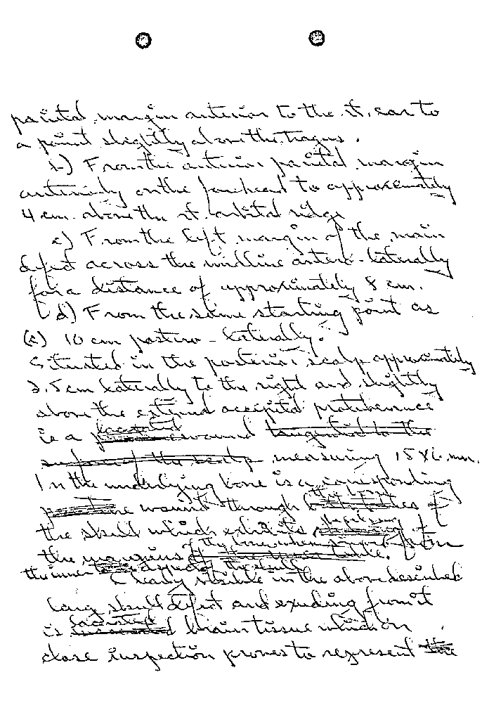
There was no legal need for secrecy and an urgent need for public information that was truthful. The entire world was in turmoil. Humes did "discuss" with Perry "the findings," based on which, as Perry later told me, he knew the wound officially described as in the back of the President's neck was actually in his back. And, although he said he did not tell anyone, Perry had to and he did.
He did have an announced and scheduled press conference on the medical evidence for that very day, undoubtedly the real purpose of Humes' call. Had it been for information, he would have telephoned Perry the night before, while he was examining the body and could check it, not after the body had been surrendered and long after the embalming and reconstruction had been completed and the corpse was in the White House.
It is Dr. Kemp Clark who first pulled the plug on this perjury (6H23):

Dr. Perry stated that he had talked to the Bethesda Naval Hospital on two occasions that morning and that he knew what the autopsy findings had shown and that he did not wish to be questioned by the press as he had been advised by Bethesda to confine his remarks to what he knew from having examined the President, and suggested that the major part of this press conference be conducted by me.

Having already told the world that the President had been shot from the front, could Perry the next day say the opposite? Or can anyone blame him for going on an unannounced vacation - translation: into attempted hiding?
Clark, also under oath, named two other witnesses to this conversation. Need it be added that Specter and the Commission had no interest and questioned neither these two nor any others about it? These were the hospital administrator and Dr. George T. Shires, both of whom Specter interviewed on other matters.
So, especially with the reports that only one bullet was expected to be recovered from the body, and that possible only from the wound in the front of the neck, there is great point in Burkley's affirmation of Humes' quotation of Perry's statement that the anterior neck wound, which he did see clearly and through which he made the tracheotomy incision, was caused by a shot from the front.
It is doubtful if there ever has been any proceeding of the importance of this assassination investigation in which there was as much perjury, except for the Reichstag fire trial. And there the falsely accused was acquitted, not killed.
The difference between the original autopsy descriptive sheet that had been suppressed until I forced it out - that had never been seen by the Commission - and the copy used in the hearings and in the Commission's files is a difference that, were the official conclusions at all tenable, would in itself entirely destroy them.
The reader will recall that when I first published a copy of the Commission's copy, this exposure and reporter Richard Levine's needling led to the fantasy-land "explanation" that Boswell had merely been a bit careless in marking the back wound, never for a moment dreaming that in the autopsy of a President there is any need for care or accuracy. (What better qualification for a Navy Chief of Pathology?)
The wound was in the back, not the neck, as all official observers
260
testified. Only when Specter went to work to rescript the assassination into a fake solution consistent with the officia1 pre-determination of what would be called truth and fact was there ever any question. Until then all the evidence was of a back wound. This includes Specter's own suppressed notes of his own interview with the autopsy witness before their testimony.
Now, we know that Admiral Burkley placed it there, too. And Burkley certainly knew. For the moment we shall restrict ourselves to his first rescue from oblivion. In the lower left-hand corner of the front of the form he wrote, "Verified GGBurkley," all run together.
He did not just initial it. He did not just sign his name. He used a word that cannot be judged as Boswell fooled the press. The meaning of "verified" is not subject to argument. Webster could not be more precise and limiting:

1. To prove to be true; to conform; substantiate. 2. To check or test the accuracy or exactness of. 3. To authenticate; specif., Law, to confirm or substantiate by oath or proof; also to adds verification . . .

Those who instinctively grasp at evidentiary straws to support the official mythology would do well to restrain themselves, for there will be more on this point in what follows. I here make this comment so that those who think they see invisible straws and grab at them do not imagine that a medical man who rises to be an admiral in the Navy and physician to the President does not know the meaning of simple words and here, for no reason at all, just got "careless" and threw in an extra and a wrong word.
Burkley's additions to both the originals of the certifications are word for word identical.
The one that says Humes turned in "all working papers associated with the autopsy, including the "autopsy notes", at 5 p.m., Burkley endorsed with "accepted and approved this date", signing it with his full name, "George G. Burkley", and as "Rear Adm M C U S N Physician to the President".
This constitutes Burkley's certification that those now-missing autopsy notes at that moment did exist and, when added to the receipt and letter so carefully omitted by Specter in publishing File 371 as Exhibit 397, were in his possession. That receipt, the item marked in both margins and the only item in it marked in any way, reads, "One copy of autopsy report and notes of the examining doctor which is described in letter of transmittal Nov. 25, 1963 by Dr. Galloway." And Galloway=s words are, "Transmitted herewith by hand is the sole remaining copy (number eight) of the completed protocol in the case of John F. Kennedy. Attached are the work papers used by the Prosector and his assistant." (sic)
The next day Burkley gave all these items to the Secret Service, which gave him the receipt from which I have quoted.
When Burkley noted "accepted and approved" to Humes' other certification, what he actually did is mind-boggling. This admiral "accepted and approved" what Humes admitted, "that I have destroyed by burning" his first draft of the autopsy report on the President!
Aside from what I have already established beyond peradventure, that this revision and conflagration was not until after Humes and everyone else knew that nobody would have to face examination of his records and cross-examination by defense counsel in a trial of Oswald, by then safely murdered, can anyone conceive of any good reason for the destruction of any record in a crime of this nature? Or its acceptance and approval by the President's physician - an admiral?
When the nature of the changes now known to have been made are considered and with the until-now suppressed confirmation that the Commission's medical evidence in its entirety is dubious and in all evidential elements false, can even the most tolerant put any but the most disturbing interpretation on, first, the unpunished destruction of
261
imperishable, irreplaceable evidence by a man qualified in forensic pathology and, second, the unhesitating acceptance and approval by the physician to the president himself?
When all the experts were military men, when all the civilians were kept out of he autopsy room by military guard, when the military destroyed the evidence and the military approved the destruction of the evidence, and when this new evidence proves the testimony about the wounds was perjurious, criminal, and all of this criminality, this false swearing, was also by the military, is not a question of some kind of military conspiracy unavoidable?
And must I not again ask, is there anything like this in our history or that of any other land considering itself free and civilized?

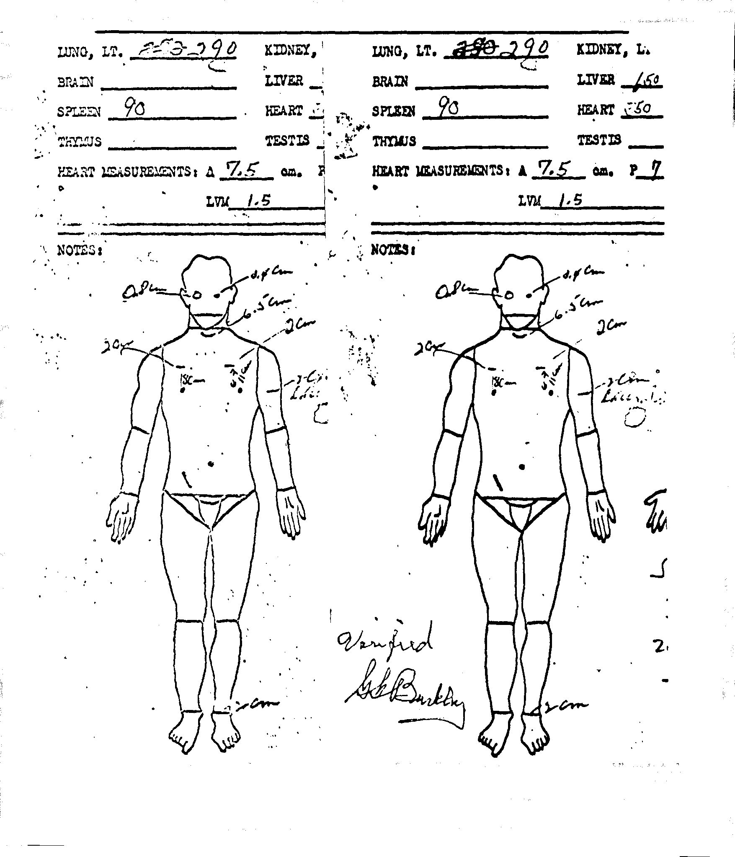
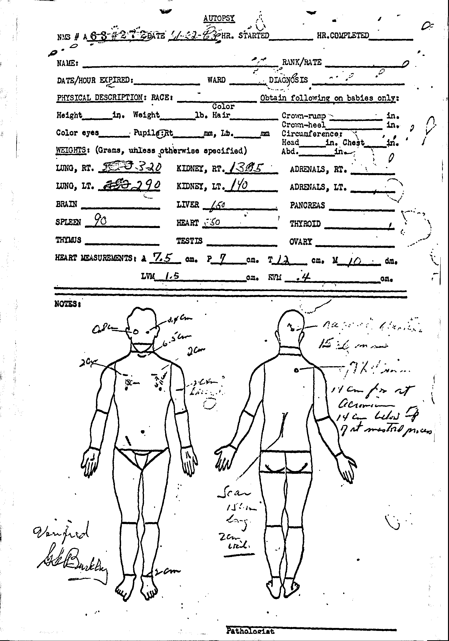
The Secret Service account of the film, X-ray and photographs, to me by then assistant Director Tom Kelley, refers to "the Memorandum of Transfer," which was also disclosed to me and follows later.

… him explains why he was given an also-illegal "exclusive" on it?
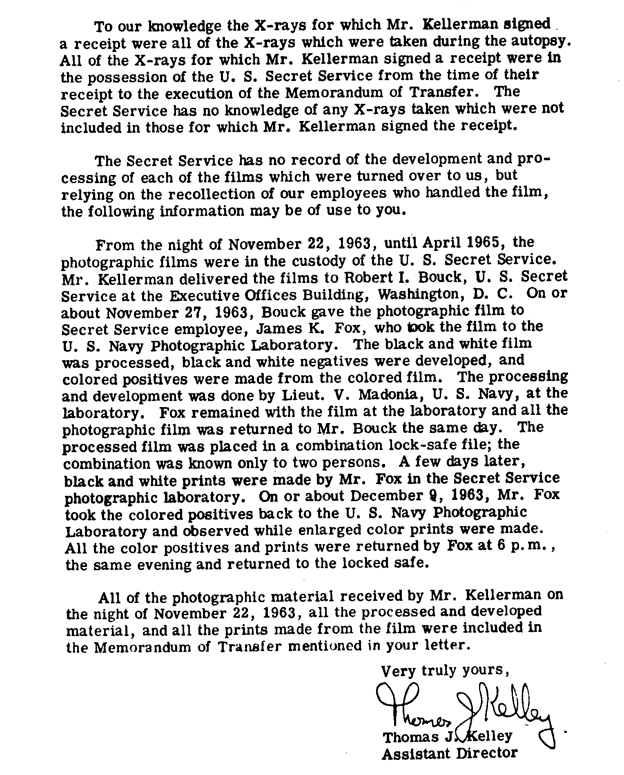
With some difficulty, I did obtain from Tom Kelley a partial explanation of what happened to the film. Because it is an inadequate and incomplete explanation, I feel it is necessary to say what I can for him: that, under the law, it there are no existing records, there is no requirement for the government to report what is in employees minds and not on paper. Therefore, what he did tell me, if adequate remains more than what it was legally incumbent upon him to tell me. Kelley is a lawyer. If he did not know the law, the Secret Service has its own general counsel and the extensive legal staff of the Treasury, of which it is part, to draw upon. Therefore, although the following report is unsatisfactory, it does represent a step toward public disclosure of suppressed evidence, a plus that in my experience is almost entirely limited to the Secret Service. It took four years of trying to get this much, Kelley's May 19, 1970, response to my last previous inquiry of six days earlier:

Incredible as it may seem, when the Commission, aside from its massive Report, also published an appendix of twenty-six large volumes, of an officially estimated of ten million words , it somehow not only found no space for the official death certificate that would have taken on up only two pages, it avoided any mention of it. This official death certificate, usually important evidence in a murder case, also is not mentioned in that part of the Report, which Specter wrote. When I finally found them, it was with those other records I rescued from their official hiding place, the copies on colored paper provided me did not come out clear. I published only the part that is the death certificate. Using it in Specter''s questioning would have been required in any trial but is omission of it in the official supposed assassination investigation of only the assassination of a President is something Specter does not brag about. Which is wise of him because it is not something to be bragged about.
Then, too, this hidden certificate of death could have meant the death of his beloved single-bullet solution to the crime. A bullet hole at the level of the third thoracic vertebra does mean the end of that creation of Specter's and that, in turn, means that there had been a conspiracy and the government, at the highest level, as we have seen, began by ordaining that there had been no conspiracy and by nominating Oswald as the lone assassin.
Specter's associate, Melvin Eisenberg, also an assistant counsel, who knew very well that spectrographic analysis proved that no bullet had caused the slits in the Presidents shirt collar and tie, asked the FBI about neutron activation analysis. The last part of this quotation from his letter also says that he knew no bullet or part of any bullet had caused those damages.
This too was proof that Specter's fabrication was, to his knowledge, an impossibility.
We have seen what did cause those damages, a scalpel in a nurses hand and questioning them at the hearings was Specter's responsibility. As we also have seen, he was careful not to ask the questions he should have asked.
No innocence for any of them, not for Specter in particular. The same Specter who now claims he had that passion for truth.
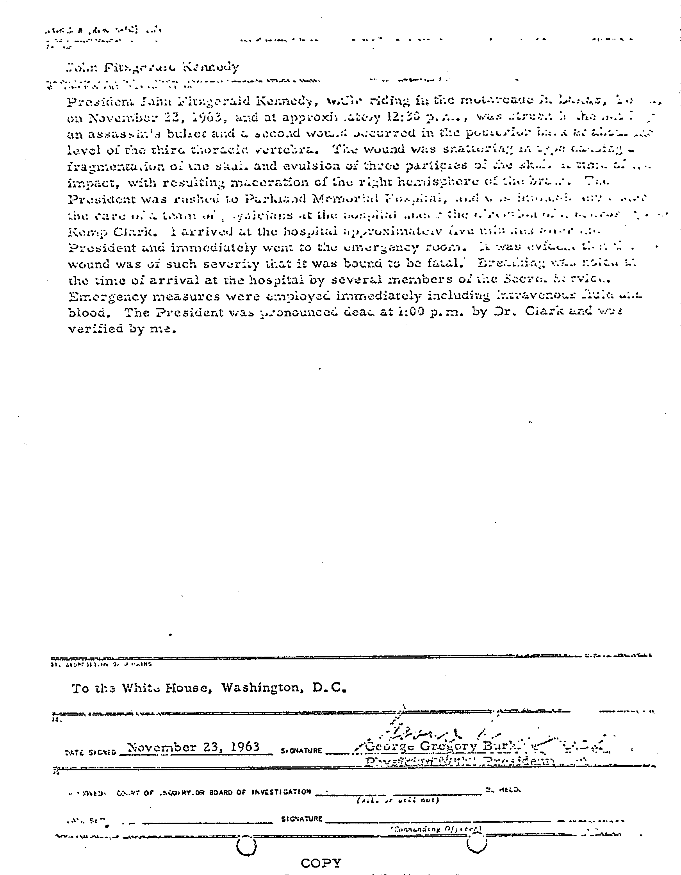
No innocence for any of the Commission and its staff who saw the FBI report ordered by the new President, Lyndon Johnson. This is because FBI Exhibit 60, part of that report, has a clear, a very clear photograph of that shirt collar and a carefully staged picture of a faked knot of that tie, the part the Specter fabrication required that magical bullet to have gone through.
In faking this picture, the picture, the sole purpose of which was to deceive, the FBI was also destroying evidence because the only evidence of that tie was its knot and the FBI undid the knot to pose its fake.
So, the Commission had this additional proof that Specter's single-bullet solution was impossible. But the Commission, including its staff and Specter in particular of its staff, ignored this FBI exhibit and the unwelcome truth it bore. There is no mention of what proof the pictures that make up FBI E60 in what the counsels wrote for their Report.
However, I sought and obtained the FBI exhibit of five pictures it took and the special one of that shirt collar and the slits in it, clearly not. bullet holes. It is much larger than the reduced size copy in FBI Exhibit 60.
I got it with, for once, no difficulty at all. But clearly no one on the Commission did that simple thing, ask for it. In those ten million words of the twenty-six volumes of the Commissions appendix to its Report, none of these pictures was included.
The reason it was so unwelcome to the Commission, to Specter in particular, is that it alone is proof that what Specter made up and is so proud of, his single-bullet fabrication, was impossible.
It alone disproves the Commission's supposed conclusions and its entire Report.
The Eisenberg memo indicates that he and the Commission did not know that the FBI had already had those NAA tests done. There is not a word of them in those twenty-six volumes and that Report. And the FBI response makes no mention of having done those NAA tests. But when I refiled the cited lawsuit to obtain the NAA test results, the FBI stonewalled as hard as I had known it to stonewall. But the Energy Research and Development Administration, which I had included in the refiled suit, did deliver those test results and the accompanying photographs. When at the very end the FBI made a delivery, it consisted of Xeroxes of a great length of adding-machine tape no two sheets of which were attached to each other. Not one of those s sheets bore any identification. No pictures were included, either. So much for the FBI's concern for that the t country and the integrity of its institutions. But I let them get away with the additional dirtiness and contempt for the laws it is supposed to support and protect.
The FBI was also supposed to deliver what it had withheld, its Lab's hairs and fibers examination of that shirt collar and tie. Instead it gave me an entirely different and irrelevant report. But I had what I needed so the truth would be known. I wasted no more time on making a stronger picture of the FBI when its President was assassinated.

… their scope restricted. However, his control was not as firm when staff members had personal contact, as Melvin Eisenberg did with Special Agent John F. Gallagher, the spectrographer, on March 16, 1964.
(Further meaning may be imparted by recalling from the first part of this book the two Eisenberg April memoranda on the conferences to determine when what shots hit whom.)
Of those technical questions Eisenberg asked, to which Hoover responded in his March 18 letter (CD525, 20H1-2), the fourth is most relevant here. Hoover's restatement of the question and his answer are:

4. Would neutron activation analyses show if a bullet passed through the hole in the front of President Kennedy's shirt near the collar button area and also if a bullet passed through the material of his tie? Neutron activation is a sensitive analytical technique to determine elements present in a substance. During the course of the spectrographic examinations previously conducted of the fabric surrounding the hole in the front of the shirt, including the tie, no copper was found in excess of that present elsewhere in undamaged areas of the shirt and tie. Therefore, no coppers was found which could be attributed to projectile fragments.

To this he added the letter's concluding sentence:

It is not felt that the increased sensitivity of neutron activation analyses would contribute substantially to the understanding of the origin of this hole and area.

In what will follow, the recounting of my Civil Action No. 2569-70 and efforts to get meaningful pictures of the damaged areas of shirt front and tie, this response will be of increased significance. Translated from Hooverese into plain English, what this says is that the damages were not caused by any bullet of fragment of bullet. Had either been, there would have been traces of cooper from the bullet jacket, as was said to be the case with the holes in the back of the President's garments.
How, then, was this damage caused? It was not caused by a bullet exiting of entering.
And what happened to the bullet alleged to have entered the back? The official stories are that X-rays show no bullet in the body although both post-Commission panel reports on the pre-Commission X-rays show fragmentation, which in itself rules out Bullet 399 as the cause.
And what caused the wound in the front of the President's neck if spectrography rules out 399, no telltale traces of it of any other bullet remaining on the clothing where it is claimed to have exited?
The reason for suppressing the spectrographic analyses are pretty clear, as is the need for all the lies up to and including perjury and the suppression of what has to this point here been exposed for the first time and what will follow.
Hoover's concluding sentence seems to say that there is no need for making any neutron-activation analyses, and this was a penny pinching investigation. But in the context of the real meaning of the answer to the question, it means much more. It means that since spectrography proves this damage was not from a bullet, neutron-activation will do no more than confirm the spectrographic analyses and prove all over again that the "solution" to the crime and the Report are monstrous fakes.
There is no innocence for the silent Eisenberg, who was soon abandoned by Dr. Light, as noted earlier, over the same evidence, of for any of the others involved in these areas. Least of all can there …
318

One of my challenges to Specter to sue me if I was wrong in what I attributed to him follows. This includes ignoring wrong evidence of which he knew that was relevant and important and failing to ask witnesses who knew the proper questions to deliberate suppression.
The first of the witnesses in the next selection from Post Mortem was a nurse with many years of experience with gunshot wounds. She gave testimony that was an additional destruction of that favorite fabrication of Specter's. What he did, instead of making a record of her observation, was to try to argue with her, to get her to say what he wanted her to say, not the truth as she knew it.
When he had as witnesses the two nurses who removed the President's clothing from him after he was pronounced dead Specter avoided any questions about the cutting-off of his garments, particularly of the shirt and its collar.
Then there are details about the important evidence that seems not to exist any more, evidence in Specter's area of the work. I then asked a question to which Specter made no response, why did Specter
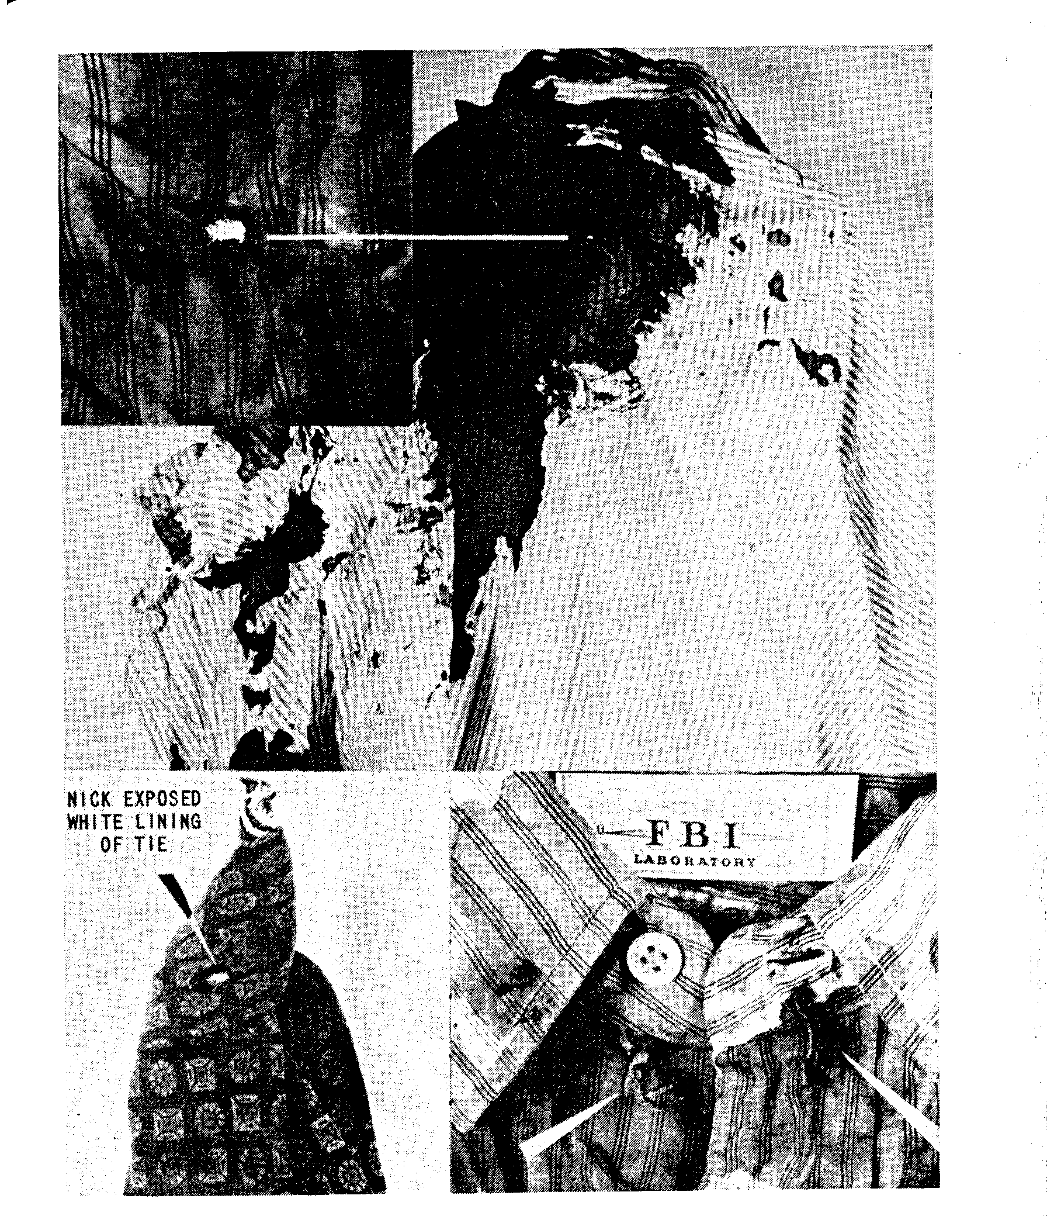
avoid all he deliberately avoided in what he was supposed to make part of the official record of the official evidence - why did he find it necessary to avoid this in all of his questioning of all the medical witnesses, including those who made the cuts in the shirt and collar?
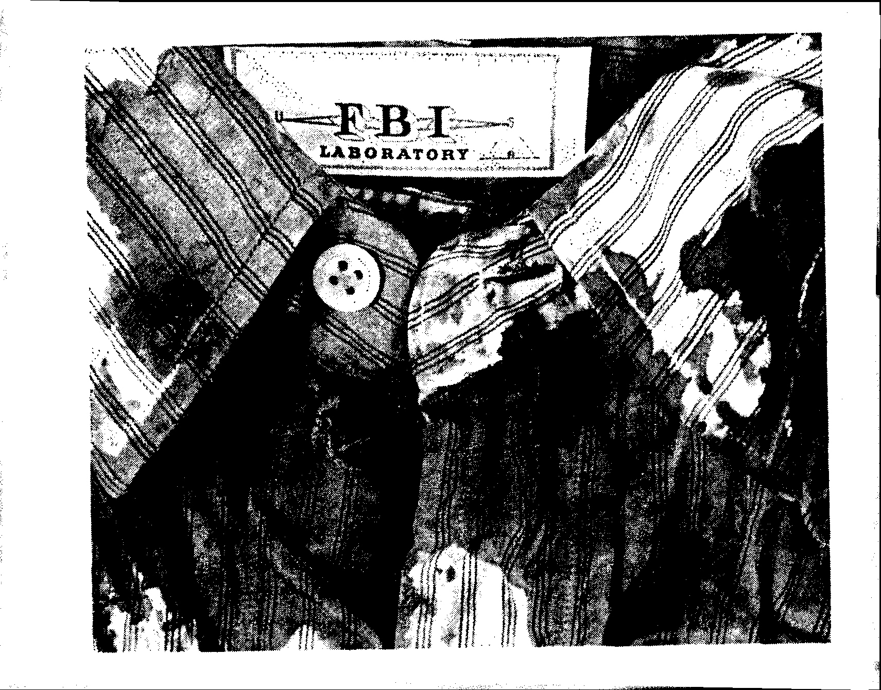
Then, back in 1975, there was this anticipation of Specter's title on his book:

Not, certainly, in pursuit of that bragged-of only client: 'truth'.

on March 21, in Dallas, with no member of the Commission present, Specter questioned Margaret M. Henchcliffe (6H139ff.). She was the first medical person to see the President:

Well, actually I went in ahead of the cart with him and I was the first one in with him, and just in a minute, or seconds, Dr. Carrico came in.

She followed this (6H141), after describing long experience with gunshot wounds in her emergency-room duties, by identifying this front neck wound as one of "entrance".
When Specter tried to get her to say it could have been an exit wound, she insisted she had never seen an exit bullet hole that looked like this one. When he pressed her further, all he got was her recitation of her expertise with gunshot wounds. Eight of her 12 years of nursing experience had been in emergency rooms in a city where gunshot wounds are common. She is one of the few courageous witnesses.
It is she who made the record of when the President was disrobed, not until after he was pronounced dead, after all the medical procedures had been completed:

Well, after the last rites were said, we then undressed him and cleaned him up and wrapped him up in sheets . . . (6H141).

Three days later, again with no member of the Commission present Specter questioned Nurse Diana Hamilton Bowron (6H134ff.). She is one of those who wheeled stretchers out to the limousine, of the first medical people to see anything (6H136). In fact, in an emotional moment, Mrs. Kennedy pushed Nurse Bowron away when the nurse attempted to assist in getting the President onto the rolling stretcher. She was one of the first three in the emergency room.
Consistently, Specter avoided the question of what happened to the President's clothing. However, she volunteered it in answer to another question, "Miss Henchcliffe and I cut off his clothing" (emphasis added) so treatment could be started.
Specter had not expected to call her as a witness. He improvised this for other reasons and she agreed to waive the customary written advance notification (6H134-35). He knew what to avoid and tried to. She had, as had other medical personnel, submitted written reports to their superiors (21H203-204). Beginning with "I was the first person to arrive on the scene with the cart", she recounted the same explanation of how she and Nurse Henchcliffe removed the President's clothing.
With this background, some of Specter's other and also-proficient practice of Orwell's memory-holing is especially in point. Having so carefully avoided all reference to the cutting off of the President's garments and the obvious cutting of the collar, misrepresented as bullet holes in the face of evidence all of which is contrary, he proceeded to forget the other relevant and existing evidence, in all elements and aspects faithfully copied by the Clark 1968 panel.
Specter knew the autopsy surgeons removed a tissue sample from the back for closer laboratory study. He also knew none had been removed from the wound in the front of the neck. He knew better than to believe that malarkey about the autopsy doctors not knowing there had been a front-neck wound at the time they had the body before them. He just avoided calling one of the in-Dallas witnesses who knew, Burkley, and did not ask the others who also were at the autopsy. Burkley and the Secret Service agents knew of this front neck wound. There is no reason to believe that, if Humes and his associates did not recognize it, none of those who had seen it and also knew of it from the conversation and activities in Parkland did not volunteer it or that the Navy doctors did not ask - particularly because they pretended not to know what happened to the bullet they said entered from the rear. Nor is there any reason to believe Burkley, the military man and physician, did not tell them all he knew.
At the Navy hospital, two "sections", or samples, were removed
358
from the edges of two wounds. Specter knew this. He entered the proof, CE391 in evidence. It is the Humes supplemental autopsy report, forwarded by Galloway to Burkley December 6.
Expediently, it just happens that this original, too, has disappeared. Tom Kelley tells me the Secret Service does not have it. The Archivist says he does not even know of it and related items: "We do not know of an original of Commission Exhibit 391 of any memoranda, letters of transmittal of appendages to this exhibit ..."
Specter, however, and not only because he entered it into evidence, did have a copy of this supplementary autopsy report. It is one of 16 items Rowley sent Rankin under date of March 13, prior to Specter's taking of the autopsy testimony. The Secret Service identification is Control 1221. Opposite that number in the listing is the one reference to any routing of any of the 16 items within the Commission, "Mr. Specter has". It was not only automatic, for he had to have it, but he have this proof that he did, from the Commission's File 498.
This supplementary report is short, two pages. There are interesting items, some of which can add more confusions, like the entry after a listing of seven sections "taken for microscopic examination", under examination of the brain. This follows:

During the course of this examination seven (7) black and white and six (6) color 4x5 color negatives are exposed but not developed (the cassettes containing these negatives have been delivered by hand to Admiral George W. [sic] Burkley).

Or, still more photographic confusion and obfuscation.
Then, under "skin wounds":

Sections through the wounds in the occipital and upper right posterior thoracic regions are essentially similar.

This means that slides were made of the tissue at the edges of these wounds.
They, too, are not accounted for. Kelley tells me the Secret Service does not have them. The Navy told me they have nothing at all. There is no Commission evidence, published or unpublished, other than this reference to the taking of the tissue-samples for study. As the Archivist confirmed, everything relevant has just disappeared.
Orwell again.
The thoroughness of the 1968 Clark panel is such that it does not list these slides in its inventory of evidence it examined.
And, what is here most relevant, there was no section made of the wound in the front of the neck. Or, if it was made, it, too, was disposed of. It is not listed, not inventoried, not testified to.
Only when a President is assassinated and autopsied in a military hospital is what is done for a murdered Bowery bum not done.
And this just happens to coincide with the minimum need for a false, no-conspiracy, frame-up Report, avoiding all the missing and here recaptured "new" evidence about that wound from the front. Neither Oswald nor anyone else could have been in front and in back of the President at the same instant. This is just further proof that what was required to be done was not done, to protect the "solution" manufactured to achieve the pre-determined end of the whole awful mess; and what was not helpful to it was ignored of misrepresented.
It was proper, not improper, that the President's clothing be cut. There was no alternative in the medically-required futility of trying to save the irreversibly-dead man who, had the impossible succeeded, would have been a human vegetable.
Only, why did the Commission and the FBI feel it necessary to try to hide this in the printed pictures?
Why did Arlen Specter, the experienced lawyer, then a former Assistant District Attorney of Philadelphia, a man who knows criminal
359
evidence, find it necessary to avoid this in all of his questioning of all the medical witnesses, including those who made the cuts?
Not, certainly, in pursuit of that bragged-of only client, "truth".
Specter is the father of the Commission's bastard "single-bullet" baby, that illegitimate, "no-conspiracy", "lone assassin" offspring he thought all the evidence and all those on the staff who disagreed to father it. (Remember again those Eisenberg April memos written after the pregnancy became visible in the March 16 autopsy testimony.) Until the moment of delivery, the Commission was a lady of easy virtue. Each of the silent members of the staff who had doubts and remains unconfessed is as guilty, as much a participant in this gang-bang of history and justice. Each, in effect, restrained the arms and legs of the victim as Specter indulged his guilty lust to sire this great lie.
To mix metaphors hermaphroditically, so to speak, this is perhaps the first time in official history that one man was his own whore and his own pimp. Though he had accomplices, the parthenogenic monster is Specter's.
And still again I dare him to sue me!
If he is man, not pimp/whore, I will read these words on the steps of his City Hall so he can sue me where he, made District Attorney and all-powerful by this foul deed, can have all advantage, leaving my fate to whatever lawyer will volunteer to defend me. By then there will be some.
ARLEN SPECTER HAD TO KNOW WHAT HE WAS DOING!
He can have no innocence.
He was in full charge of this part of the work, Francis Adams, his initial superior, having quietly left to return to his New York legal practice rather than be part of this. (If we can respect Adams' departure, what of his silence?)
Specter had to know the damages to the shirt front and tie were from a scalpel, not a bullet, and he nonetheless faked the entire monstrous "solution". This freed and exculpated assassins, framed an innocent man, to legitimatize the illegitimate official account of the assassination of the man who had started a re-ordering of national priorities away from war and toward peace, toward the belated granting of part of their share of the national heritage to those so long denied it.
Were Arlen Specter the largest stockholder in war industries, he could no better have served the purposes history soon enough shown were served by this assassination.
For these purposes, the assassination required proper baptism.
Specter's holy water came from the foulest sewer.
And all the eminent nostrils smelled frankincense and myrrh.
Need one have more than a Mankiewicz' concern? Was not the President (safely) dead?
With the understanding imparted by this first examination of the until-now withheld pictures, the withholding of which was of sufficient importance to the government to force me to sue for access, what happened to the tie is clear.
All the Borgias did not die in medieval days. There is a new breed.
All the Councils of Kings, the assassins of blighted antiquity, have not crossed the Styx. Their modern counterparts range from the Potomac and the Hudson to the Golden Gate.
Their successors flourish in Washington, D. C., the United States of America of the last half of the twentieth century, in the period between Hitler 1932 and Orwell 1984.
360

The five pages that precede the following quotation from Post Mortem recount the offer of a man born to great wealth to pay for printing the book if he could edit it. And also duplicate some of my work under FOIA. He admitted to being an on anti-Kennedy kick. I rejected his offer and have not heard from him since. Those pages also refer to additional denials of access to the Kennedy-family materials while violating that agreement giving access to those who did not meet the conditions of that agreement. Then follows my account of one of my interviews with Doctors Perry and Carrico. But still again, what I wrote was critical, very critical of the Arlen Specter who remained silent about what was so critical of him.
These interviews produced first-person accounts. From Carrico. It included his supervision of the nurses as they cut Kennedy's tie off at the knot and nicked the shirt collar, what we have just seen that Specter also did with those nurses when he questioned them when they were Commission witnesses.
The questions I asked of Perry and Carrico are questions Specter should have asked them if he .had pursued truth, but he did not ask ahem or others like them.
That failure is another part of who Specter now refers to as his Passion for Truth.

It was deer season in Texas. Some of those I interviewed outside the hospital had just returned from tripe to hunting country, some were about to leave. Parry had sought deer and antelope the previous week. He and his family are fond of the meat. Hunting is a form of exercise he enjoys. They had not had good luck. His 11-year-old son had the only chance at a deer, a bad shot, so they bagged none.
This led us into a discussion of hunting, rifles, ammunition and the effects of various kinds of ammunition, designed for different purposes. As with many men who really enjoy hunting. Parry is an expert on ammunition. In common with many hunters and gun hobbyists, he hand loads his own ammunition. In connection with this writing and that on the King assassination, I have made a study of rifles and ammunition, have consulted various experts, standard literature and criminalists, and I believe that Perry is much more expert in these areas than most doctors in other parts of the country. It has been my opinion that there are few cities in the country in which the assassination could have been committed where the witnesses could have been as helpful to any sincere investigation because of their knowledge of wounds, weaponry and ammunition.
This, too, is a secret in the official investigations. Neither the Commission nor the FBI was interested. Their interests lay in the other direction, in hiding. Perry's amateur expertise is one of these secrets, through no fault of his.
Most of this is Arlen Specter's fault. I found Dallas officials who developed intense personal dislike for him and the manner of his "investigation". Specter knew what to do to keep what he wanted out of the official evidence. One new example of this is Allan Sweatt, then Chief Criminal Deputy in the sheriff's office. Sweatt was responsible for the immediate taking of statements from eyewitnesses. He handled all the pictures immediately known about. But Sweatt was not e witness before the Commission, was not the subject of any FBI interrogation in the Commission's evidence. Specter used Sweatt's polygraph room to conduct the Ruby lie-detector test. He used polygraph "experts" whose credentials are considered dubious in Dallas. The first thing Specter did was to chase Sweatt, an authentic expert, from his own office. Sweatt was not present when Ruby was questioned.
So, if there ere inadequacies and errors in the testimony of the doctors and if, as I believe, in some cases it crossed the line into criminality, the responsibility is Specter's. The doctors deserve sympathy and sympathetic understanding of the position in which all had been put. All were under inordinate pressure. Perry is but one example. He is but one of the many with technical knowledge valuable (if not, indeed, essential) to any thorough and honest investigation whose expertise was hidden from the members of the Commission and its record, secret and published.
The first doctor available was Charles Carrico, by then on the surgery teaching staff. He confirmed all I have written that relates to him and what happened in his presence and added that which Specter did not want and had not asked for.
Carrico was the first doctor to see the President. He saw the anterior neck wound immediately. It was above the shirt collar. Carrico was definite on this. The reader will remember that Dulles had blundered into making Carrico locate that wound when Specter failed to probe this essential matter. It is not by accident or from stupidity that Specter did not ask this fundamental question. The only qualification Carrico stipulated in my interview is that the President's body was prone when he saw it. However, when I asked if he saw any bullet holes in the shirt or tie, he was definite in saying "No". I asked if he recalled Dulles' question and his own pointing to above his own shirt collar as the location of the bullet hole. He does remember this and he does remember confirming that the hole was above the collar, a fact hidden with such care from the Report. Although there is nothing to dispute it in any of the evidence and so much that confirms it, this had to be ignored for in and of itself it means the total destruction
375
of the lone-assassin prefabrication. So it, too, was memory-holed, according to Carrico, the doctor who was there and under whose supervision it was done, the clothes were cut exactly as I report. In emergencies, speed is essential. Clothing is cut to save life-precious split-seconds. Practice was not to take time to undo the tie but to grasp it, as he illustrated with his own, and out it off close to the knot. The knot is not cut. The customary cut is made where there is but a single thickness of necktie. With a right-handed nurse, what happened with the President's tie was inevitable. In this cutting, minute nick was made at the extreme edge of the knot. Because of the danger of injury to the patient, the collar button and the top of the shirt are unbuttoned, and that is what the pictures of the President's shirt show did happen in this case. Trained personnel did exactly what they are trained to do, what they do instinctively. Because these medical personnel are trained to do what they automatically did in this ease, Specter had no interest in it. His interest was in the case he framed.
I asked Carrico what Specter did not dare ask, the simple question whether, in his opinion, and base on s experience in emergencies, the nick on the knot and the slits in the collar were made by the nurses, not by the bullet. Carrico considers it unlikely, He saw neither the nick in the tie nor the cuts in the shirt before the nurses started cutting.
Was any other examination made, I asked him. He said that he followed standard procedure, running his hands down both sides of the back without turning the body over. The purpose is to ascertain if there is a large wound. If there is, it can be felt through clothing.
If Carrico, an honest, straightforward man, spoke so openly with me, I have no doubt that he would have been no less informative with any and all official investigators, had they -- any of them - truth for their client.
From Carrico's office in Room 208, I want to the sixth floor, where Drs. Robert N. McClelland and Perry have offices opposite each other. McClelland was in, Perry was then not. McClelland was pleasant greeting me cordially. I asked him about his contemporaneous statement, that "the cause of death" was "a gunshot wound to the left temple" (R527). He does remember it and began an apology by saying "it was a total mistake on my part". His explanation is the "Ginger", Dr. Marion T. Jenkins, called the spot to his attention, McClelland seemed genuinely disturbed about this. He was bitter that the New Orleans assistant district attorneys had asked him about it and self-satisfied with how he talked them out of calling him as a witness -- by telling them he would swear it had been a "total mistake".
I asked him why he never corrected this alleged mistake, especially when he was deposed and Specter, having avoided it with obvious care, asked him instead if there was anything he hah said that he wanted to change or anything he wanted to add (6H39).
McClelland had no answer. So I asked how he knew it was, in fact, a "total mistake". He then shifted to this position: "I don't know that it wasn't and I don't know that it was." We both realized this was a far cry from his opening, "it was a total mistake," for almost immediately, and without vigorous questioning, he was admitting openly and without leading questions that it might; not have been any kind of mistake. A bit embarrassed, he formulated still another position, "I presume it was a wrong assumption."
He was anxious to complain about Garrison and his assistants, and I listened to a long, bitter and irrelevant diatribe, which seemed to satisfy him. When he ran down, I asked how he would or could now account for such an error, if and error it was. He then conjectured it was a spat of splattered blood. Perhaps an experienced surgeon and a professor of surgery cannot tell the difference between a bullet hole of entrance to which he attributed the crime of the century and a spot of blood. I found it not easy to believe. So I asked him how he came to
376
realize that perhaps he was in error. That, it turns out, was not anything he had seen or of which he had personal knowledge, but the autopsy report taken around and shown by the federal agents! It was not in the autopsy report so it was not true, regardless of his own professional observation and opinion.
There was another obvious question and I asked it: Had he, Jenkins, or anyone else wiped this alleged spot to see if it was no more than a spot of blood or to see if it was a bullet hole when all knew there would be an inquest which would have to establish the cease of death? His answer was simple, direct and unequivocal: "No."
I reminded him that Jenkins also had testified to the existence of this left-temple wound. McClelland had no explanation.
Jenkins was not available. His second reference to this under oath was remarkably detailed and precise in locating the alleged wound in the left temple (6H51). This followed immediately upon an off-the-record "discussion" with Specter, the content of which Specter described as "on a couple of matters which I am now going to put on the record" (6H50). With regard to Jenkins' professional belief and observation of the carefully described and oriented left-temple wound, Jerkins testified, "you have answered that for me". This is one way of conducting an "investigation", with the lawyer telling the expert witness what to say and believe.
Thus it is clear, regardless of whether the doctors' observations were correct or in error, on what could have been a vital element of the evidence, the only doctors who have personal knowledge have no basis for denying their immediate, competent, professional and unsolicited observation, that there had been a left-temple wound of entrance and that it was the likely cause of death. Instead, they were told by Specter and by federal agents what to say and believe and what not to say or believe.
When I left room D614A and walked across the hall, Perry was in.
He is a warm, friendly man, inclined to smile pleasantly while talking, with what appears to be justified pride in his and his institution's professional accomplishments. While he remembered me and my belief that the official account of the assassination is wrong, he was not reluctant to be interviewed. His recollections of the great events in which he had bean caught up are, and for the rest of his life will be, sharp. From my interviews with him, I am without doubt that, had he not been subjected to powerful and improper pressures, there would have been no word he would have said that would not have been completely dependable.
From time to time embarrassment showed. He began defensively, going back to the anterior neck wound. He does not deny telling the press that it was one of entrance. He does say that he had been given a tape of one of his interviews in which he hedged the statement by saying it was, to a degree, conjectural. Most doctors, under those circumstances, great urgency, the President as the patient and without their having turned the body over, would have said something like "appeared to be" in describing the wound as one of entrance. While superficially maintaining the position in which Specter put him under oath, of saying he did not really know whether the wound was of entrance or exit, Perry readily admits that Humes correctly understood him to describe it as a wound of entrance. He also admits that federal agents showed him and the other doctors the autopsy report before their testimony.
As I led him over those events and his participation, what he did end the sequence, he recalled that he first looked at the wound, then asked a nurse for a "trake" (short for tracheotomy) tray, wiped off the wound, saw a ring of bruising around it, and started cutting. In describing the appearance of the wound and the ring of bruising, he used the words, "as they always are". Pretending not to notice the significance of this important fact he had let bubble out, I retraced the whole procedure with him again. When he had repeated the same words, I asked him if he had ever been asked about the ringed bruise around the
377
wound in the front of the neck. The question told the experienced hunter and the experienced surgeon exactly what he had admitted, one description of an entrance wound. He blushed and improvised the explanation that there was blood around the wound. I did not further embarrass him by pressing him, for we both knew he had seen the wound clearly. He had twice said he had wiped the blood of and had seen the wound clearly, if briefly, before cutting.
The official representation and that of an unofficial apologist to which we shall come would have us believe that bruising is a characteristic of entrance wounds only. This is not the case. The reader should not be deceived on this or by Perry's admission that there was bruising. Exit wounds also can show bruising. One difference is that exit wounds do not have to show bruising. That in this case there was bruising by itself need not be taken as an expression of Perry's professional opinion that it was a wound of entrance. The definitive answer is in those words he twice used, quoted directly above, "as they always are". It is entrance wounds only that always are of this description. Thus, Perry had said again and in a different way that this was a shot from the front. In context, this also is the only possible meaning of what Carrico had said.
In the official version, the President's nonfatal and all of Connally's wounds were caused by the same bullet. We discussed them. Parry was called in on the Connally surgery "by the boss" because he is an expert on arterial injury. When the other doctors noted the location of the thigh wound, they feared the possibility of proximity to an artery. One would never know this from Specter's questioning of any of the doctors or from any of the reports of federal agents. There is no reason to believe it is because of the reluctance of the doctors y to speak freely.
Because of the reason for which he had been called in, Perry made careful observations of that wound as he made his examination. The hole was much too small for a bullet to have caused it. He said that from his examination of the X-rays, the fragment was relatively flat and could not have been deposited by a whole bullet that then backed out. He showed me with his fingers that the fragment was less than a half-inch under the skin and that it had gone about three to three and a half inches after penetration. This near-the-skin trajectory alone is more than enough to invalidate the entire official story. Because he saw no danger to any artery, Parry did not remove this fragment. This, he said, is the usual practice. He volunteered that, had the fragment been there from an unremembered childhood accident, it would have presented no hazard to Connally. I asked, had there been such s childhood accident, would it not have left a scar? Parry said the fragment was so thin it need not have.
Gradually, as we discussed his observations, Perry came to realize that he was providing a professional destruction of the official story. So, when we were discussing the Connally thigh wound, I reminded him that the official police account, written at the time of the crime and quoting the doctors, had said the same thing, that this wound had been caused by a fragment.
He then volunteered on this point that the X-rays showed fragmentation in Connally's wrist. When I quoted Shaw's and Gregory's testimony that there was more metal in the wrist than can be accounted for as missing from Bullet 399, Perry nodded his head in agreement. Perry was not unwilling to express criticism of the autopsy doctors. Humes had told Specter that the bruise on the President's pleura might have been caused by Perry's surgery. Perry was affronted by the suggestion. He said they never cause such bruising in tracheotomies in adults and are exceedingly careful to avoid it in the smaller bodies of children. When Parry learned of this bruising, he had wondered if the cause was fragmentation. If he then had no way of knowing it, on the basis of my "new evidence", that today does seem to be the most reasonable explanation.
The autopsy doctors were wrong in attributing the chest incisions
378
to subcutaneous emphysema. The way Perry said this, it was as though were saying, "Any child should know that." Perry, personally, had asked for these incisions. They were for a "closed chorostomy". This is irrelevant except as a professional opinion on the competence of Bethesda doctors.
Having learned what Specter suppressed, that Perry is an amateur expert in ammunition, I discussed other evidence that Specter suppressed, the pattern of fine fragmentation in the right front of the President's head as disclosed without explanation in the panel report. Perry was without doubt that this could not have been caused by a jacketed, military bullet. The reader should remember that, under the terms of the Geneva convention, military ammunition is encased in a hardened jacket for "humanitarian" reasons, to prevent just this kind of fragmentation in human bodies. Military ammunition is designed to avoid explosion of the bullet in the body, for a clean transiting of the body. This is not the case with hunting or "varminting" ammunition, that is, a bullet designed for the humane killing of pests or undesirable animals.
Perry's opinion is that the fine fragmentation and its pattern in the right front of the head alone could be the and of the Warren Report. As he thought about this "new evidence" on the wounds, Perry said that, from his experience, the panel description of the pattern of fragmentation is consistent with what he would expect from a "varminting" round. It is the opposite of the behavior of a military round, which is supposed to prevent this.
To illustrate his point, which is not his alone, Perry described the explosion of a varminting bullet on a recent hunt, when he had shot a prairie dog. The damage in each case was similar. The inference is that the massive damage to the President's head could have been caused by an entering bullet. Other amateur experts, like Dr. Richard Bernabei, had already told me this.
All his colleagues hold the highest opinion of the county coroner, Dr. Earl Rose, who was avoided with such official diligence that his name is not once mentioned in all the testimony. Rose objected vigorously to the kidnapping of the corpse. It was his responsibility, under the only obtaining law, to perform the autopsy. All the doctors agreed that, had he done it, the questions and doubts that now exist would not.
After the interview I discussed the "new evidence" with Perry, inviting him to come and see it for himself. I described the reporting of medical fact by the Clark panel, then quoted the death certificate. He said that if the government could do such things he would be terrified. I told him, "Then you should be terrified."
Were one inclined to be terrified about those things which have become normal with government and cannot be tolerated in any kind of decent society, there would be no end to terror on this subject.
Another case is one more illustration of the official misuse of the Kennedy name. It happened when I was away in early May of 1972. During this absence, I received an undated letter from Rhoads. He had declassified "the one page of Mrs. John F. Kennedy's testimony ... that had been withheld ..." He enclosed a copy.

There were many pious speeches in the "Top-Secret" executive sessions of the Commission about calling the widow. There was always the pretense of concern for the feelings of the bereaved. It had finally been decided that the chairman and Rankin would question her at her 3017 N Street, Northwest, Washington residence, in the presence of the then Attorney General, Robert Kennedy. This was postponed until the time the Commission expected to have its work completed, hardly the proper or appropriate time for interviewing the only close eyewitness to the fatal shot. A witness with her knowledge should have been one of the first called and one of those most closely examined.
But Finally, at 4:20 p.m. on Friday, June 5, 1964, it came to pass.
379

Mrs. Kennedy's testimony had been delayed and then kept secret. Paul Hoch and I were trying to break it loose and we finally succeeded, I was surprised at its brevity, as I was about the Rankin unhidden attempt to make it mean what she did not mean.

It was so brief end superficial that, as printed, the whole thing requires less than three pages (5H178-181). When the formalities are eliminated and if one considers everything else relevant, the relevant is about two pages. Including formalities, it took exactly ten minutes, no more. It was all over at 4:30.
Mrs. Kennedy was looking directly at her husband when his head exploded. The Commission suppressed the relevant frames of the Zapruder film (as I exposed in Whitewash II). It pretended to make a typographical error, saying that Life had supplied a series ending with Frame 334. But simple arithmetic with a J. Edgar Hoover letter told me that Life had been asked for and had supplied nine additional frames, through Frame 343. The Commission suppressed them from its printed record. It was not because of the indescribable horror felt and shown by the widow as she saw the terrible thing from inches away, not because of official sensitivity about her feelings, that these frames were not published. It is because they, too, contradict the official account of the fatal shot and raise doubts about the nonfatal injuries.
Her husband's head did explode in her very face.
At the point where, from the printed transcript, it appears she was about to describe this, the Commission, with seaming honesty, inserted [Reference to wounds deleted].
This is a deliberate and multiple lie. Mrs. Kennedy made no specific reference to any wounds. Not here and not elsewhere. Rankin saw to that, it being his obligation to take testimony from her, not schmalz, to ask her about the wounds, not avoid it.
So, he did avoid it. The question to which she responded was not about wounds. It is, "Do you remember Mr. [Clint] Hill [her Secret Service Agent] coming to try and help on the car?"
And this one acknowledged is not by any means the only change in her testimony. As a matter of historical record, I here reproduce the entire page.

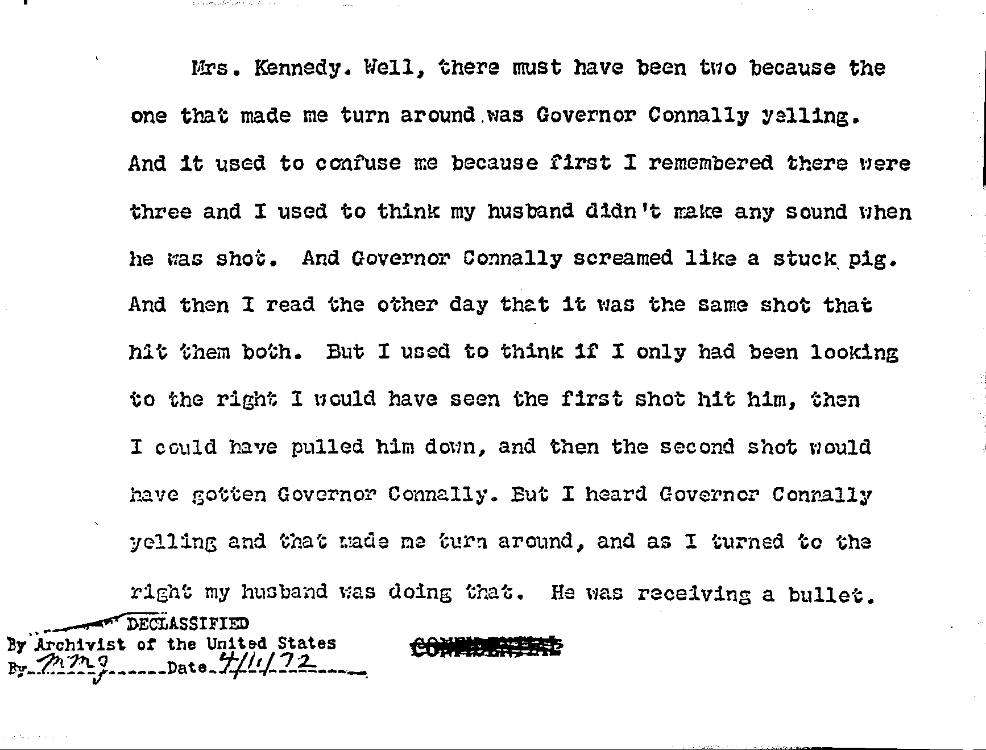
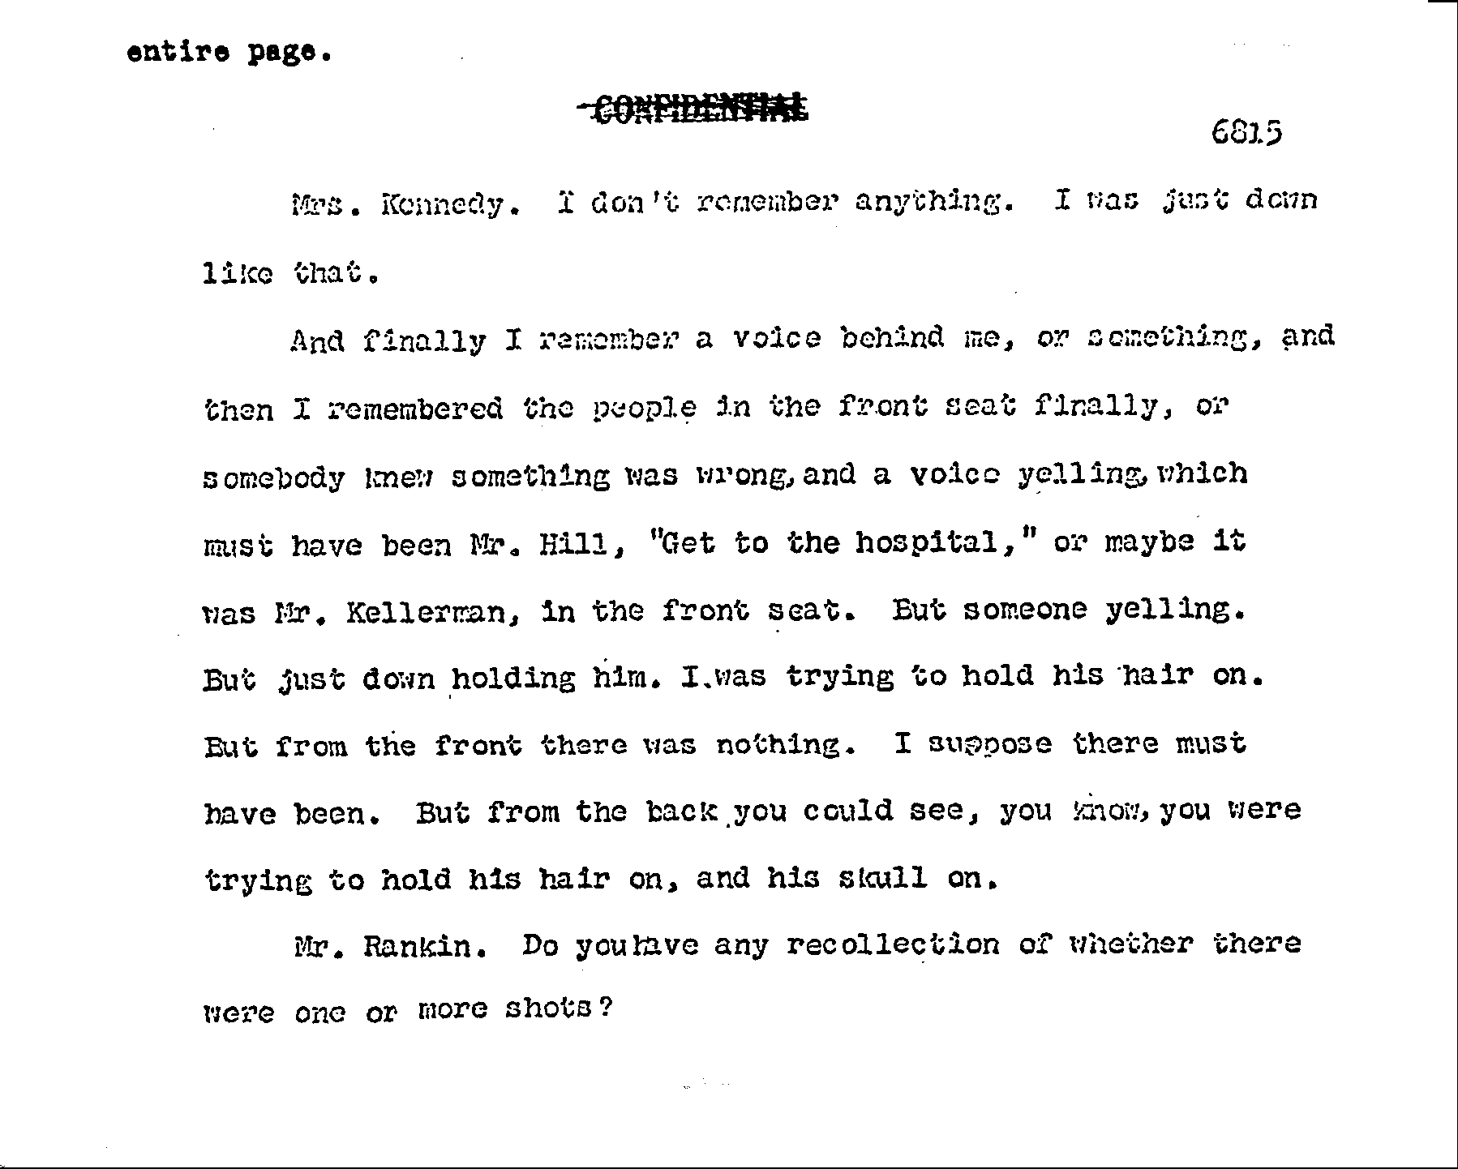
This can be compared with the printed page.
As there are changes not indicated in the published transcript, so also do they serve specific purposes, not merely to delete the non-existent "reference to wounds". They are not whimsical. This trickery with the sworn testimony is to protect the predetermined official mythological "explanation" of that assassination from its destruction by the widow. Because she was the widow, was the closest eyewitness, that destruction, at the time the Report was released, might well have been total and permanent.
My efforts to gain access to even an edited and censored "reference to wounds" by Mrs. Kennedy go back six years from the time, a month after its declassification, Rhoads sent me the withheld page. My first letter asking for it was written June 26, 1966. Although I was not then aware that lying is the way of official scholarship, the response had a generous supply of what now, clearly, are lies. To use more polite language is to deceive the reader and history. Two excerpts should suffice:

The manuscript transcripts of testimony of witnesses among the records of the Commission are withheld from research because they contain matter deleted in the published Hearings for the reason that the Commission considered publication to be in poor taste or the information to be irrelevant to and facet of the Commission's investigation (Hearings, Vol. I, p. v.).
* * *
… The National Archives merely has custody of the records of the Commission and can make available only those records that have been cleared for research use. I should like to emphasize that it is our policy, and has consistently been our policy to provide access to researchers on s basis of complete equality.
381
The irrelevant comprises most of the published hearings. What is "in poor taste" is and always has been readily available, much of it published. Repeatedly I have had to be my own censor in masking what is in poor taste and the defamatory, such as allegations of homosexuality, in using the unrestricted. And avail if a few of Mrs. Kennedy's graphic words might be misinterpreted as in poor taste, that is the nature of spontaneous testimony, as it is its importance. In any event, it is neither why her words were edited nor encompassed by the inserted description of what was suppressed.
The representation that the "Archives merely has custody of the records of the Commission and can make available only those records that have been cleared for research" is the most deliberate kind of duplicity and entirely misrepresents the reality, as the reader should remember. The Archives had and exercised the right and obligation to declassify the Commission's own records. It is only the records of other agencies that have to be "cleared for research" from outside the Archives. The Archives used its legal responsibility for political purposes, to suppress, and for propaganda, not for scholarship. Cases have bean cited and we shall resume with one in what follows.
With the recounted history and with the month's delay in sending this one page to me, I was suspicious. I found myself wondering if it could be only by accident that this page was sent the first time I was working away from home in six months. Could it be no more than happen-stance that I would be getting it in a flood of other accumulated mail and at a time when I would be deeply preoccupied with different work? Consistent with these doubts is the absence of a date of the letter, the only case I can remember in a truly enormous correspondence.
So, I made a word-by-word comparison of the suppressed page with the printed representation of it. Prior to any indication of any change, I found one that seems significant and, like all the others, is not in any way indicated in the published, altered version.
In the first sentence of the first of the two longer paragraphs, the published version has but two seemingly minor changes. The word "finally" was shifted. It alters completely what she was saying. It is made at best ambiguous when it was unequivocal. It is made to seem that she, or "a voice behind me" or "somebody'' undescribed ''finally knew something was wrong". And the tense is changed to make it seem that her recollection is of the time of her testimony, not the very instant of the crime. "Remembered" is changed to "remember". In saying what she actually said, "and than I remembered the people in the front seat finally" reacting, she is not criticizing the Secret Service agents but saying there was, a longer interval between the time of the first shot and the time of reaction, "finally". She carried this further in the next paragraph, which confirms the unwelcome Connally and Kellerman testimony, meaning that the first shot was much earlier than officially admitted.
Rankin was typically cagey and misleading in his formulation of his question. He did not ask her how many shots she heard. Instead, he put it this way, attempting to influence her response: "Do you have any recollection of whether there were one or more shots?"
One of the changes appears to be legitimate, Mrs. Kennedy's use of "that" is meaningless without description. It was changed to what seems accurate. What the court reporter should have included in the transcript but did not was added. Her recollection is faulty, as this shows, because it had been changed by what "I read the other day". There was, of course, no interest in what she had read. The changed recollection is what officialdom desired. Thus, she is made to say what the existing pictures prove quite wrong, that she did not turn "to the right" until "my husband was doing this [indicating with hand at neck]". She turned much earlier. This is what the rest of the testimony on this suppressed page says.
She did not hear the first shot. And, what "made me turn around was Governor Connally yelling." This is what Connally and his wife swore to, that they had heard the first shot, as he could not if it had
382

… hit him. Bullets do travel faster than sound. Connally remembers his reaction to knowing the President has been hit and remembers being hit separately and later. The Commission could not accept his testimony and conclude as it did, so it did not accept his attestation, his wife's, or this entirely confirmatory testimony by Mrs. Kennedy.
Skipping the remainder of that sentence for a moment, to present it in proper context, the next, as edited and published, reads, "And Governor Connally screamed." It is not considerations of good taste that inspired censoring of the rest of that sentence. The accomplished intent is to hide the clarity of her recollection and testimony and the emphasis she placed on Connally's "scream" causing her to turn. She described how he "screamed", "like a stuck pig". She emphasizes this again toward the end of the paragraph, "But I heard Governor Connally yelling and that made me turn around ..." She began the paragraph in the same way, what "made me turn around was Governor Connally yelling". Three times in the same paragraph she testified that what made her turn around was not awareness of a bullet having been fired, but Connally "yelling" and screaming "like e stuck pig".
And without having heard the first shot, how many were there? What did she volunteer before Rankin's dishonest question designed to persuade her to testify to fewer shots then she knew? She testified there were four! There was the one she did not hear, the one that made Connally yell; and "I remembered there were three."
Delay in questioning her, the manner of questioning her and whatever she "read the other day" had the inevitable and intended effect. They "confused" her. As with Zapruder, whose recollection of reality was changed from the uncongenial to the official, and as with so many others, she was conditioned. As if her suffering were not enough!
And the poor woman, treated like Pavlov's dogs, wound up thinking her clear recollection was wrong when it was not. She could not understand how she could remember what was officially verboten until "I read the other day that it was the same shot that hit them both”! She, Governor and Mrs. Connally and the distraught and dedicated Kellerman, 100 percent of the close witnesses on this evidence, were correct. But correctness was not the desire of those who boasted "truth is our only client". So incorrectness became correctness.
Just like Orwell said, only 20 years early.
Her distress is further reflected in another changed sentence. She did not mean she wanted the Governor killed. What she actually testified to is, "But I used to think if only I had been looking to the right I would have seen the first shot hit him, then I could have pulled him down, and then the second shot would have gotten Connally."
What her unaltered testimony really says and means, because she had turned to the right before Frame 210, the first point at which the commission claims the President could have been hit, is that, if she had been aware of the first shot, if she had heard it, instead of reacting to Connally's yelling, she might have saved the President from being hit by the fourth and fatal one, from the only one she saw hit ("He was receiving a bullet").
The reader need not wonder about what was removed at the point the Commission says "”[Reference to wounds deleted]". It includes a further reference to back of immediate awareness or reaction "in the front seat". But no reference to any wound, no description of any, the purpose for which the closest eyewitness should have been questioned. In both versions, the honest and the altered, there is the incomplete sentence not referring to Connally but a later time and voice, "But someone yelling". In the published form, between this and the bracketed insertion, there is only "I was just down and holding him down", which is not what she testified. Her authentic words are, "But just down holding him. I was trying to hold his hair on. But from the front there was nothing. I suppose there must have been. But from the back you could see, you know, you were trying to hold his hair
383
on, and his skull on."
Part of the skull had disappeared, as we have seen. Her intentness on having the President's head seem intact, which is understandable, may explain what happened before the head was exploded and "I was just down and holding him down:: her unrecalled venture onto the trunk of the car, where Clint Hill may well have saved her life, almost at the cost of his own. Hill's belief, that she was trying to retrieve a piece of skull, makes as much sense as anything else. Subconsciously, in what must have been the most excruciatingly painful reliving, and emotionally, in agonized words that seem incoherent, she said more than the Commission wanted said.
"But from the front there was nothing" can mean that there was no flap of hair and skull for her to press back into an intact head. Two pieces were missing. The Commission was not anxious for this to be known, witness suppression of the Harper reports I discovered, and the continuing suppression of those pictures of the piece of skull. "From the back" here, I believe, means the piece of skull, from the back of the head.
The understandable repugnance comes through unintendedly in her depersonalizing of what she did, substituting for the personal pronoun: "you were trying to hold his hair on, and his skull on." There was no, "you". She alone suffered that greatest of agonies.
Yet in a sense this subconscious misspeaking was apt. In a very real sense it was appropriate for her to formulate a charge against the Commission she had no reason to make, that it was "trying to hold his hair on, and his skull on", where there was none. And where all officialdom had to know there was none.
Figuratively and literally, this is true. Characterization of men who would do such a thing when a President is assassinated -- and misuse his widow for such a purpose -- is unnecessary. It is not necessary to attribute motive, either, for at this point there can be but one, and it is obvious.
Mrs. Kennedy did confirm that the President had been shot much earlier than the government could acknowledge and still pin a bum, no-conspiracy rap on Oswald and history. She did confirm the unwanted but unavoidable testimony of both Connallys and Kellerman, which also mean precisely this. She did remember it in a way irrefutably confirmed by the existing and misrepresented film -- all of it that captured that scene. And what she testified she did is confirmed by thin film and by all the testimony about what she did (Whitewash Ii, part III).
So her testimony had to be suppressed and distorted. This was a nobility of purpose and purity of soul to which the involved officials all could and did rise.
And it is all consistent with that medical evidence that had been suppressed and what this book now brings to light. That confirms her. So, she was distorted and suppressed, it was pretended that her testimony was edited for "taste" only, and the Report could issue. Had her testimony not been rearranged and suppressed, this could not have bean dared.
If Malcolm Parry was not "terrified" before, he well might be now.
It come as somewhat of a surprise when, shortly after returning home, I learned that, contrary to what I had been told was Burke Marahall's assurance, he was granting what from the first seemed like exclusive access to the materials covered by the contract to a far-out character, the only one seeking access precluded by that contract.
Fred Graham phoned me on Thursday, January 6, telling me frankly that he wanted to "pick" my "mind about the Warren Commission Report. I am on very short notice trying to pull myself together as to minor detail and I can't recall what was said about it. And that is, it had
384

The next selection of excerpts includes the end of my expose of a Robert Kennedy conference of a Los Angeles official who kept Sirhan Sirhan's lawyer out. In polite words they discussed how they would make the evidence inaccessible. In fact, some of that evidence was destroyed.
Sirhan was convicted of assassination Robert Kennedy.
Ryan was an assistant United States attorney who handled the government's defense in my lawsuit to obtain the results of all FBI scientific testing in the John Kennedy case.
The records referred to were provided by ERDA while the FBI continued its determined stonewalling. The results of the NAA testing of the paraffin tests made by the Dallas police confirm that they proved Oswald had not fired a rifle. From this limited and unprofessional account of the results of that NAA testing it is apparent that the FBI had to be determined to resist disclosure and even make a less than honest representation of them to the commission.
They prove Oswald could not have been the assassin because he had not fired a rifle that day.
order for my signature ... I can't very wall make an affidavit ... I don't know whether we need an affidavit. Couldn't you just simply prepare an order? I think there should be something in the record that supports my order, and now whether it is a good legal support or is not is another question.
JUDGE LORING: Couldn't you recite an examination of the photographs, discovery material of such a nature and so forth, otherwise it would serve no useful purpose.
PITTS: That's what I had in mind.
JUDGE WALKER: I will do it that way but you will have to help me ... (p. 11)
* * *
DEPUTY CHIEF HOUGHTON: … the files of this investigation should be separate from all the other files and they will be under lock and key and there will be a minimum distribution of keys. At the moment there are three. ... one I will have ...
Mr. PITTS: Nielson has one, and who has got the other?
DEPUTY CHIEF HOUGHTON: Captain Brown. We are going to isolate the files ... (p. 32)

The end of it all was almost as Dulles ended that January 22, 1964, executive session, with Judge Walker saying, "I don't think we will have this written up at this time for distribution." (p. 33)
Like the Warren Commission, those who were supposed to be impartial, the judges, were partisans. They did what they wanted to do, not what justice required. Like that order for which Walker would find "some kind of ground ... whether it is a good legal" order. They feared the decision could be reversed because the trial was not fair but were assured that Nixon would alter the complexion and views of the Supreme Court in time for the remade court to support them.
They were aware that the physical evidence had to be preserved. Nobody raised any questions of space for storage and there was space, described as bays, in which the evidence could be kept in "packages" and "containers," the clothing in plastic bags. Along with this were what could be taken as hints that some might be destroyed.
Whether or not this was the intent, it is what happened -- the very next month! But as with the Warren Commission, it took persistence and diligence by those later seeking truth to expose the destruction of evidence.
With this destruction of evidence there was the plan for withholding it "under lock and key."
This characterizes the police, the prosecution and the courts in all three major political assassinations.
It us anything but justice or the quest for truth or decency in society and government.
It is a close duplication of the FBI's suppression of these scientific tests, not doing what was required in them and then making access as difficult as possibly to what little it would let out, law or no law.
Pratt did "put it on some kind of ground." He did "find myself some ground and do it." He did not worry about "good legal support" and he was openly contemptuous of the appeals court.
Nixon had already remade the Supreme Court by then.

More "New" Evidence
Those hundreds of pages of thousands of figures Ryan gave us that we had not asked for do have values, values obvious since September 27, 1964. Their values are why they are suppressed in the Warren Report. One is clear in the last testimony in the 26 appended volumes
436
that appeared two months later.
I did not seek them or the raw material of those tests only because I could not pay for them.
In its desperation to protect the judge acting as its agent, the government had to deliver something that in its allegations would appear impressive. What they gave today is less significant than what I sued for.
If exculpating Oswald were the major question, after more then a decade I'd have found some way of paying for these records and would have sought them. To report that they do exculpate Oswald is to report the simple fact. That is why they, too, had to be suppressed. Broader and deeper issues became more significant with the passing of the years and the changes time brought. Oswald's remarried wife told their children their father was the lone assassin. There is the abstract question of justice. But there remains this unsolved crime and this kind of malfunction of all our institutions.
My earlier suits ended the decade of suppression of those TOP SECRET executive-session transcripts in which the Commission was horrified over the possibility that Oswald had served a federal agency and deliberated how to "wipe it out." Thereafter the major interests benefiting from belief Oswald was innocent are these agencies. For others concern should be about the state of the country as a consequence of all of these now unquestionable abuses and subversions.
Most of those hundreds of pages are the raw materiel of the testing of the paraffin casts the Dallas police made of Oswald's hands and face to determine whether he could have fired a pistol and a rifle or handled one that had been fired (15H749). The tests do not prove that either did happen. They are capable of proving that either could have happened. They are capable of proving that neither did. Other common substances can leave the same deposits as residues from gunfire. The absence of deposits is exculpatory.
These paraffin tests were subjected to neutron activation analysis. They show deposits on the hands, which need mean no more than that Oswald handled any of the many ordinary materials that can leave the invisible traces NAAs pick up. This means that he could have fired a pistol, not that he had. There is no similar evidence on his cheek. The tests given me show that in seven "control" cases where others fired a rifle this evidence was left on the cheeks. This was the last problem the Commission addressed in what began as a whitewash and turned into a cover-up.
An authentic expert was the Commission's very last witness. FBI Spectrographer John F. Gallagher was not called until September 15 (15H746-752), when the Report was already set in type. He was called in such haste that the transcript opens with an apology for it. His testimony, taken in complete secrecy, is a brief six and a half pages, not enough for the beginning of an introduction to the testimony he could and should have given.
In this record of intended dishonesty there is no greater abomination, no more repugnant abandonment of any standard of honesty or decency. No more completely definitive self-exposure of the deliberateness of the falsification of the actualities of the assassination and of all of history to follow. He could and should have testified about all the evidence for which I sued. He was asked about and testified to none of it.
Counsel Norman Redlich asked Gallagher (15H7147) "are you familiar with any neutron activation analyses which were conducted in connection with the assassination of President Kennedy?" Gallagher’s response was limited to "Neutron activation analyses were conducted at Oak Ridge National Laboratory, Oak Ridge, Tenn., on the paraffin casts from the right hand, and left hand, and the right cheek of Lee Harvey Oswald."
Here Redlich interrupted. He did not ask if any other neutron
437
activation testing was done. Gallagher did not volunteer that it was. In his effort to make it appear that Oswald did fire a weapon, Redlich slipped in asking Gallagher two questions we shall see are self-incriminating. Redlich wanted and got affirmative answers to "with regard to the rifle cartridges, did you examine the cartridges which were actually found on the sixth floor ..." followed by, "And did you determine that the elements barium and antimony were present ...?"
This was deceptive questioning intended to frame a case against Oswald. Redlich kept out of the record that the other evidence, including those shells, had been submitted to NAAs. But he could not and did not get Gallagher to say that Oswald had fired any weapon (15H750). Gallagher did testify that "there are common commercial products which do contain" the same chemical elements (15H750). They are "found in a variety of common substances" and "are not specific."
These "common objects" as listed by Hoover (20H1) begin with what Oswald spent all day handling on the job, "printed paper and cloth" -- books. Among others are "paint, storage batteries, rubber and matches." If any guilt attaches to Oswald from this testing, it is that he did the job he was paid to do, handle books.
When the cast of the cheek was studied, there were greater quantities of these traces on the wrong side of the cast, the side away from the cheek, than on the cheek side itself. This is what the papers given me prove and Gallagher swore to (15H751).
Redlich went on to become Assistant Corporation Counsel of New York City (under Rankin as Corporation Counsel). Then, in 1975 he became dean of the New York University Law School. With these qualifications, he failed to ask Gallagher if there had been comparative testing made on subjects who had fired and handled weapons. The papers given me establish repeated tests of this kind and that in each case the readings were much greater than any from Oswald. Redlich also failed to ask Gallagher a single question about Gallagher's own work on the spectrographic and neutron activation examinations of all the other evidence -- all those dealing with the crime itself. All these results are contrary to the official and preordained "conclusions" of the "investigation."
There is and there can be no innocence here. Redlich concluded it with a feeble effort to hide his questionable conduct. He asked Gallagher if they had had a brief prior discussion and if in the testimony they had covered all they discussed (15H752). This is to say that they had connived in advance to eliminate what neither the FBI nor the Commission wanted known.
The Commission had to delay calling Gallagher until after its work was entirely over except for problems like this and those posed by Senator Russell's disagreement (Whitewash IV, pp. 21-22, 97, 132, 208). What Redlich did was as dangerous as it was unconscionable. Nobody dared go into the actual results of any of the tests. And the earlier nitrate testing on the paraffin casts made by the Dallas police also yielded exculpatory results (R560).
This deliberate hiding of the truth was already in the Report at the time of Gallagher's testimony, which should have been the earliest taken by the Commission rather than the very last. The deception is furthered under "Expert Examination of Rifle, Cartridge Cases and Bullet Fragments" where the Report says that these "were all subjected to firearms identification analysis by qualified experts" (R79). These were neither all the tests nor the essential ones.
That this testing was limited and was not definitive also is hidden. At no time and in no way was the Commission or the FBI ever able to link all the bullets and fragments to the common origin that is a precondition of any investigation or conclusions by either. If these fragments did not have common origin, the entire "solution" on this basis alone is a deliberate fraud.
The Report and the 26 volumes completely omit these tests
438
even mention of the fact of the NAAs being performed except on the paraffin casts.
Buried in Appendix X -- not in the text -- is the subsection "The Paraffin Test." After what could not be avoided, itemizing some of the common substances that do leave deposits like those from firing a weapon or handling one that has been fired ("tobacco, Clorox, urine, cosmetics, kitchen matches ..."), the Report admits "A positive reaction is, therefore, valueless in determining whether a suspect has recently fired a weapon." (8561) It fails to state the obvious corollary, that the absence of traces is exculpatory. It quotes not Gallagher but another agent as saying that he "would not expect to find any residues on a person's right cheek after firing a rifle." This instead of the known evidence that in all the control testing these residues were deposited!
It was easier to suppress these tests and the fact of their being made.
Were this not enough, the Report then calls the paraffin tests "unreliable." Is that why the tests were made?
It concludes this section (R562) with a distorted version of the Oak Ridge paraffin testing without here or elsewhere mentioning Gallagher's name or the controls run in those tests, controls exculpating Oswald.
It says only paraffin casts were tested at Oak Ridge! (R562)
All this addresses more than fact, more than dishonesty. It is a clear representation of intent. The intent to foist off on an anguished people a fake solution to the assassination of the President could not be more apparent. Why else lie and hide and pull all these Watergate-like dirty tricks in secrecy and then contrive an Orwellian Report that was known to be absolutely false?

Despite all the perjury and stonewalling, the FBI could not avoid delivering more and completely definitive evidence. It includes what Redlich and Gallagher contrived to suppress about what both mentioned, those empty rifle shells. It includes the real story of the so-called "missed" bullet. It includes tests required to have been done with NAAs. If there were no NAAs, it is only because the results were known and proved the opposite of what was wanted.
When Hoover died Nixon became the first President to appoint another FBI Director. His choice, his own hack, L. Patrick Gray, turned out to be a felon, one of Nixon's stable of felons. As FBI Director, Gray personally destroyed irreplaceable Watergate evidence, then lied about it. The last of his contradictory versions under oath was televised before the Watergate committee August 3 and 6, 1973 Hearings, pp. 449ff).
Clarence Kelley, the man Nixon felt best qualified to succeed a Gray, did not serve an apprenticeship under Hoover. Enough of those who learned the Hoover way from Hoover remained in the FBI.
Once we nailed the FBI in its lying about what was requested in my suit, it had no choice but to pretend to comply -- in its terms rather than with what I actually sued for. In a letter of April 10, 1975, Kelley claimed full compliance with the delivery of what he represented as all the NAAs. He listed them. The invisible touch of the ghost of Hoover swirls around Kelley's actual words intended to say "full compliance'' without actually saying it, which would have been the grossest and most deliberate of lies:

"It is considered that" these new pages, he wrote Jim, and "that already furnished to Mr. Weisberg, responds fully to his FOIA request." (Not one paper I had asked for was ever delivered.)

The operative word here is "considered." Who "considered" what? The FBI lied and Kelley lied. They hide this from themselves with semantics, whatever anyone may attribute to "considered." This…
439

Illustrative of the ignorance of the fact of the non-investigation by those who consider themselves critics and whose criticisms come from profound ignorance of the actual official evidence is their failure to wipe out false claims in defense of the governments failures and untruths.
For example, blaming; the Kennedy family for what the government actually ordered the autopsy pathologists not to do when it is required for a full autopsy, what we have already seem is Finck’s New Orleans testimony he swore they were ordered not to do by the Navy.
But the truth is that before the autopsy began Robert Kennedy signed the authority for it.
The Kennedy authorization is for a full autopsy. Nothing not done or withheld.
The copy disclosed to me was unclear and it is also unclear on publication but what is relevant can be made out. It is above the large blank space that is above Robert Kennedy's signature. Above that blank space is language that calls for any exemptions from a full autopsy to be stated. In that Robert Kennedy entered nothing at all – not a single word. He and the family did none of the things attributed to them by the government, by Specter and by defenders of the official assassination mythology.

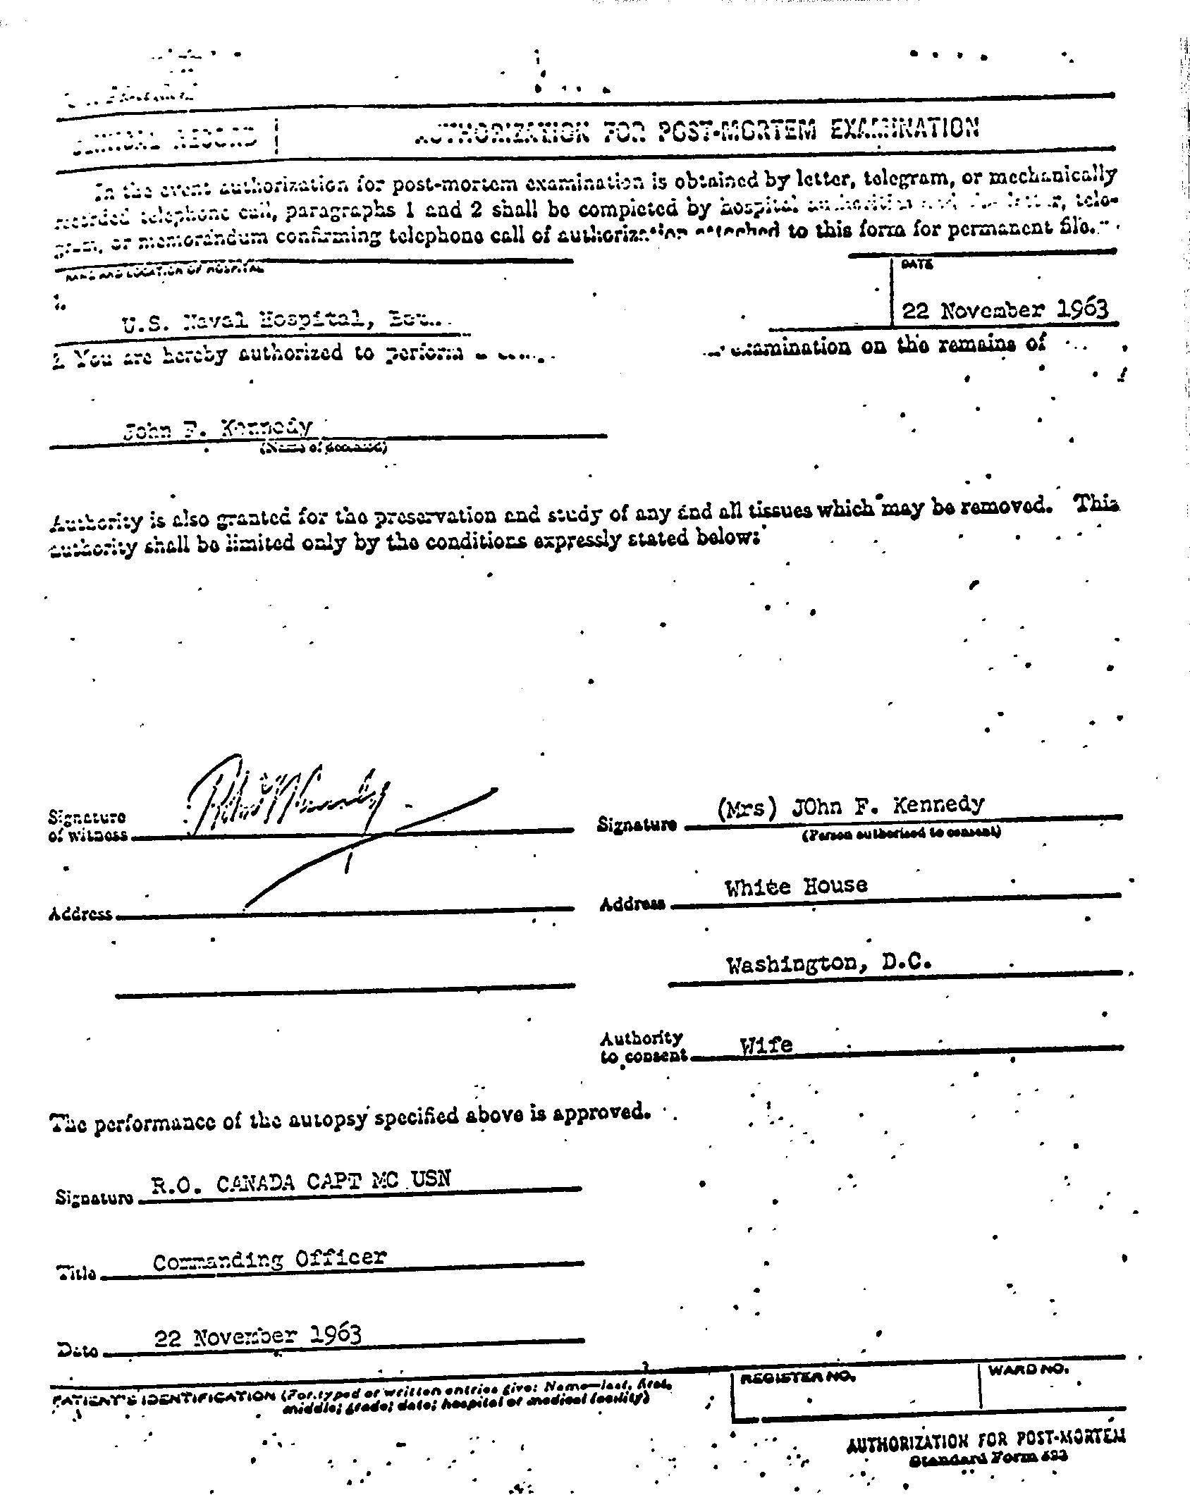
As we have seen, Specter boasted of being, the first to get out the truth about what Humes did to the autopsy report. Specter also claimed that there had been no changes in the original autopsy. He knew all he claimed was not true. He knew more than any other that all this was false and deliberately false to protect his many fabrications. Most of all his single-bullet fantasy and the government’s preconception that there had been no conspiracy, the basis of the Warren Report.
As we have seen, when Humes and Specter said that what Humes destroyed was his autopsy notes they both knew this was a very significant lie. We have seen the string of receipts I published in 1975. Those receipts cover all those who had those notes from the time Humes burned the original autopsy report in the fireplace in his rec room as soon as he knew Oswald was dead. It was well after the time of his burning that Humes turned his notes and his revised autopsy report in what Specter now says does not exist. We have seen a string of receipts, for what Specter now says never existed, as the they passed from hand to hand.
I held the original of this substituted autopsy report in my hand at the National Archives. I made a photocopy to preserve the little things, like the fact that Humes wrote it on a tablet that had thin blue lines that would not show on offset printing. The Xerox, what I reproduced in Post Mortem, is the Archives copy of the original for me.
This substitute autopsy protocol alone makes Specter a liar who lied to protect the actual assassins, to hide the fact that there had been a conspiracy to assassinate the President, to keep from the people the proven facts that prove the assassination was a coup d'etat, to change the leadership and the policy of the government.
One of Humes’ changes of the many of them in his substitute protocol after he burned the original one is on page 7 of his substitute.
In its original language in his substitute protocol, under (d), in Specter's location of the head wound, what he actually wrote ca n be read through his lining it through. What he wrote before he go back to the office of the admiral in charge is a puncture wound tangential to the surface of the scalp. But as he testified, and that testimony was as Specter was well aware was ordered, which Specter also knew, to make the many changes he made. Humes had a distinctive handwriting. In his distinctive hand he eliminated all quoted above and replaced those meaningful words with the single word that does not include any of those eliminated words that are meaningful. That one word is "lacerated."
The difference is enormous.
This and much more, very much more like it, are part of the proof of Specter's knowledge when he proclaimed that there were no changes in the original autopsy. Specter knew what he said was a lie and a very significant lie.
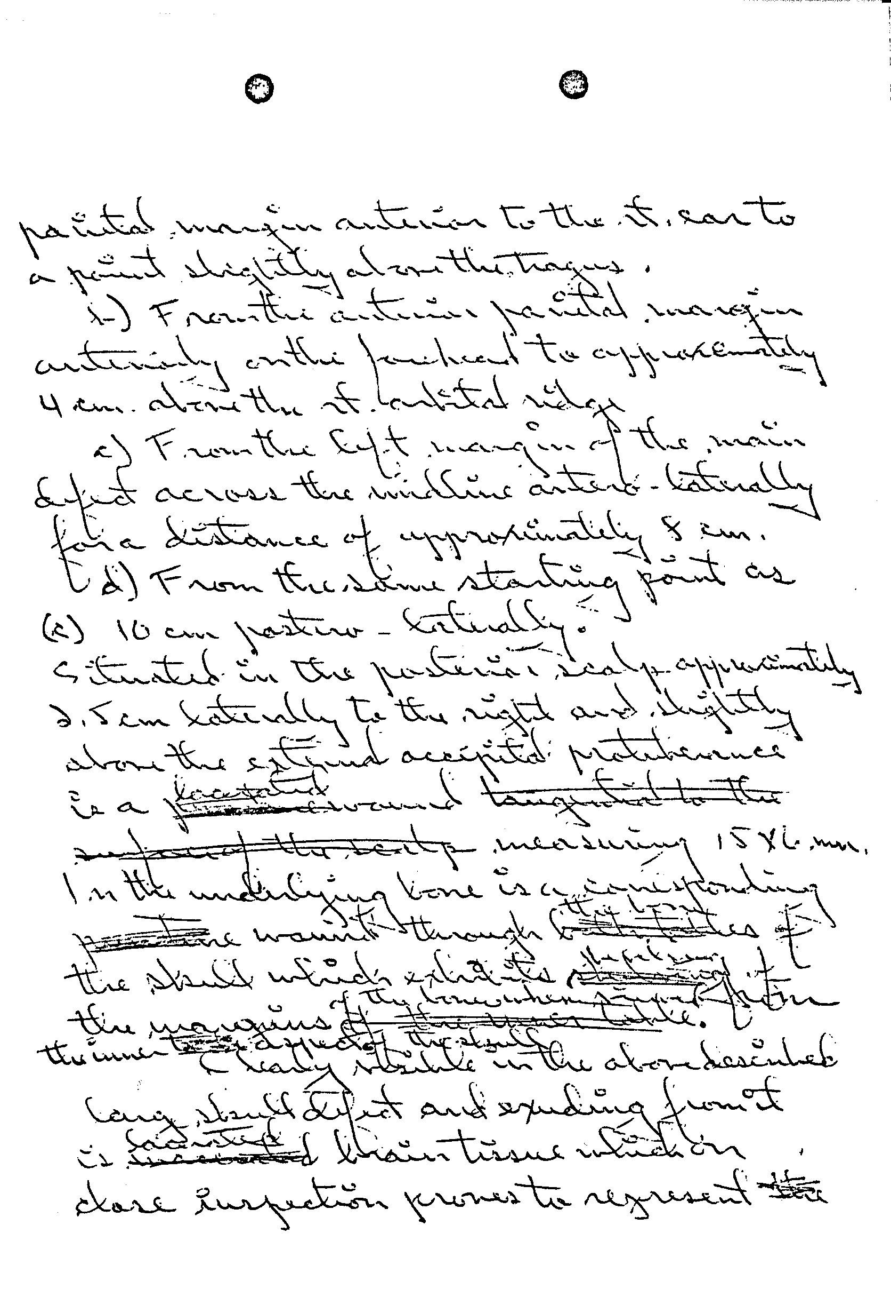

A year and a half later, what was called the Memorandum of Transfer from Admiral Burkley was delivered to Evelyn Lincoln. That was on April 26, 1965. Lincoln was then in the National Archives, of which she was not an employee. She was there in connection with the Kennedy Library, which, as all Presidential libraries are, is part of the National Archives. This list includes a number of items some of the critics on both sides say are missing or altered.
There is no proof that what is alleged to be missing is really missing. They are items the Kennedys wanted not to get out and be used in improper commercializations, as happened when copies of the autopsy photographs were stolen and sold to a supermarket tabloid.
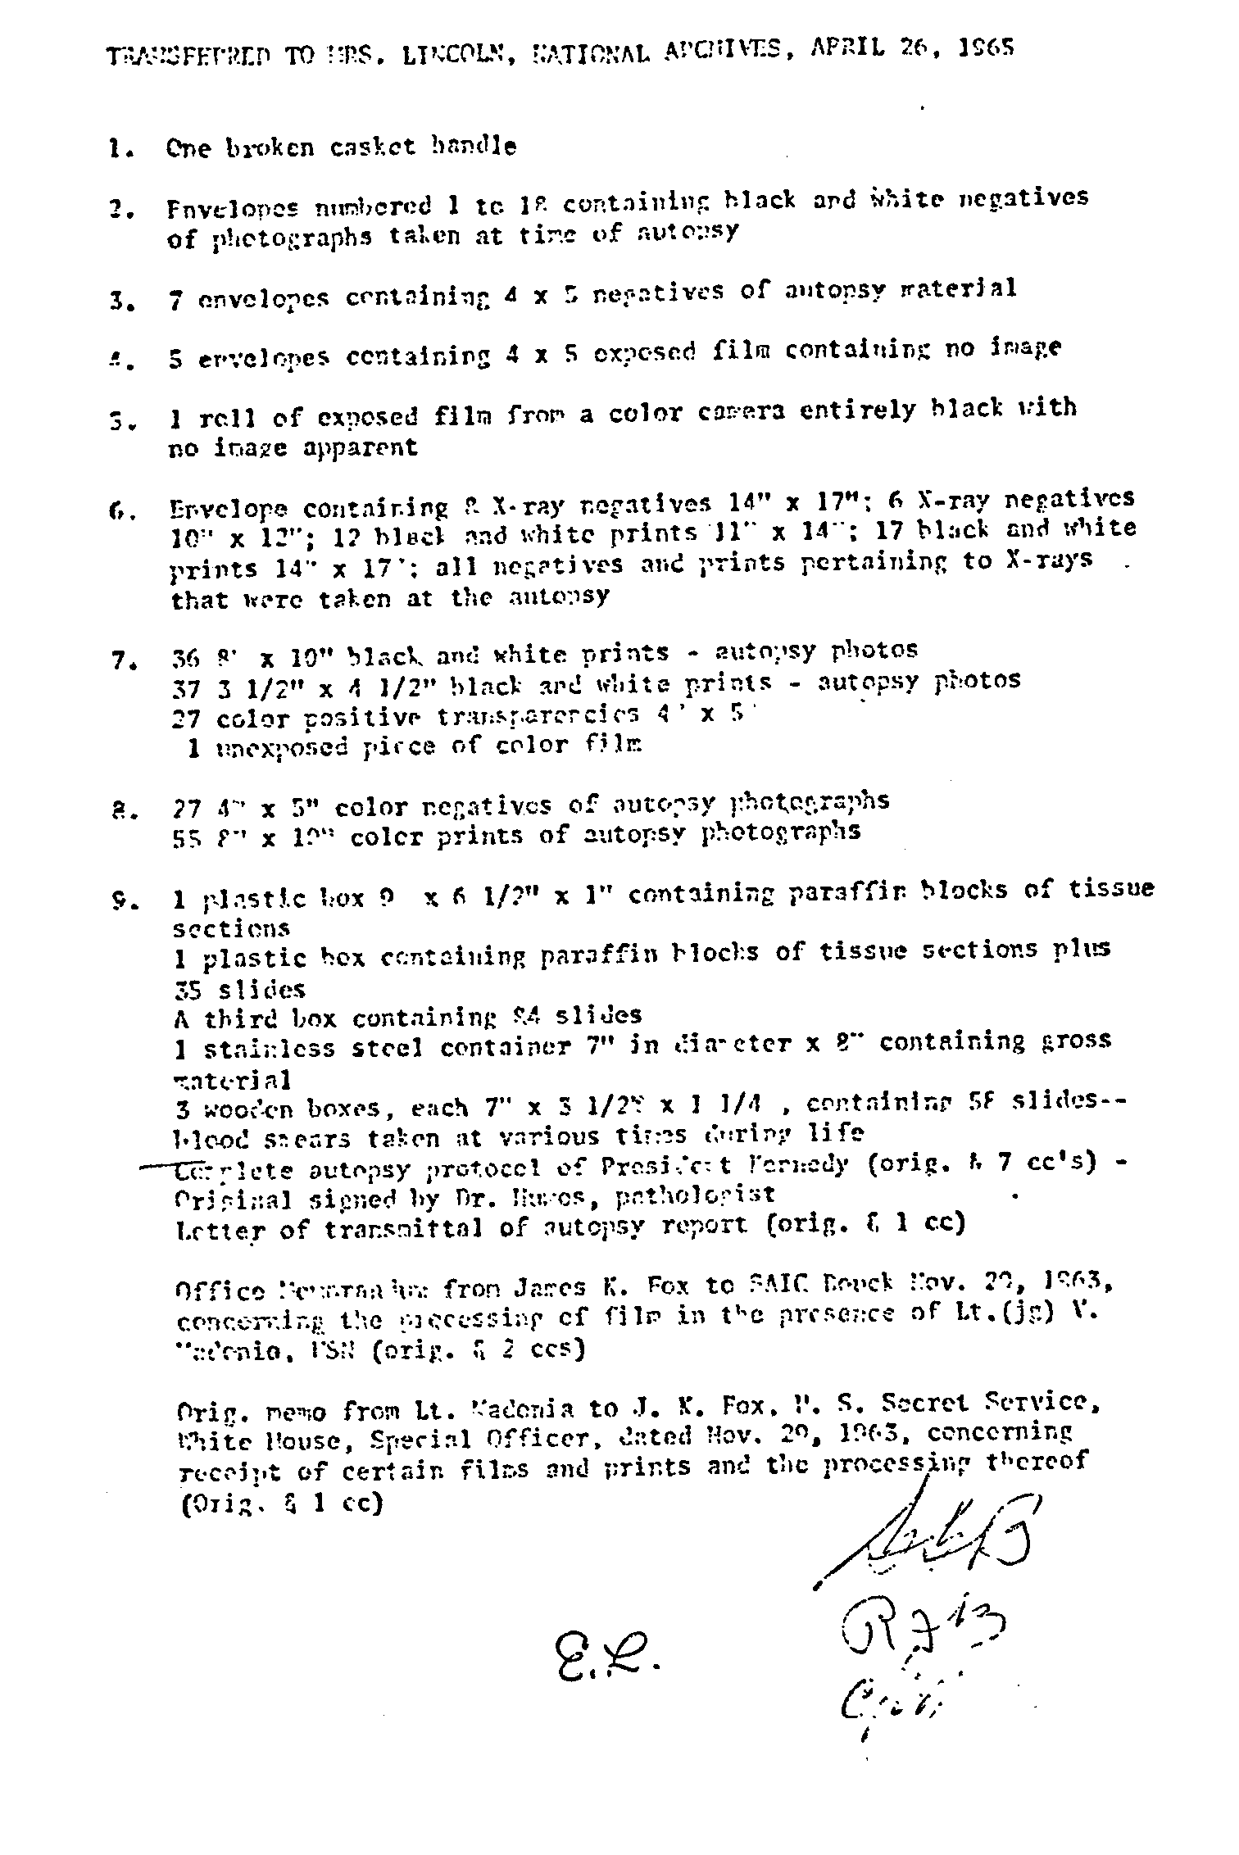

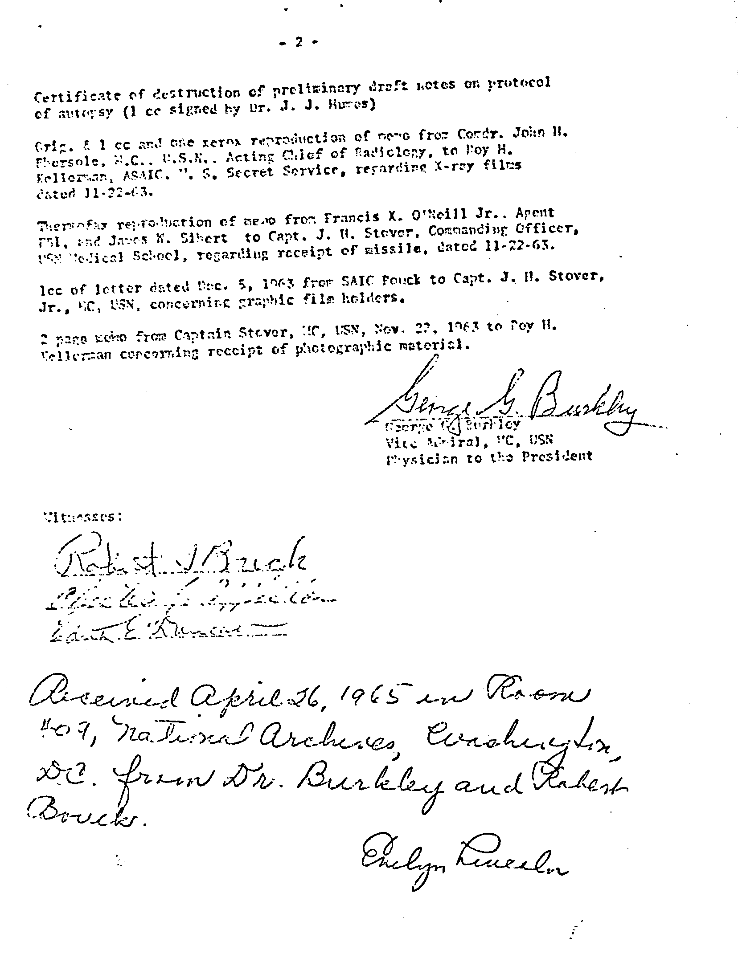
There are ninety-six more pages I had copied as I read Specter’s book but I believe they now are not necessary for a proper examination of the book that is, really, as we have seen in more than adequate detail, is very far from all that is official and available and that, from the officia1 records, is really Specter versus Specter.
As we also have seen, again very much less than is available, what we have seen of Specter’s passion, it is not -- it cannot possible have been as he claims in his book and on its cover, for truth.
It is not unreasonable to wonder if Specter gives a damn for what is true.
What is true about what the Warren Commission did and did not do and report to the nation about the assassination.
For what the people have been told, especially when Specter was the one doing the telling.
For suppressing why what was hidden and kept secret in what brags to be an open government in an open society.
For telling the people that Oswald was a lone assassin when all the actual official proof is that he was not an assassin and that the assassination was the end product of a conspiracy.
For not letting it be known that there was an official decision not to investigate the crime itself and to declare that Oswald did what he could not have done, from the actual official evidence.
And why Specter made up a phony and impossible frame-up of Oswald that was essential if its decision not to investigate the crime itself and to attribute it to Oswald alone if that hopefully unique horror in any free society was to succeed.
Why those who saw that Katzenbach memo did not tell anyone, especially the people of this country, that they had had a coup d'etat – really that they were protecting that coup d’etat, only they can say. None has. And several, here Specter, wrote books in which they could have been truthful.
If they cared more for the country and its system of self-government.
The case of Specter versus Specter, which, intendedly, this book is, is as ugly as anything in our history. Let us hope it is untrue.
In is an anti-American book because it defends – tries to hide – what was a coup d’etat and because they, in this book Specter, hide that fact from the people and never told them the truth about anything at all.
Unless it was the spelling of names.
If I, first an aging and then an old and partly handicapped man, could and did do what these excerpts of what I learned and then to the degree possible for me, took all I could of what I learned to the people, it is obvious that any member of the warren Commission staff could have done ever so much more with the knowledge from the inside that they alone had access.
Even becoming a publisher to do that when faced with a monolithic publisher boycott.
My what they could have done for the nation and for their own integrity – if the cared more for the country and less for what they would have suffered if they had been real rather than pretended patriots.
Keeping silent when it was time for all men who cared to speak out was anti-American.
But giving an entirely false account of it for his own and undeclared purposes, which is what Specter did, is much much worse.
What can his purpose have been when his book is enough to ruin him if opposed by anyone who can learn the truth, as can be done easily by a simple check of the available records.
So it does not seem to be a book written for his own political purposes.
A friend who discussed this with me believes what seems to be a reasonable explanation: Specter wrote this book in a campaign to be appointed to the Supreme Court.
Where he would be together with the entirely unsuited justice who owes that seat to Specter, Clarence Thomas.
Hardly the man to replace Thurgood Marshall.
Whatever may have been his purpose, the Specter who wrote this, one of the most deliberately dishonest of books, that he did this book disqualifies him from any office because any public office requires trust, dependability, and here Specter versus Specter leaves no question at all about it, Specter cannot be trusted at all. Unless you have a need to cover up a coup d’etat.

See p. 262.
See p. 525.
See p. 524.
See pp. 55ff.

