Chapter 7
What Was "Accepted and Approved" in Specter's Area

On his front cover, where Specter lists what he wants to be believed are his greatest accomplishments, first of three is his proudest boast of what he does not say is but in fact was his fact-less invention, his single bullet (still called) theory. This is also the second of the five, to him, proud accomplishments on his back cover. There his first is the first public disclosure of why JFK's autopsy surgeon burned his "notes." This fails to stack because it is not the first "public" version. Specter does not boast of his accomplishment when he avoids telling his reader that one of the two radically different "public disclosures" was the felony of perjury, Specter took that testimony from him without any effort to establish whether it was true of false. Specter was aware that Humes, after the version Specter claims now was the first but not indicating otherwise, gave that second version under oath.
Or, that second version of which Specter boasts was the felony of perjury or, if not, it established that the version Specter took under oath for the Warren Commission was perjury.
Of this he does not boast. Or even admit that it was something less than another of his great accomplishments.
There is more, much more that Specter was responsible for on the Warren Commission of which he had to know and is silent, finding it not worth bragging about. If not what he would rather have unknown, now that his career is that of a politician, and I do not use this as other than a respectable term because politicians are important in a society like ours and I've known some for whom I've had high regard, in both major parties.
There is a part of Specter's work on the Commission that was, I believe, the most important part, inquiry into the wounds, and death, what caused them and the autopsy report, also referred to as its protocol. Although not medical, his single bullet impossibility was more shooting than medical but it was his, not to the credit of those whose specialty was the shooting.
There is, in the lives of all of us, what on reflection we do not brag about. Specter is not only no exception, I can think of few who have in their careers, their lives, more that they would rather forget than what I know of Specter's career on the Warren Commission. What he now boasts about, at book length, what omits quite an abundant supply of these things and much that in reality was nothing like what he has in his book.
One of the more significant omissions from his Warren Commission career of which he is so proud is one of the five Parts of his book, with a few mentions on other pages.
Starkly put, the prosectors were ordered not to do a complete autopsy on the President!
What the record of the Warren Commission and of the FBI could not miss – and Specter asked not a single question about when that was his job - is that the autopsy was not complete.
There is no mention of this in Specter's book but he boasts on his cover of what is not true and he had to know was impossible. This misleads the reader and those who trust his book. It is his account of the autopsy. Specter kept this truth out of the official record when it was his job to make a full record.
As is indicated earlier, it is no longer possible for me to consult and draw upon the third of a million pages of government assassination records and most of my work on them because it had become physically impossible for me, at eighty-seven, because they were in our basement also because some had been stolen when my wife and I were in a nursing home. That was clearly by or for someone whose major interest was the JFK assassination. File drawers in my office that had been so overstuffed I could not get back in its file folders what I had taken from them suddenly had plenty of space. Some of those file drawers, when I was able to leave the nursing home, had as much as two inches of space. Several of the missing files I known were of great interest to David Lifton and at least two I know was stolen for him. They were "borrowed" from me by a Baltimore policeman, Richard Whetherby, who had earned my wife's confidence and mine. The main one was my comment and analysis of Lifton's most indecent and impossible of all fictions supposedly about the assassination. And it made him a rich man. Aside from what he made up that was disproved by records he had and not by that alone, that the President's body was kidnapped and altered, there is nothing really new and factual in his large book but be rewrote it, as he told me and others, at his agent's suggestion. In the revised version Lifton says that he invented the wheel and discovered sex.
So, there was much in my office, some in boxes that are no longer there. Boxes disappeared with their contents. There was in them what is new and is not duplicated in the main files that now are in Hood College where, after all the preliminary work on them has been done, they will be accessible.
Hood is a fine small college that is always up at the top in the annual U. S. News peer review of colleges and universities.
As indicated earlier, this comment on and analysis of Specter's book is just about limited to my earlier books all of which are based on the official evidence.
Because the disclosure that the most important of autopsies under our system was ordered not to be complete and isn't complete and because that was a military autopsy, I decided to draw on more of the vast amount of factual reporting on and about Specter rather than his fancies, which are his alone, anyway. This is far from all of this nature that is in the books I printed to all of which Specter had access and in most of which I was severely critical of him. It does not draw on what Specter did not have access to. This is only that which he certainly knew about, not the more than two dozen manuscripts that exist as a record for history, as well as this also will be.
Except possibly for illustrations I here do not draw much on the first of the Whitewash series, which dates to February, 1964, just a few months after the Commission's public disclosures. There also is much relating to Specter in the book that followed it, published December 2, 1966. Heaviest on the sources is my 1975 Post Mortem. It is in that book that we find that we find that one of the military autopsy pathologists made his involuntary disclosure of the military control -- over the autopsy of a president.
As I wrote in Post Mortem, at the very beginning of the chapter "13, The Sub-Ministers of Truth and Their Ministrations" (pp. 143ff.).

In my first book on this subject, but not for the last time by far, I raised the question of perjury and its subornation (WHITEWASH: 180), and with regard to the autopsy and the autopsy surgeons. I then sent a copy of the book with a letter of challenge to each of the autopsy doctors. Each was silent, then and since. It is not alone Boswell who said nothing. He is alone only in having uttered a childish complaint that reached me.
Thereafter, in my second book, Whitewash II: The FBI-Secret Service Cover-Up, where I devoted all of the second part to the autopsy and who and what relate to it. I called Arlen Specter, the Commission lawyer who handled this testimony and the pertinent exhibits, a liar. I embellished this to say he was a willful, deliberate liar. Then I noted that if this were false it was actionable and said I awaited word from the man then District Attorney of Philadelphia and aspiring to be its mayor.
Specter was less vocal than the doctors.
During his mayoralty campaign, I was invited to make a public speech in Philadelphia. Preparatory to it, I phoned the papers, told them what I had written and reported my intention of repeating it. I did, in public, and without the presence of any reporter from the major papers. Later, on the largest radio station in his city, I dwelt at some length on Specter's record. It was a four-hour broadcast that elicited no response from him.
In this speech during his campaign, I added chapter and verse to the challenge that he sue me for libel and dared him further by saying the only reason he could not and had not sued me was because he knew the truth and knew that I knew the truth and would not dare a judicial determination of the fact, even in the city in which he had the great legal muscle of being District Attorney (p. 143).

Some ridicule that was not particularly mild followed.
I also challenged the autopsy pathologist about whom I also intended severe criticism, to sue me if they disputed what I said. (None did.)
After criticizing the opening of the autopsy report:

In every respect other than time, this statement is in conflict with Humes' testimony (2H373). For example, his testimony on when he wrote the autopsy (and Boswell and Finck had no part of the writing):

Commander Humes. In the privacy of my own home, early in the morning of Sunday, November 24, I made a draft of the report which I later revised and of which represents the revision. That draft I personally burned in the firep1ace of my recreation room.

The Commission and all the government and press, then and since, have apparently seen nothing ghoulish, nothing at all wrong in the burning of a President's autopsy in a recreation room. Some ''recreation"! The difficulty here is determining whether Humes is a simple liar in his services for Clark or a perjurer in his Commission testimony. Perhaps, as one could be certain with an honest government and a dedicated judicial system, we will know. That, however, is not as important as the deliberate deception and this part of the rewriting of history and recasting of the assassination.
The difference in when Humes burned his evidence - and his observations in the draft of the autopsy he burned was evidence, for he was the chief expert witness - is material. It is highly significant. Note that he says the draft that he wrote November 24 - and he specifies it was a Sunday morning - is what he burned. There exists a draft that was the revision. It is this he held in his hand. It is part of the Commission's 371 file and of Exhibit 397.
So there can be no doubt of the materiality, I quote his answer to a question by Commissioner John J. McCloy on the next page.

I was working in an office, and someone had a television on and came in and told me that Mr. Oswald had been shot, and that was around noon on Sunday, November 24th.

The Commission that accepted this false statement is the one that accepted many others it also knew were false. It had to have been later than he said for Oswald was shot later. With Oswald dead, he knew there would be no cross-examination on the autopsy report. The changes he made are not editorial, not with "low" becoming "high," "left" changing to "right," "puncture" - meaning entrance - being eliminated, and many, many other such things. These changes might anywhere else be regarded as culpable, but with Arlen Specter, this Commission, this Attorney General and Department of Justice, when a President is murdered, they are normal, essential, natural as breathing. I emphasize he said he was still working on the autopsy after Oswald was shot, and after he knew it (pp. 144-145)

Specter's work.
Specter in charge.
What Specter refers to as "the" FBI report without further identification of it when there are millions of them is the first of the five volumes of the special report on the assassination Johnson ordered of the FBI the night of the assassination. It is the one supposedly on Oswald and the assassination than there are what the FBI regarded as exhibits. There was also a Ruby volume. We skip to that first volume to mention it that it disagreed with the preordained conclusion of the Commission in making no mention of that missed bullet. The Commission came to realize, thanks to Tom Dillard, as stated above, that it could not get away with not mentioning the missed bullet. But if it added to the FBI report, when the best shots in the country could not do what the Commission attributes to Oswald when they had only three shots to fail with, there was no possibility of their failing less with four shots, which the FBI "solution" would have required.
Specter knew the truth of what I published but he also knew that was not expected of the Commission:

There are three parts to this FBI report. The first deals with and is entitled "THE ASSASSINATION. Double-spaced and with generous margins, it consumes three and a half pages! Shocking as is this scant regard for such a shattering and traumatic event to which the most publicized police agency In the world devoted its not inconsiderable skills, talents and manpower, even more stunning is what it manages to both state and avoid stating in the mere 500 words of which it considers the assassination of an American President worthy.
The first two sentences of the second paragraph read:

"As the motorcade was travelling through downtown Dallas on Elm Street about fifty yards west of the intersection with Houston Street (Exhibit 1), three shots rang out. Two bullets struck President Kennedy, and one wounded Governor Connally."

There were but three shots fired, the FBI reports. Two of these struck the President and one, the Governor. It does not say that, of the three shots, one that struck the President also struck the governor, nor does it intend to. As we shall see, the FBI knew this was impossible. What, then, of the "missed" shot already painstakingly traced in the chapter, ''The Number of Shots"? How could the FBI dare say there were but three shots, two of which struck the President and one the governor, thus accounting for all three, when it knew, in the words of its Director, that the "missed'' shot could not be associated with any that hit the Presidential car or its occupants? It is only too obvious that there is here no acknowledgment of the missed shot, which means a minimum of a fourth and the total elimination of Oswald as a lone and unassisted assassin. ''The language is not subject to semantic evasion. There were only "three shots." Of these, "two bullets struck President Kennedy, and one wounded Governor Connally." And there is not even a mention of the wound in the front of the President's neck!
If any but the obvious explanation of these words and their scandalous meaning can be made, let the FBI now make it.
Any other explanation is severely inhibited - if not, in fact, totally eliminated - by the FBI's account of the President's non-fatal injury, which appears in the second part of its report, on page 18. Here, with equal and equally inexplicable brevity, the FBI demolishes its own report and that of the Commission that followed it:

''Immediately after President Kennedy and Governor Connally were admitted to Parkland Memorial Hospital, a bullet was found on one of the stretchers. Medical examination of the president's, body revealed that one of the bullets had entered just below his shoulder to the right of the spinal column at an angle of 45 to 60 degrees downward, that there was no point of exit, and that the bullet was not in the body."

What oddly imprecise language for an agency with the reputation of the FBI, yet how clear and unmistakable the meaning, and no matter how carefully phrased!
A bullet was found on one of the stretchers. The FBI will not say as the Commission did – falsely – that it was proved to have come from the governor's stretcher.
One of the two bullets the FBI says hit the President only "entered" his body. And not in his neck, as the Commission, despite its own indestructible evidence, had alleged, but below the shoulder and to the right of his spine, as we have already established must have been the case.
There was ''no point of exit'' and ''the bullet was not in the body".
And only a single bullet was found.
There is but a single possible meaning: This bullet hit the President and penetrated his body so slightly that it fell out and was found at the hospital (p. 193).

Specter's work.
This is from the first book, of 1965. But Specter did not have to have it spelled out for him. It was his work and he knew the facts, regardless of what he wrote. That was his responsibility.
Specter was skilled in misleading and that in his part of the investigation of what was a de facto coup d'etat, what should have had every patriot doing his very best to establish truth.
In his part of both the Report and the twenty-six volumes of the appendix there appears what is represented as the official "Autopsy Descriptive Sheet."
It is from an exhibit of Specter's that he used effectively in questioning Navy Doctor J. J. Humes. It is part of Exhibit 397 (Whitewash, p. 197).
Only that is not the official copy, not the one for the record that the Commission had and, as reported above, proceeded to hide in its files where nobody would think of looking for it, a file in which it could not belong, judging from what the Commission printed. It and more like it were actually in the massive file of what went to the Government Printing Office to be printed – which the official copy was not.
But it and more were not printed. The copy had been some of the malarkey to which Boswell resorted to try to hide what they were all party to.
Boswell was even quoted in the media as saying that if he had known that body chart was important he'd have been more careful and would not have made the mistakes he said he'd made, as in placing what he and the Commission referred to as the shot in the "neck."
But both versions of that body chart locate that wound in the back.
As did the also hidden death certificate by Admiral Burkley. It is published for the first time in Post Mortem, both sides in facsimile on facing pages 308-309. And it places that wound in the back at the level of the third thoracic vertebra.
A few more of those expressions of Specter's "passion" follow. All confirm the opposite of what Specter and the Commission says.
Exactly where the autopsy body chart locates it.
The difference between the two Navy body charts is on the official one, the one that was hidden. It bears the "verification" of Admiral Burkley. In the lower left-hand corner on the original he wrote, as he did on other records that were hidden until I was able to require the Archives to give them to me, "Verified GGBurkley," all run together like this:

Here we use two of Burkley's "verification" of two of the records Humes created the Sunday evening he handed his autopsy in.
One is Humes "C-E-R-T-I-F-I-C-A-T-I-O-N" of his burning of his autopsy report and that all else he "transmitted" as he says, "officially."
Specter asked no questions about this when he had Humes as a witness and under oath. More on this and at the very highly improper destruction of evidence in a murder case, which an assassination case is, appears in NEVER AGAIN! in the chapter "If It Isn't Written Down, It Wasn't Done" (pp. 133ff.).

The next of these autopsy records Burkley annotated: ''Accepted and approved" has Humes stating that among the records he turned in was his "autopsy notes." Specter is real proud of his accounting of those notes as burned:

There are a few more relevant records but here I want to record the fact that all of this, improper as it was, has not a word, particularly not a word of objection or of outrage or words of the law about destroying evidence from Specter. What applies to the autopsy of a Bowery bum as I mentioned earlier, ought apply to a murdered President.
It is Specter' proud boast that it was he who brought to light Humes' explanation of why he allegedly destroyed those autopsy notes, because they had the President's blood on them and he did not want that commercialized.
But with those pages part of the government record, there is no chance of their being commercialized. Besides, he did not destroy the bloody body chart.
In addition, that official body chart, which I held in my hands, is loaded with the President's blood and other body fluids.
That is Humes' most recent story and it has no credibility at all, as we have seen.
Specter's area.
The truth is recorded officially and I have enough of those records, in facsimile, in Post Mortem.
Two more official receipts for those notes dated three and four days after Specter and Humes say he burned them are the covering letter for them and other records by Admiral C. B. Galloway, to Admiral Burkley at the White House and the letter with which the Treasury Department. Meaning in this case its Secret Service component at the White House. Listed in that memo of transfer by Secret Service agent Robert Bouck is one item with a line drawn in its left margin. That line was on that record when I obtained it. It marks what is specific in the list, that one copy of the autopsy report the Navy had and got rid of and ''notes of the examining doctor.'' Those are the same notes that Specter is so exalted in being the first to get attention for Humes' story that the great danger of people commercializing the President's blood left him to destroy those existing notes, which Humes said had the President's blood on them.
Then there is the official copy of the receipt by the Archives to the Secret Service. It includes those notes that Humes and Specter glorify in their accounts of Humes' destruction of them.
There were electrostatic copiers then and the government, including the Archives, used them heavily. But for the assassination of this President, barely legible carbon copies were regarded as good enough. Not only on this Archives receipt to the Secret Service. I made many complaints to the Archivist and those under him, asking that they obtain the clearer copies that existed. But in not a single instance did he or they do that.
Because Specter and Humes glorified in their stating and insisting that no changes were made in the Humes autopsy report – none at any time, when in fact he wrote an entirely new and different protocol as soon as he knew that Oswald was dead, I include only one page of the original of Humes' replacement handwritten draft. The copy of that replacement protocol Humes wrote on a white tablet that had pale blue lines but the Xeroxing did not retain them. There are quite a few changes on this original, of the replacement protocol. I held in my hands. It is this "original" which the Archives copied for me. (This also had been hidden and I rescued it from where nobody would have thought of looking for it.)
Obviously, there are many, many changes on it. Humes testified that these changes were dictated to him in Admiral Galloway's office Sunday evening, November 24, the day Oswald was killed and the day before the President was buried. A significant change on this page is in item (c). Where Humes had written of the head wound of alleged entry that it ''is a puncture wound tangential to the surface of the scalp..." which is fairly specific on several facts important in any investigation, what emerged after the changes ordered in that leaves it no more than that it "is a lacerated wound." In addition, as the admiral had done on all records the word "puncture," which means entry, was eliminated. Two times on this page, page 7 of Humes' holograph, reproduced in facsimile in Post Mortem, on page 515.
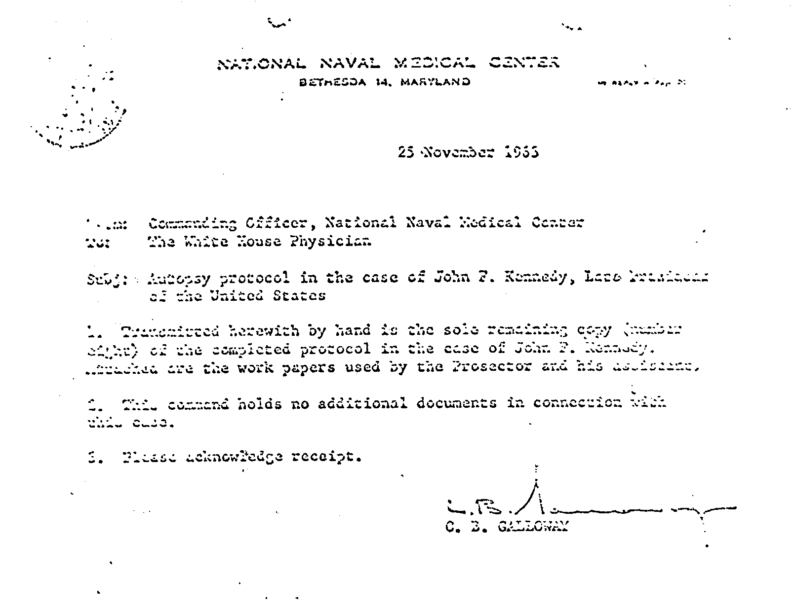

Humes had the location of this wound sketched for the Commission because, somehow, he knew they'd not have a picture or X-ray of it for him in his testimony. He gave a verbal description to a Navy medical artist. I reproduced two of those sketches in the first book, of 1965, on page 196. As is quite
visible, Humes located this head wound four inches below where the later Department of Justice panel of

experts located it. That is the wound of the radical change in what Humes had written is reported above.
All of this and ever so much more like it are what Specter says is his ''Passion for Truth" and what he believed held better omit from it.
This is enough, I believe, to leave it without question that the truth of Specter's alleged quest is in what the government could not abide, that what Humes destroyed was the first holograph of his autopsy report.
Humes also has two different locations for his little fire, the recreation room of his house and a place not mentioned in the Navy hospital.
The obvious reason for destroying it had nothing to do with blood on that body chart. It was destroyed because it held what was not supportive of the official pre-determination that Oswald was the lone assassin.
With that not the official position, the official pre-determination of the assassination well before anything like a real investigation was possible and, equally obvious, destroying what could support the official position that there was no conspiracy.
But the evidence in this and my other books, the official evidence, with no conjectures and no "theories," are that without any question possible, there was a conspiracy.
Two, really.
Why the government made that up – and we do come to the official records of it – can only be conjectured and more than one conjecture is not unreasonable.
Here we have still another account of Specter's boast of his "reputation for integrity."

