Geometry Concepts

1.0 Definitions

(a) Plane geometry is a systematic investigation of plane geometric elements and their relationships by geometric constructions and/or numerical methods.

(b) Plane geometric elements are: points, lines, angles, and segments.

(c) Geometric figure is a collection of one or several geometric elements devised from the axioms of geometry and algebra by means of geometric constructions.

(d) Axiom (postulate) is a statement (conclusion) based on experience or observation admitted to be true without proof.

(e) Proof is course of logical reasoning by which the truth or falsity of a statement is established.

2.0 Points, Lines, and Segments

Definitions

(a) Point has no dimension and denotes position only.
(b) Straight line is the shortest distance between two points.
(c) Ray is a straight line of which one end is in the infinity.
(d) Segment is the portion of the straight line between two points.
(e) Parallel lines (parallels) do not intersect no matter how far extended (Fig. On left).
(f) Concurrent lines meet (intersect) in a point called concurrence (Fig. On right).
(g) Transversal is a line intersecting one or several other lines.
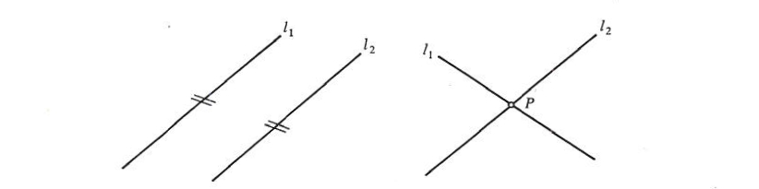

Proportions

- Two Parallels cut off proportional segments on any two transversals

a:b = c:d
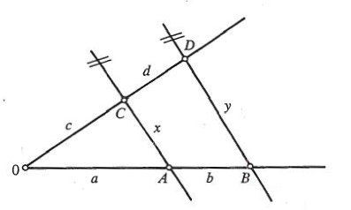

- Angles

Definitions

- Two rays (arms) proceeding from one point (Fig. below) divide the plane into two parts called the internal angle a and the external angle a'.

(b) Sense. The angle is positive if measured in the counterclockwise direction and is negative if measured in the clockwise direction.

(c) Complete revolution of a line is a rotation through an angle called the perigon.

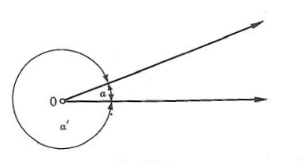

Angular Measures

Angles are measured in degrees, minutes, and seconds or in radians.

Classification of Angles

Two Angles

(a) Complementary angles. Two angles (α and β) are complementary (Fig. Below-Left) when their sum is equal to the right angle. α + β = 90˚

(b) Supplementary angles. Two angles (α and β) are supplementary (Fig. Below-Middle) when their sum is equal to the straight angle. α + β = 180˚

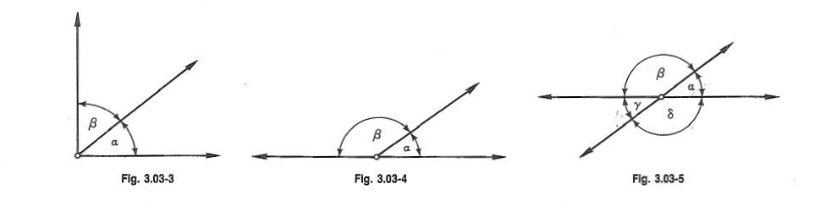
(c) Vertically opposite angles. Two angles which have a common vertex and whose arms are two straight lines (Fig. Above-Right) are said to be vertically opposite to one another.

α = γ β = δ α + β = 180° α + δ = 180° α + γ + β + δ = 360°

(e) Angles formed by a transversal to a set of parallels (Fig. below) are called:

Step Angles: α₁ = β₁ α₂ = β₂

α₃ = β₃ α₄ = β₄

Alternate Angles: α₁ = β₃ α₂ = β₄

α₃ = β₁ α₄ = β₂

Opposite Angles: α₁ = β₄ = 180° α₂ = β₃ = 180°

α ₃ = β₂ = 180° α₄ = β₁ = 180°

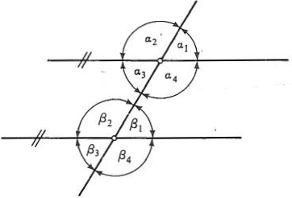

4.0 Triangles

Definitions

(a) Triangle is a portion of a plane bounded by three segments called sides. The sum of sides is the perimeter p.

p = a+b+c

(b) Sum of interior angles of a triangle is 180°, and the sum of exterior angles is 360° (Fig. below) α + β + γ = 180° α' + β' + γ' = 360°

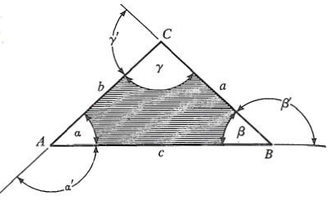

- Special cases. A triangle with three unequal sides is called a scalene triangle (Fig. Below-Right). A triangle with two equal sides is called an isosceles triangle (Fig. Below-Middle). A triangle is called an equilateral triangle when its three sides are equal (Fig. Below-Right).

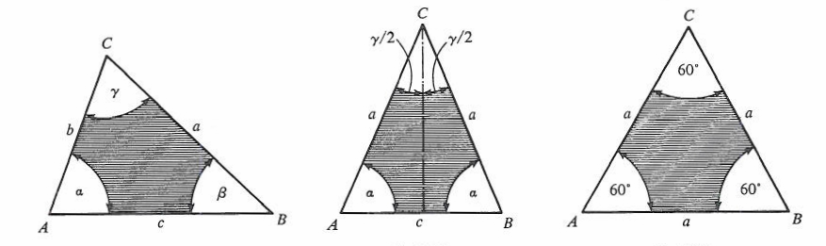

Right Triangle

(a) Right triangle has one right angle. The side opposite to it is the hypotenuse and the other two sides are legs (Fig. Below).
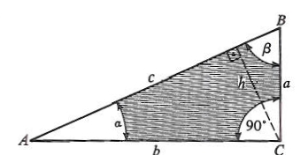

γ = 90° α + β = 90°
(b) Relationships between the sides of the right triangle are defined by the Pythagorean theorem. a² + b² = c²

Isosceles Triangle

(a) Isosceles triangle has two equal sides and two equal angles (Fig. Below)

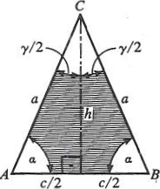

a = b α = β α + γ /2 = 90°

(b) Relationships between sides of the isosceles triangle and its altitude are defined by the Pythagorean theorem.

a² – (c/2)² h²

(c) Equilateral Triangle

An equilateral triangle has three sides and three equal angles (Fig. Below).

a = b = c α = β = γ = 60°
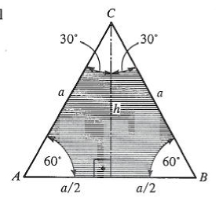

- Quadrilaterals

A. Definitions

(a) Quadrilateral is a portion of a plane bounded by four segments. The sum of interior angles of a convex quadrilateral is 360°.

(b) Quadrilaterals are classified as: square (Fig. A), rectangle (Fig. B), rhombus (Fig. C), rhomboid (Fig. D), trapezoid (Fig. E), and trapezium (Fig. F).
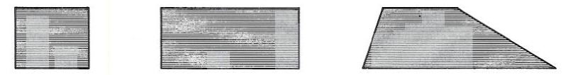
A B C

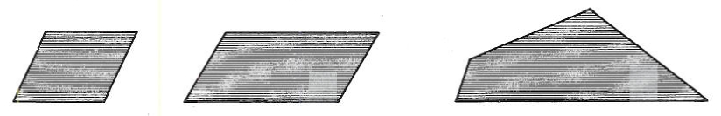
D E F

- Polygons

- General polygon with n sides (Fig. below) has the sum of interior angles equal to (n - 2)180°, and the sum of exterior angles equal to 360°.

- Area is found by decomposition into triangles

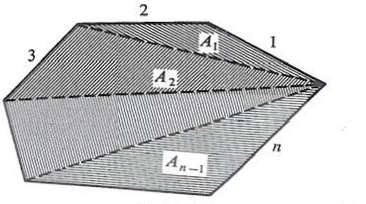

6.0 Circles

(a) Definitions

- A circle is the part of a plane bounded by a curved line, all points of which have equal distance from a point within called the center.
- Length of the bounding line is called the circumference C, and the equal distance is called the radius R.
- Diameter of the circle D is the length of a chord through the center, D = 2R.

- Circle (Fig. Below).

C = 2rR = rD = circumference

A = πR² = πD²/4 = CR/2

7.0 Congruence, Similarity, and Equality

(A) Congruence Theorems

1. Triangle. Two triangles are congruent if they have identical:

  - Two sides and the included angle [SAS]
  - Two angles and the included side [ASA]
  - Two sides and the angle opposite to the larger side [SSA]
  - Three sides [SSS]

- Polygon. Two polygons are congruent if their corresponding sides and angles are identical.

- Circle. Two circles are congruent if their radii are equal.

(B) Similarity Theorems

1. Triangle. Two triangles are similar if they are equal in:

- Three angles
- 2. Ratio of three sides
- Ratio of two sides and the included angle
- Ratio of two sides and the angle opposite to the larger side

- Polygon. Two polygons are similar if their corresponding angles are equal and their corresponding sides are proportional.

- Circle. All circles are similar.

(C) Equality Theorems

1. Triangle. Two triangles are equivalent if their areas are equal (Fig. below) (a, h congruent).

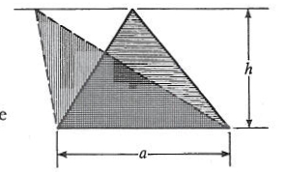

2. Parallelogram. Two parallelograms are equivalent if their areas are equal (Fig. A Below) (a, h congruent).

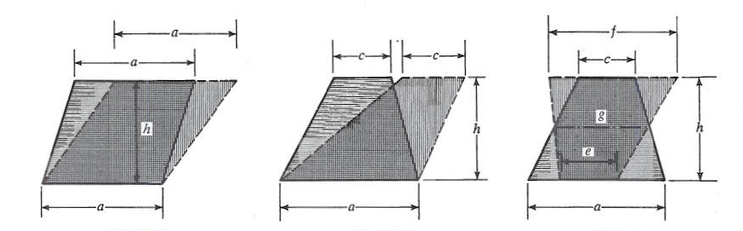
A B C

3. Trapezoids. Two trapezoids are equivalent if their areas are equal (Figs. B & C Above) [a, c, h or g, it congruent, where g = (a + c)/2 = (e +f)/2].

8.0 Cartesian Coordinates

(A) Notations A point P is given by two mutually perpendicular distances x, y (coordinates) measured from two mutually perpendicular axes X, Y (coordinate axes), which intersect at the origin 0 (Fig. Below) and define the coordinate plane.

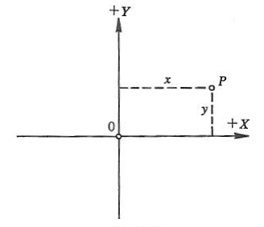

(B) Quadrants The coordinate axes divide the coordinate plane into four quadrants (I, II, III, IV) and assign directions to all coordinates (Fig. Below).

(C) Sign of x The coordinate x (called abscissa) measured along the X axis is positive to the right and negative to the left of the Y axis.

(D) Sign of y. The coordinate y (called ordinate) measured along the Y axis is positive above and negative below the X axis.

9.0 Points

(A) Cartesian coordinates (Fig. Below). The distance of two points P₁,(x₁, y₁,), P₂(x₂,y₂) is
________________
d = P₁, P₂ = √(x₂ ₋ x₁)² + (y₂ - y₁)²

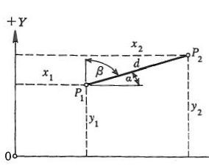

(B) System of Points

(1) Area of a triangle given by vertices P₁ (x₁, y ₁), P₂ (x₂, y ₂), P₃ (x₃, y₃) is

A = ½ [x₁₍y₂ ₋ y₃) + x₂(y₃ – y₁₎ + x₃(y₁ ₋ y₂)]

where A is positive if the vertices are numbered counterclockwise and negative if numbered in the opposite direction.

10.0 Straight Line

(A) Equations of Straight Line

(1) Every linear equation in x and y represents a straight line.

(2) The intercept form (Fig. Below) is

x/a + y/b = 1

where a, b are the intercepts on the X and Y axis respectively and tan Φ = - b /a.

(3) The general form (Fig. Above) is

Ax+By+C = 0

where A = b, B = a, C = -ab, and tan = -A/B.

(B) Special Cases of Ax + By + C = 0

(1) If A = 0, then By + C 0 defines a line parallel to the X axis at d = - C/B (Fig. A).

(2) If B = 0, then Ax + C = 0 defines a line parallel to the Y axis at d = -C/A (Fig. B).

(3) If C - 0, then Ax + By = 0 defines a line passing through the origin 0 in a direction k = -A /B (Fig. C).

(4) If A = 0, B = 1, C = 0, then y = 0 defines the X axis.

(5) If A = 1, B - 0, C = 0, then x = 0 defines the Y axis.

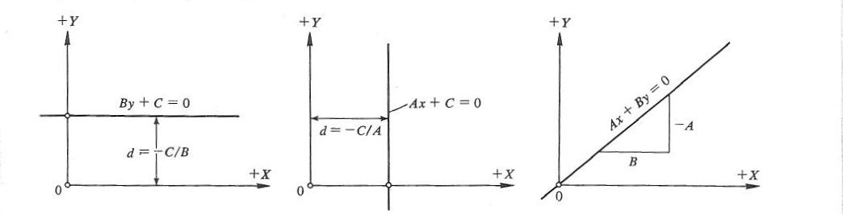
A B C

(C) Points and Straight Lines

(1) Straight line passing through a point P, in a given direction k (Fig. Below) is defined by y-y_{i} = k(x-x_{i}) where x,, y, are the coordinates of P, and k = tan Φ.

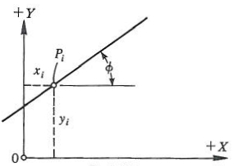

(2) Straight line passing through two points (Fig. Below) is defined by

y-y_{i} = y_{j}-y_{i}
x - x_{i} x_{i} - x,

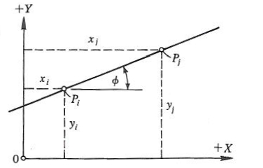

where (x_{i},y_{i},), (x_{j},y_{j}) are the coordinates of P_{i}, P_{i} respectively and its direction is

k = tan Φ = y_{j}-y_{i}
x_{i} - x,

(3) Distance from a point P, (x_{i}y_{i},) to the line Ax + By + C = 0 (Fig. Below) is
_______
d_{i} = Ax_{i}+By_{i}+C / ± √A²+B²

where the sign of the denominator is opposite to the sign of C.

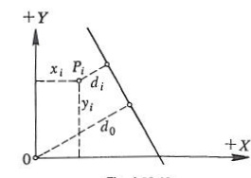

(4) Distance from the origin 0 to the line Ax + By + C = 0 (Fig. Above) is

D_{o = ____}C___
±√A²+B²

which is a special case of (c).

11.0 Two Straight Lines

(A) Relationships-Direction Forms

Two lines defined by y = k₁x + l₁ and y = k₂x + l₂ are:

(1) Concurrent, if k₁ ≠ k₂

(2) Parallel, if k₁ = k_{2,} l₁ ≠ l₂

(3) Collinear, if k₁ = k_{2,} l₁ = l₂

(4) Normal, if k₁ = -1/ k₂

(B) Relationships-General Forms

Two lines defined by A₁x + B₁y + C₁ = 0 and A₂x + B₂y + C₂ = 0 are:

(1) Concurrent, if A₁/B₁ ≠ A₂/B₂

(2) Parallel, if A₁/B₁ = A₂/B_{2,} C_{1 ≠} C₂

(3) Collinear, if A₁/B₁ = A₂/B_{2,} C₁ ₌ C₂

- Normal, if A₁/B₁ = -B₂/A₂

12.0 Circle

(A) Basic Equations

(1) Center at 0 (Fig. below). Equation of a circle of radius R with center at the origin 0 is x² + y² = R²

