Chapter 21
Conclusions: Trashing The Unscholarly Trash

As we have seen, it is virtually impossible to make any honest, factual comment on the Twyman and Fetzer books that is not an adverse comment. When my friend Hal Verb, of San Francisco had a few words to say that were less than complimentary about the Twyman atrocity, he was viciously attacked by Twyman's side-kicks. From the sublimity of their subject-matter ignorance, of which they remained oblivious, they did not have to make strenuous effort to establish the most of basic of truths, they were indeed subject-matter ignoramuses. As Fetzer was not content to do for himself alone in a criticism of Verb in the monthly newsletter, The Fourth Decade. Fetzer had to highlight the subject-matter ignorance of Mantik, too. These ego-dominated fools with advanced degrees are so impressed by the entirely irrelevant knowledge they have from their education and experience they think it makes them an authority an all else.
Verb responded to Fetzer's criticism in that same newsletter for July 1998. Here is a short but illuminating excerpt from it:

At one point in his argument about film alteration, there appears this comment by Mantik: ". . . the FBI made extensive efforts to capture all possibly relevant photographic evidence." . . . it is to laugh. . . . just read Harold Weisberg's excellent study of the film evidence in his Photographic Whitewash and it will amply demonstrate how "extensive" the FBI's efforts were. The exact opposite of Mantik's claim is the reality. . . .

Verb believed that Mantik's incredible display of ignorance of the actualities, of the grim reality that no real investigation of the assassination was intended or made, his ignorance of the nature of the investigation, which exudes from all the many, many thousands of officially published and officially disclose pages, is laughable and as he regarded it, it is that. But because the true nature of the non-investigation of the crime -- as I brought to light in NEVER AGAIN! -- there was an official decision on the highest level not to really investigate the crime. As soon as Oswald was dead, it was decided to blame him for it. That man, regardless of all the learned degrees he has earned, can write about a crime as serious as an assassination while being so dismally, abysmally ignorant of the established fact can also be considered to be an outrage because of the nature of the crime and because he, inevitably, deceives and misleads the people about it, and that has the effect of exculpating all that those who did wrong, on any level and in any degree.
It underscores the meaninglessness of all the boasting of their degrees when they write about the assassination. They are learned and they should know that they are not learned about assassinations in general or about this one in particular. For all their education they remain subject-matter ignoramuses. It is like a nuclear scientist taking the position that because he is a nuclear scientist he is also informed about heart surgery.
It means that whether or not they are conscious of it, these and others like them are engaged in a double rip-off, of the mind along with the pocket, and with that doing the dirty work for errant government..
That Mantik's ignorance is laughable, as it is with his boastings and those of his associates, does not eliminate the fact that it subverts the working of the democratic system, which requires that the people be informed, and it obscures the truth about what is, as always, a de facto coup d'etat.
It is not a game for would-be Perry Masons.
The FBI had but one interest in assassination pictures: that they show Oswald with a smoking gun. All others they shunned to the degree possible. I got startling illustrations of this in CA 78-0322, my FOIA lawsuit for the assassination records of the Dallas office. Those records establish the fact that the Dallas FBI office did avoid getting pictures it knew about and could have gotten and it even declined free copies of photographs of the most valuable evidence. When some of my Dallas friends sought to locate those who are stated in the FBI records to have had relevant pictures they could no longer be located at the address the FBI had. In one case, and it is enough to be illustrative of this incredible reality, that the Dallas FBI not only refused free copies of assassination photographs -- it went even farther, it did not trouble headquarters with knowledge of the existence of these photographs, still and motion.
The FBI also knew that a group of amateur photographers had taken 8mm. movies of the motorcade, including in Dealey Plaza. They had formed an association they called The Dallas Cinema Associates. They chose Mrs. Irving (Anita) Gewirtz to head them and Ruby Brenk to edit their film. They also sold the rights to David Wolper, so the FBI could and did not keep the existence of The Dallas Cinema Associates secret.

Not when Hollywood had it, not with the attention Hollywood can get.
The Dallas FBI sent reports to headquarters and headquarters sent copies to the Commission. It was with the Commission's copies that I brought the existence of The Dallas Cinema Associates to light in Photographic Whitewash. But in not a single instance did the FBI get a copy of any of this film, for its own records. Wolper gave a print of what he used to the Archives, where I viewed it. It was largely schmaltz. However, when my friend Dick Sprague looked those people up he got prints of their unedited film and there are sections of the of it that can be said to be of evidentiary value.
One of those films shows Billy Lovelady in the TSBD entrance shortly after the shooting and the shirt in which he is, which I first described on page 294 of Photographic Whitewash seems not to be the shirt on the man, said officially to have been Lovelady. It has those large black and red checks Mrs. Lovelady described to me as the shirt that day when she tried to sell it to me for five thousand dollars.
However, the shirt on the man in the doorway in the widely-publicized picture taken by the Associated Press photographer, Ike Altgens, the man in the doorway officially said to have been Lovelady is wearing what seems in that picture to be a grass-weave kind of shirt. That is precisely the kind of shirt Oswald wore. I examined it in the Archives. On the actual shirt the imperfections visible in it are in that Altgens picture and are quite visible in it. So, whether or not it is beyond question, the unique imperfections do seem to be a positive identification of that shirt. The black-and-red checks in the DCA film that was by John Martin, who overexposed it, seem to be a negative identification – not Oswald.
I published the official pictures of Oswald in the shirt in which he was arrested in Dallas and enlargements of that part of the Altgens picture on the page before the inside back cover of Whitewash II. and on that inside cover. Here is a Xerox of that frame of the Martin film. Mantik has Whitewash II but does not mention this.

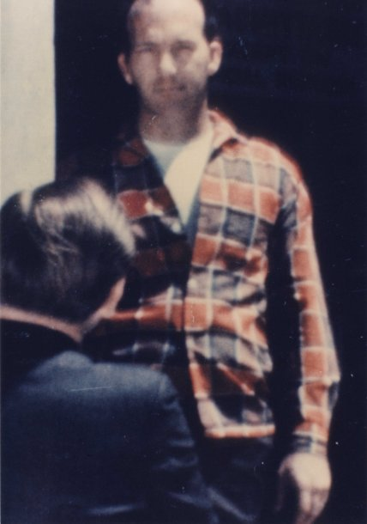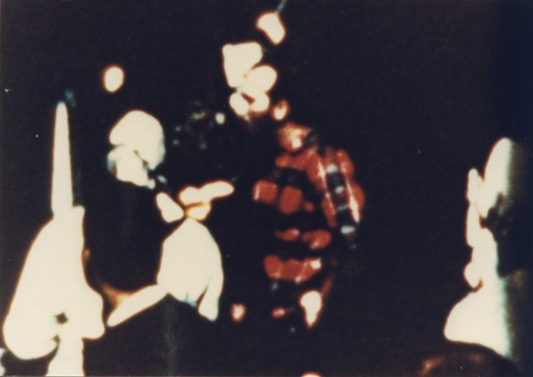
Oswald obviously could not have been the sixth floor assassin while standing and watching that assassination from the doorway. The man was then said, officially, to have been Lovelady. Quite relevant film was offered to the Dallas FBI free and the FBI declined clear pictures that show the actual assassination, in the FBI's own words, and diligent investigators that Mantik says the FBI was, The Dallas FBI did not even tell headquarters about any of this!
Two records relating to this, entirely unknown at the time, were disclosed to me in CA 78-0322, for the assassination records of the Dallas office. In the Dallas files they are 89-43-493 and 518. The first reports a call from Eastman Kodak informing the FBI that an engineer named Charles Bronson had taken both 8mm. movies and 35mm. still pictures in Dealey Plaza and that the FBI was welcome to copies. Bronson had told Eastman that he believed some of "the film had been taken at the instant President Kennedy was assassinated."
SA Milton L. Newsom took SA Emory L. Horton with him to see these films. Here is the second paragraph of Newsom's report, which was to his special agent in charge and did not leave Dallas until it was forwarded for me – fifteen years later:

Films taken by Mr. BRONSON at the time of the President's assassination including 35mm. color slides which were taken with a Leica Camera, and 8 mm. Kodachrome film were reviewed. These films failed to show the building from which the shots were fired. Film did depict the President's car at the precise time shots were fired; however., the pictures were not sufficiently clear for identification purposes.

In Newsom's own words Bronson's films were "taken" at "the precise time shots were fired," and his clear still pictures were taken with a Leica, one of the very best cameras available.
One criticism of these films by Newsom represents the preconception of the investigation. One of the reasons he declined free copies he says is that "they failed to show the building from which the shots were fired." That preconception was never proven to be true, that all the shots came from that building, but the first working day after the assassination that was the FBI's fixed conclusion, well before anything that could be referred to as a real investigation was possible.
And, although the films "did depict the President's car at the precise time the shots were fired," Newsom declined those free prints on the spurious ground that allegedly "the pictures were not sufficiently clear for identification purposes."
Both of his conclusions are false. The motion picture film has almost a hundred frames of not only that building but of the very window from which the FBI says all the shots were fired. That was very shortly before the shooting and there is nobody in it.
Those Leica pictures were, as could be expected, sharp and clear and, aside from the fact that Oswald is not in them, -- the one "identification" interest the FBI had, they are excellently suited for "identification purposes" -- if there had been a real investigation because of the large number of witnesses who are quite clear in them and for other essential investigative uses.
After Dallas disclosed these records to me my friends Earl Golz, then an investigative reporter for the Dallas Morning News and Gary Mack, who then did radio and TV in nearby Fort Worth, looked Bronson up. He showed them those pictures. They promised to protect his interest and Bronson allowed the paper to use the films. Golz and Mack saw to it that Bronson's rights were protected. They copyrighted his films for him. The paper devoted almost the entire front page of the Sunday, November 26, 1978 issue to the story. One of the 8mm. frames that in the original film is only a tiny fraction more than a quarter of an inch wide is enlarged to where it is eight and a half inches wide. And it is clear after newspaper reproduction of it. Clear enough to be on the front page.
Inside there is a still picture of the President being assassinated that the FBI turned down. It is cropped with part eliminated, but the rest, which was greatly enlarged is still very clear at a width of six and a half inches.
One of the two inside pages devoted to this sensational story consists entirely of nine frames of the 8 mm. movies. They are enlarged so that these frames, which are greatly reduced in width, allows all nine enlargements to fit on a full standard-sized newspaper page. This is enormous enlargement from eight millimeters.
These are only two of the many illustrations of what Mantik refers to as "The FBI made extensive efforts to capture [sic] all possible relevant photographic evidence." It is, as Verb wrote, the exact opposite of the established fact.
The Mantik who had my Photographic Whitewash, as we saw above and from it knew of the pictures of the Dallas Cinema Associates and the FBI's lack of interest in them and of its not getting them when it could have had them free, to.
The FBI's demonstrated concept of what it meant by "capturing" what Mantik describes as "all possible relevant photographic evidence" while refusing the Bronson film even when, in its own words they showed "the President's car at the precise time the shots were fired" merely because they did not show Oswald with a smoking gun!
Newsom knew the FBI's party line on pictures. Before then it had been demonstrated by his boss, Special Agent in Charge Gordon Shanklin. According to a De Loach to Mohr memo for Hoover on the day after the assassination, even though the FBI knew that Time-Life had bought the Zapruder film and of other major media interest in it the FBI thought it was valueless and even though the FBI then had the copy the Secret Service gave it, neither of the men at the very top in Washington nor their agent in charge in Dallas knew it from the first three paragraphs of that memo, the record copy of which is Serial 453 in the headquarters main JFK assassination file. The FBI knew so little about this it could not even spell Zapruder's name right and it had his dress manufacturing operation as "a women's wear shop":

We have received inquiries from "Time" magazine, "Telenews," The New York Times" and a number of other communications outlets relative to several minutes of 8 millimeter color film which was reportedly taken at the scene of the assassination by one Abraham Zapruber. Zapruber is the owner of a women's wear shop called "Jennifer Juniors" in Dallas. "Time and Life" magazine have allegedly promised Zapruber the sum of $40, 000 if he will turn the film over to them. Zapruber has been quoted as stating "The FBI has this film and will not give it back to me."

Ed Guthman and Jack Rosenthal of the Department have received similar requests from the same news outlets. I called SAC Shanklin at Dallas to ask him if we had this film. After checking, Shanklin called me back and stated that the Secret Service had first obtained this film from Zapruber. Shanklin stated he believed that Zapruber had later offered a copy of the film to us. He stated he would have to check further regarding the matter; however, he knew that he had this film and was having it processed at the present time at a commercial shop in Dallas. Shanklin stated he did not believe the film would be of any evidentiary value; however, he first had to take a look at the film to determine this factor.
This is how the FBI "captured" the Zapruder film, by having no interest in at it all and by not asking him for it or even to let the FBI see it.
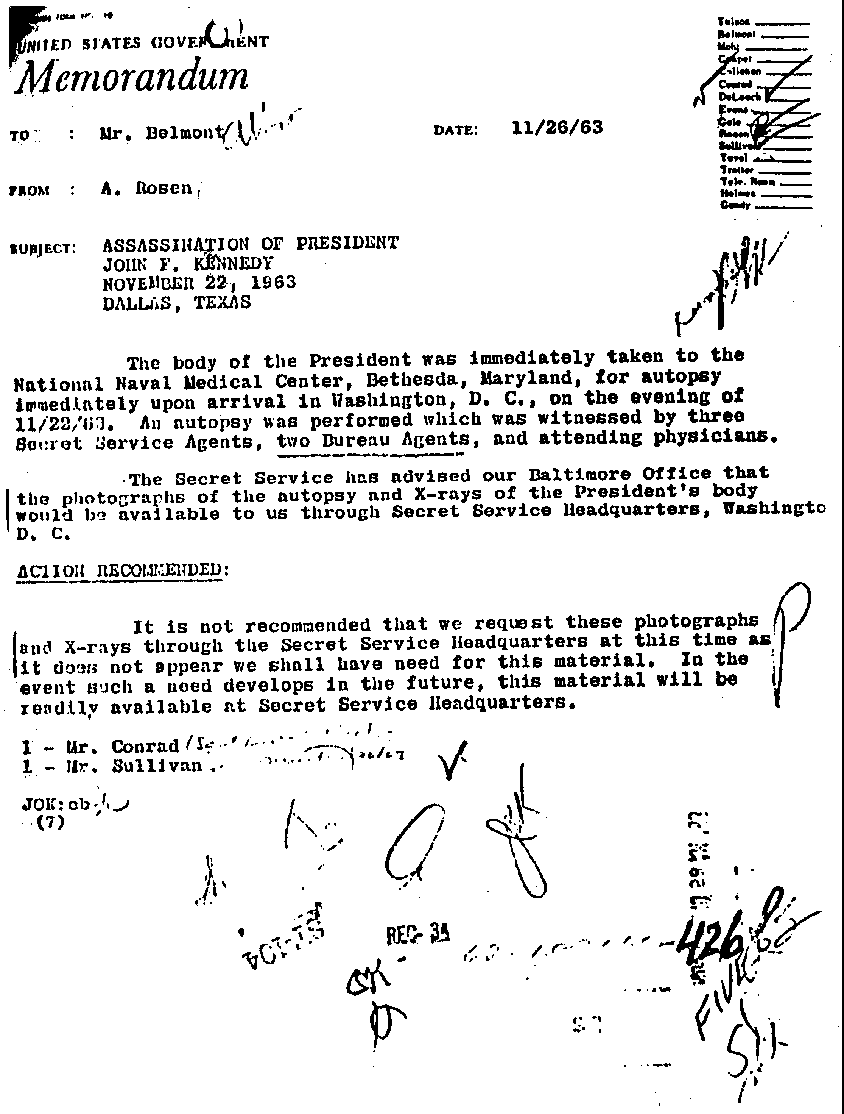There is another similar reflection of the exceptional diligence of FBI headquarters, in Mantik's words, its "extensive efforts to capture all possible photographic evidence." In the FBI's official opinion, the FBI at the very top and all around Hoover, they did not even want to the autopsy film when it was offered them. In a memo dated November 26, 1963, the then head of what was then known as the FBI's "General Investigative Division," Alex Rosen, wrote Hoover through the man under Hoover, Alan Belmont, that they do not want this film. While in the Xeroxing some the of the initials with which the top echelon marked this, Hoover's "OK-H" is clear"
The FBI, then in charge of the investigation before the Commission was created, had no interest in the most essential of photographic evidence, that of the autopsy.
How much more diligent could the FBI have been in those non-existing extensive efforts "capture" all the relevant photographic evidence?
And how much more persuasive could Mantik have been in his determination to establish himself as an authentic subject-matter ignoramus?
These people, the Twymans, the Fetzers, the Mantiks and others like them, are overwhelmed by their sense of their importance and omniscience and, obviously, as we have seen, by their incredible egos. They believe, and with some the belief is genuine, that because they have had the benefit of better than average education they know all there is to know about everything, including what they write about that they have not even taken the time to learn the basic established fact about.
They get these far-out ideas and, overwhelmed by their belief of how smart they are, in their concept of their brilliance, fact is irrelevant to them. To them fact is what they think based on what they do not know.
They know all there is to know about what they know so very little – or nothing at all about – and about which they are so very wrong when they write about what they know nothing about or do not understand.
The Mantik example above, of the FBI's determination "to capture all relevant photographic evidence," is but one example of many like it.
Mantik has a documented book devoted entirely to the official efforts to suppress the existing film, to the degree possible, and he still writes with such determined ignorance about it, describing this resolute official FBI determination to avoid all possible photographs as "extensive efforts to capture all" of them.
Mantik was in touch with me and I knew a little about what he was writing and saying. I tried to caution him, as I did some of those associated with him, not to be irresponsible. They had to be within the meaning of the official evidence, the validity of which had been established. Mantik then lost all interest in corresponding with me and that kept me from wasting that much more time in trying to keep these determined subject-matter ignoramuses from making bigger fools of themselves and from deceiving and misleading the people even more than those of their view and the government and those who support the official assassination mythology had already confused them.
They know how long it took to become a qualified engineer, a medical doctor, a radiologist and to teach philosophy (which does not mean to be philosophical) but they cannot conceive that to become expert in any other field, a great amount of work is also required.
Aside from its very large Report the Commission published its twenty-six large volumes of testimony and appendicies of an estimated ten million words -- of which all of them are largely ignorant. Then there was the initial Archive deposit of the Commission's records, which took up two hundred cubic feet, a vast amount of paper that soon began being considerably enlarged.
I do not know how many pages of records the FBI alone among agencies has been forced to disclose but I know that two decades before this writing I had compelled it in lawsuits to disclose to me – which means made public – about a third of a million pages of them.
This is most of the basic, official information that since has been added to enormously -- but with not much of the additions basic assassination information – by the Assassination Records Review Board (AARB). It has stated that before its life ended it had made public more than four million additional pages of agency records.
A vast percentage of both the Commission's and the FBI's disclosed records are not really assassination records. Both went off into irrational digressions and both were heavy with conjectures, fabrications and irrelevant rumors. The presence of all this unedited paper made even the very first searches hard to keep on the real subject, the facts about the assassination. When there were these fantastically large additions to it, being able to decide what records to look at of all those millions could not easily be made on an informed, rational basis.
(Among the AARB's earlier bragged about accomplishments are forcing the FBI to disclose the names of two of its informants that could endanger their lives if they were still alive. One was a woman in Dallas who had no direct or indirect connection with anyone connected with the crime and who herself was not and another was the informant who reported to the FBI what Communist Party leaders believed about the crime. This chitchat is not in any rational sense assassination information and the massive accumulation of it will, in the long run, deny access to the actual assassination information when over the years people try to decide which of those five million or so pages of records they want to go over. The added bulk defeats access to a large degree. And all of this is based on the unproven assumption that Oswald was the assassin, with no real search ever, by any agency, for any other assassin or assassins.)
The more assassination trash like Twyman's and Fetzer's appears and gets attention, the more hopelessly confused the people are as by this monumental accumulation of trash. The people are mislead and deceived by it. The more those who support the official mythology are supported, the result is, if any still live, the more the actual assassins are protected. If they no longer live, then the more the corrupted, dishonest history of the assassination that, like all presidential assassinations in this country are, was a de facto coup d'etat is perpetrated.
The more ancillary attention these books, that are really worse than trash, receive, the more it confuses, misleads and deceives even more people than the book's readers. One example of this is a Internet-circulated review of the Fetzer by one of the largest distributors of books Amazon.com. But before reading the excerpts that follow it should be understood that book sellers, wholesale or retail, all sell books, and at least in theory they need not have knowledge of the content of any that they sell. Who prepared this "review" is not indicated on the Internet web-site entry mailed me anonymously. It is dated August 25, 1998. That printout also states that the book was published in October, 1997, a rather long delay for the usual review.
It begins by referring, in bold-faced type, to the trash we have been examining as "Objective and Scientific Studies of the Death of JFK":
ASSASSINATION SCIENCE provides a collection of studies by physicians, scientists, and other serious students that is intended to place the investigation of the death of JFK on an objective and scientific foundation. The contributors are among the best qualified individuals to ever examine the medical and the photographic evidence of this case, including a world authority on the human brain who is also an expert on wound ballistics, a physician with a Ph.D. in physics who is also board certified in radiation oncology, a philosopher who is an expert on critical thinking and also a former Marine Corps officer, a physician who attended both the dying President and Lee Harvey Oswald at Parkland Hospital, a leading expert on the photographic evidence who served as a special advisor to the House Select Committee on Assassinations (HSCA), and other highly qualified students of the assassination of JFK.

Except that some of those referred to did have the experiences and education indicated, none with any relevance in investigating an assassination or in writing about it, not a word of this glowing tribute to a monumental trash-heap, as we have seen in much less detail than is possible. While some of those hailed as specialists are specialists, they are not qualified, not one of them, to be regarded as "The best qualified individuals" to write about the assassination. Almost all are subject-matter in ignoramuses, as we have seen in disgusting detail.
What is really appalling after this sample of it that we have seen, a small sample because more is not necessary or worth the time, is praising Fetzer as "a philosopher who is an expert in critical thinking." We have just seen what it means for Mantik's knowledge of the assassination about which he theorizes from the depths of his ignorance to extol him as "a physician with a Ph.D. in physics who is also board certified in radiation oncology," which has no relevance in any legitimate assassination investigation. Finck was "an expert on wound ballistics" but he was not what we need, an experienced expert in the forensic sciences. That Dr. Charles Crenshaw tended one of the injections into the President's legs does not qualify him as any kind of expert on the assassination. His able lawyer Brad Kizzia, is expert on the limited facts he needed to be well-informed about, to the limited degree required to represent Crenshaw in his lawsuit against JAMA, but that is far, very far, from all the established assassination facts. Kizzia does not address more than the limited area of his involvement. That "leading expert on the photographic evidence" is Robert Groden. In his two books he is a wholesale plagiarist who altered some of the pictures he used, and he has without getting permission to, used some of them. He was sued and reportedly lost the case based on his unauthorized uses. He is a man who remains ignorant of the basic facts after having worked for the HSCA. His books are so bad on fact that that I took the time for a book-length examination of them. Them manuscript is titled "Picturing Corruption of the JFK Assassination." That is what he did. He can't even steal straight.
The person who wrote this review, not named, is ignorant of the subject matter, high on conspiracy theorizing and possessed of little if any critical capabilities.
The second paragraph sounds as though Fetzer himself wrote it.

ASSASSINATION SCIENCE is distinctive among works on the assassination of President Kennedy for several reasons. First, it is the only collaborative study that brings together the original work of physicians, scientists, and other serious students; there are ELEVEN contributors rather than only one. thus, readers have the benefit of exposure to the research efforts of multiple investigators who set forth their findings in clear and accessible language. Second , it includes the most important studies of the medical evidence since the publication of David Lifton's BEST EVIDENCE in 1980 and the most important studies of the Zapruder film ever presented. These results completely undermine previous investigations of the death of JFK, including especially the official government inquiries of the Warren Commission and of the HSCA.

It is distinctive but not as the reviewer says it is distinctive.
Aside from the irrelevance with which this paragraph begins, those extolled in it without basis and what it says of their end-product, as we have also seen, is just plain false. The ignorance and prejudice of the author of the review is clear when he refers to the crazy, the absolutely impossible fairy tale Lifton commercialized into a fortune as "the most important of studies" for its era. It is a clever rip-off, a very dishonest blend of rehash and fiction. And, as we have seen, the Fetzer junk heap does not "undermine previous investigations of the death of JFK." Except to the ignorant. What Fetzer put together is not an investigation of that assassination and that junk does not "undermine" the few serious private critical investigations of long before the assassination bug bit him. They were and are outside Fetzer's interest or knowledge.
The next paragraph, most of which is worthless and for which we take no time, begins with the reviewer's proof of personal ignorance of the field, especially of what was published. It is self-certification as an ignorant liar:

"Third, it provides the only comprehensive and detailed critique and response to a series of articles published in the JOURNAL OF THE AMERICAN MEDICAL ASSOCIATION (JAMA) in 1992-93)."

That series of three articles was published in 1992. There were immediate "responses" from physicians, quite a few of them, so on that basis alone Fetzer's collection was not "first" or only.
They are not by any means "comprehensive" and they are not nearly as detailed as they could have been if those who wrote them had real subject-matter knowledge. Instead, as we have seen, many are authentic subject-matter ignoramuses. And on that "only" and "comprehensive" demonstration of ignorance, when my NEVER AGAIN! (Carroll & Graf) was published in 1995 it was of five hundred and fifty-five pages. That is considerably more than this Fetzer collection so much of which is by those incredibly ignorant of the assassination. Collectively, they are, not up to the one "critique" that is in NEVER AGAIN! and aside from Kizzia, to whom I gave a copy of the manuscript for his use in his lawsuit, not one has and reflects knowledge of its existence.
So, far from being the only one or the first of the "critiques" of that JAMA series, it is neither "comprehensive" nor as "detailed" by far, where it is factually correct and based on the official assassination evidence.
Next the reviewer states that this Fetzer collection, mostly by Fetzer himself and text mostly by the expert who praised the FBI for its diligence in seeking out all the pictures it avoided, dedicated itself to ignoring, "reports and explains the most important findings in the history of the assassination." A peculiar way to refer to theories, conjectures and proven falsities that, had they all been legitimate, would not have addressed most of the official claims in the assassination.
Every conjecture is referred to as a "discovery," when not one is that. These "discoveries" are largely fictional, like the "discovery" that as "an absolute minimum of six shots were fired." It credits as a major "discovery" the proven falsehood and old-hat claim that the Zapruder film was altered and it does the same with the X-rays – also not at all new. The last of this childish and ignorant listing is the most ridiculous and is another authentic establishing of the reviewer's ignorance: "the discovery that the Warren Commission inquiry was a political charade featuring a phony bullet a phony limo -- phony wounds."
This "discovery" about the Commission was in all of the first books about it thirty or more years ago, beginning with mine of 1965, Whitewash. There was no "phony" limo and the wounds were very real, not "phony." This addition to the corps of ignoramuses in and involved with the Fetzer trash is, like most of them, ignorant of what was published. It justifies pretending those do not exist to attribute another "discovery" to what discovered nothing about the assassination at all. Those were not "phony" wounds." They were, as this ignoramus should know, misrepresented officially. But they were very real, very fatal.
After this baseless and ignorant puffery, which is like the supermarket tabloids are to journalism, there is what is titled, "Praise for Assassination Science." It is by Kerry Walters, described as "Distinguished professor, Gettysburg College." In what field he is distinguished is not said but aside from the omnipresent field in which there is such intense competition, the field of assassination ignorance, another possibility is of imagination. Walters' interest in the assassination is reflected by the fact that with a third of a million, once withheld official, pages in my archive and available to all who have the interest, and with Walters only an hour or less away, he has never come to take a look at a single page of them:

"Assassination Science is a watershed. Past and future assassination studies will have to read through the painstaking logical lens with which it scrutinizes the murder of John Kennedy. The contributors collectively offer an exhaustively documented and tightly reasoned argument bound to give the most loyal defender of the Warren Commissioners or Gerald Posner pause for thought. There is no sentimentalism or sensationalism here, even though the web of bureaucratic roadblocks and deceit encountered by Fetzer in his investigations would make for an exciting thriller. Instead, the cool clinical breeze of rigorous thinking blows throughout."

As Hal Verb said of Mantik's demonstration of his subject-matter ignorance, it is to laugh "that this "distinguished professor" distinguishes himself as a fool for writing about and offering opinions about what he knows nothing at all about. As still again we see.
With what precedes this stupidity quoted above, no added comment is necessary. But I also do note that if Walters' field is history or political science, he has not sent one of' his students to Hood College, which is also only about any hour away, to research the files of the late Sylvia Meagher, author of the eloquent Accessories After the Fact (Bobbs, Merrill), one of the earliest books on the Kennedy assassination. Or of Ray Marcus, who made the first definitive study of the assassination bullet. Both are deposited at Hood College.
It is pathetic that those who are undoubtedly authentic scholars in other areas so debase themselves and scholarship.
Lifton is next and with what he thinks of himself his praises of Fetzer are modest and hark back to his own work. He singles out, with the trickiest and most evasive Liftonian language, what the Fetzer book, says about the Zapruder film, that fiction being among Lifton's earliest inventions to draw attention to himself. But the best he can say for what is in the book is that readers "are in for a surprise." He also limits that to "the shooting."
Professor Peter Dale Scott, who is conspicuous for the errors in his writing supposedly about the assassination, and his criticisms, says the book supplies important scientific assessments of the medical evidence . . . I was particularly gripped by compelling new arguments that the Zapruder film had been altered . . ." We have seen above more than enough of what so "gripped" Scott. That this was a physically impossibility did not "grip" him.
Publishers Weekly, most influential publication in selling books to the booksellers, with no indication of the knowledge or lack of it by it reviewer, says "The accumulation of carefully researched data will impress those with an open mind.
And therein lies the evil of all this assassination trash.
In less uninformed language what Publisher's Weekly is really saying, without intending to, is that the ignorance, the trash, the self-seeking lies and the prideful but baseless boastings substituted for fact but referred to as fact will influence the reader. The uninformed reader will be led to believe what is not true by this uninformed puffery that is not a legitimate review and to ignore what is true, which is not in any event readily available from most bookstores.
Not attributed on the fourth of five pages is this tribute to the Fetzer trash heap: "Completely lacking in wild speculation" and it "sticks to the hard facts."
If that did not come from the unabashed Fetzer himself it came from the tooth fairy, as the preceding text reflects.
It is, as we have seen, the exact opposite of the truth.
Misleading the people on any important subject is its own subversion in a democratic society. It is this sense, Fetzer's and Twyman's quest for personal attention and their use of "scholars" to deceive the people, in their self-promotion, are a kind of subversion of the democratic system. Our system depends on an informed electorate letting its wishes be known. When what society really wants, and polls from the first have, increasingly, reflected this, is truthful information, information it can believe. Palming off conjectures, fabrications, impossibilities, and untenable theories as fact about the assassination, which is a de facto coup d'etat, does subvert the system. It protects the coup conspirators and encourages coups in the future.
As professional scholars these men who are experts in other fields, had to have learned in their formal education what real scholarship is.
And what it is not.
It is not substituting conjecture for fact and passing it off as fact.
It is not writing from the most profound ignorance of any matter, least of all an the assassination of a President.
It is not pretending that ignorance is knowledge and is a proper basis for writing.
Save for Lifton, who misused it for his own selfish ends, not one of these people is an authentic assassination expert or scholar.
Not one has done the great amount of work necessary to get to the beginning of a full understanding of what happened when the President was assassinated.
All of these intellectual, lunkheads depend on the most undependable of the literature and sources supposedly on the assassination and not one of them makes any real use of what is dependable that has been published.
Ph.D. and medical doctor Mantik, who had Photographic Whitewash the one book devoted to exposing the FBI's diligent avoidance of all possible assassination photographs, praised for its "intensive efforts to capture" all of them. This is not to single Mantik out for ridicule. It is to use a simple, a very comprehensible illustration that credentials in other fields are not credentials for writing about the assassination and to illustrate what is inevitable when ego or other motives drive scholars to pretend to scholarship in a field in which they are not scholars, not Sherlock Holmeses but are Pink Panthers, junior grade. And apprentices at that!
This also illustrates the essentiality of having a good knowledge of the officially established fact because without it any writing in the field can not be responsible. As we have seen less fully than is possible.
It illustrates, too, that what one ordinarily would feel safe in presuming is never safe in this controversial subject. Especially not when one side has a visible motive for arguing a point of view rather than presenting solid evidence that cannot be questioned.
Ordinarily it would be safe to assume what Mantik assumed, blissfully unaware of the reality as he was.
What he did typifies this Twymanesque and Fetznerian substitution for real scholarship, as with sufficient samples of specifies we have seen. Not by any means all of them but certainly more than enough of them.
There is also an absence of the real questioning by scholars seeking truth rather than espousing conjectures or trying to present themselves as the returned Sherlock Holmes. None sought any other possible explanation for the theory he came up with or in Mantik's case, any other possible explanation of his observation.
None seems to have consulted a scholar who held different views or a subject-matter expert who might.
The obvious explanation of this is that they want no explanation other than their own; want no refutation of their conjectures. That means they want the personal attention they have sought and that getting this personal attention means more to them than making the usual scholarly effort to learn the truth, to subject belief to a real and an impartial examination.
There is a problems they all face: if they got an opinion that disagrees with theirs or a recommendation that they do what they have not done to preserve their integrity and they immediately assume that the one who gives this normal, every-day caution is an enemy out to sabotage their, to them at least, great accomplishment.
None wants any devil's advocate to go over what he has made up.
None wants to risk having it demolished.
In 1965 and 1966 disproof of the "solution" to the assassination that is in the Zapruder film was published. We have seen some of this earlier. In more than thirty years there has been no refutation of it. No complaint from those who perpetrated it and who knew full well what they were doing when they did it. These proofs relate to the fatal wound in the head and the unmagic of the "magic" ballet. The official story was refuted in the first book on the Commission and its Report by the Zapruder film. Then the would be Perry Masons like Lifton saw the opportunity for money and personal attention from convoluted conjectures about it that were equated with fact.
Nobody, not one of these commercializers and exploiters – and even if they are in other areas, authentic scholars -- in this area they are exploiters and commercializers. Ask why in the world would anyone run the great risks involved in altering that film with the intent of changing it to have it support the official explanation only to evolve what utterly destroyed that official "solution."
And all the conjectures and baseless "theories" present as fact obscure this.
It makes no sense at all.
It makes no sense at all.
As for this alleged faking of the Zapruder film, it is also restricted the official solution to the very limited time for one man to have gotten those three shots off, an absolute impossibility. For those "scholars" who do not have or did not use the Commission's twenty-six volumes and its Report, that the best shots in the country, under vastly improved conditions, could not duplicate the shooting attributed to the duffer Oswald, was reported from its official source in 1965, in Whitewash (page 26). And in greater detail in 1995, in NEVER AGAIN! (pages 301-305), all from and cited from the official evidence in those twenty-six Report appendices.
This impossibility was official knowledge , in the official evidence. Who can believe that officialdom would alter the Zapruder film and, after alteration of it, have it prove that the shooting, attributed to Oswald, was impossible not only for him but for the best shots in the country?
This, too, makes no sense at all.
The same is true of the X-rays allegedly altered or forged allegedly to support the coming official story – and what that would be that was known from Sunday, November 24, only a few minutes after Oswald was killed and it was known there would be no trial.
Why would anyone in his right mind alter X-rays, with all the risks that entailed, only to have those allegedly altered X-rays defeat the only purpose of altering them, to have them support the official "solution"-- which they do not do!
They show "dust-like" fragments in the head and that was impossible from the hardened military bullets on which the official story is based.
As we saw, the official readings of the autopsy film also refuted the official explanation although these reports "conclude" the opposite.
The outstanding experts of the Department of Justice panel placed the entry point of the fatal head wound four inches higher on the head. With the official story and the autopsy protocol placing that point of entry four inches lower, and with the official "solution" based on that lower point of entry, with the point of entry shown on the X-rays to be four inches higher, thus refuting the official "solution," who in his right mind can believe that the X-rays were altered to defeat the purpose of altering them and, with that, to refute the official explanation of the assassination?
That official explanation is based absolutely on the claim that the so-called "magic" bullet, in its unprecedented career, did not shed a single fragment in the neck area. But, as we saw, the official examinations of those X-rays by both panels, confirms the presence of metal fragments in the neck area. They could not possibly have come from that bullet.
This, alone, also refutes the Report. It defeats the only purpose of the alleged alteration of that film.
Who in his right mind can believe that X-ray film was altered to do this?
The autopsy protocol makes no reference to the presence in the head of that 6.5 millimeter fragment in the back of the head. While more can be said about this, is it not enough to note that, putting it there when it is not in the autopsy protocol, undermines that protocol on which the entire "solution" is supposedly based?
This too, makes no sense at all.
Leaving it there could have been enough of a basis for demanding the exhumation of the body to retrieve it and examine it, and if that had been denied, it would have further undermined the little faith there was in the government's "solution."
None of this makes any sense at all so there is no need for more like it.
Yet it all has to be accepted as true to credit this Twymanesque and this Fetznerian ignorance and nonsense presented as, and as we have seen, praised as the real assassination scholarship.
Few people were reached by the intellectual and factual trash of these books than were reached by the puffery for it. As we saw, it was on the Internet. This and the other source cited gave this trash the highest praise. They range from Liz Smith, Hollywood gossip columnist who is syndicated by the Los Angeles Times, and reaches millions and millions of people, to the respectable and respected Publisher's Weekly. The limited quotations from the puffery for these ignorant books by these ignorant authors are enough to make the point that they seriously mislead and misinform many people and leave them more confused the official assassination mythology did.
This is part of the great harm done by the self-seeking Twymans and Fetzers who, while remaining steadfastly subject-matter ignoramuses, regard themselves as the true experts and take their conjectures and fabrications, really their lies, to the people, who are misled by them, and to the media, which equates all writing on the assassination with this kind of trash and uses that as its excuse for ignoring what is factual about the assassination.
Inside the media, the outpouring of this frightful trash serves as an excuse for the major media never having met its responsibilities in its reporting and non-reporting on the assassination and on the serious, factual books about it, which were largely ignored.

