Chapter 23
How Baseless Conjecture Becomes “Proof.”

Filed separately, with the evidentiary-hearing transcripts to which all but one relates, was a file of some of the pictures introduced into evidence in the evidentiary hearing in Ray v. Rose, in 1974. All but one of those used here bears its identification as its identification as an exhibit in those proceedings. Their numbers do not , however, reflect the sequence in which they were taken. There is, in some of these pictures, what can sometime enable us to be confident that they were taken after what remained of the day of the assassination and that night.
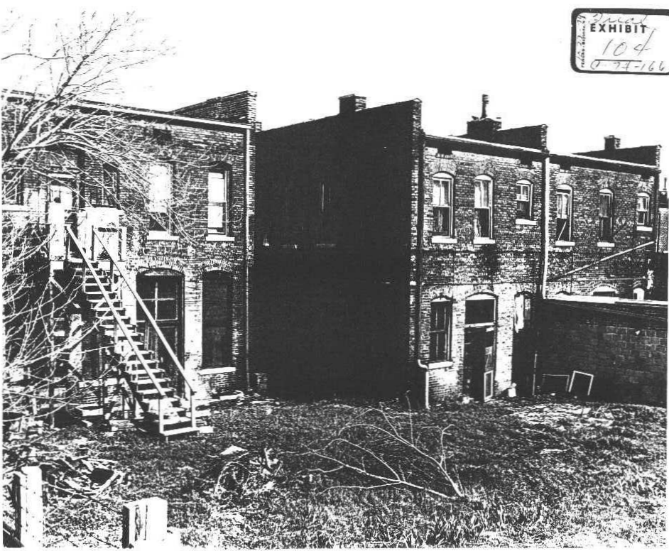
Although lowest in number, Exhibit 104 was taken after April 4. That the dense brush behind the flop house was not only cut down but almost entirely removed establishes that. A little of the brush that was not removed can be seen. This picture shows clearly how rundown that area was and the deterioration of those buildings within that area. The building on the left, looking at this picture, is of the southern part of the flop house that housed Canipe’s place of business on the ground floor. The building to its right, as looked at, which is to the north of it, shows the back of Jower’s place on the ground-floor level.
It also shows the window screens that had been pushed out of several windows but in this picture they have been moved, probably when the brush was cleared and removed. I know this from having had contemporaneous news pictures taken within minutes of the assassination that were stolen and from the police reports.
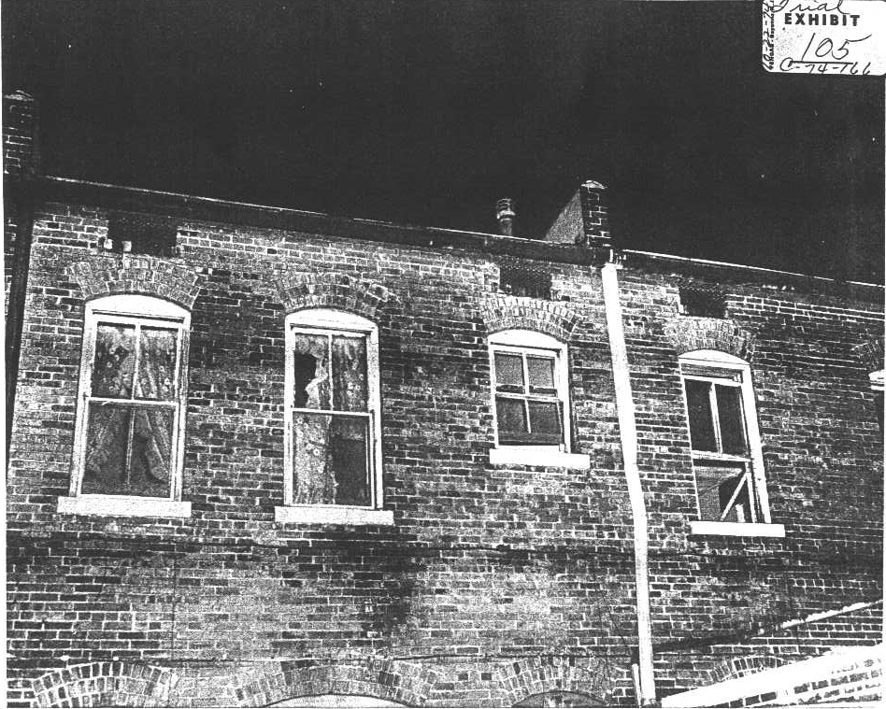
The smallest window on the back of the flophouse on the right, as looked at, is the window of that bathroom, but it is not in the same position as it was when that shot was fired. I had news pictures of it taken almost immediately. One showed something whitish and upright in the northernmost corner of that windowsill. In the picture it looked like what one would not expect in that place, a small vase. Bob Gruenberg, then a Chicago Daily News reporter who was there to cover the King march, was in that bathroom shortly after the shooting and remembered that (the window was almost closed and that there)
had been something suggestive of a small vase in that corner of the sill.
Exhibit 105 was taken after the end of that daylight and we do not know how long after it, whether on that day or on another day. It has something like a flat piece of board on edge, visible where that window is open.
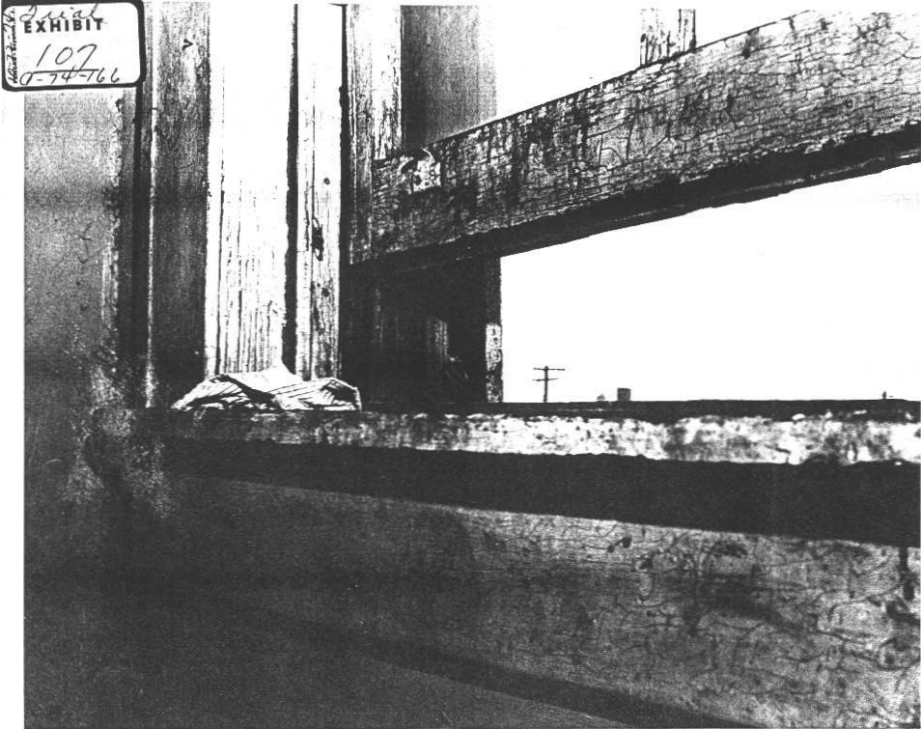
Exhibit 107 is a close-up of that open window before the inside part of the windowsill was sawed out but the rag in the corner is flat and what and what I remember from the contemporaneous news pictures was upright in that corner. The picture does show the weather-beaten appearance of the wood of that bathroom window and frame and how exceptionally close to the partition wall that window-frame is. It seems probable that a dividing wall was installed, after probably long after those buildings were built.
A look at the second-floor floor plan of the southern-most building of the flophouse may indicate how these buildings in that block were originally constructed. Putting a partition in would have placed it closer than normal to that bathroom window-frame, touching or almost touching it.
Exhibit 106, which does show more clearly how close to the wall that window-frame is, was taken after dark but before the inside part of that windowsill was removed.
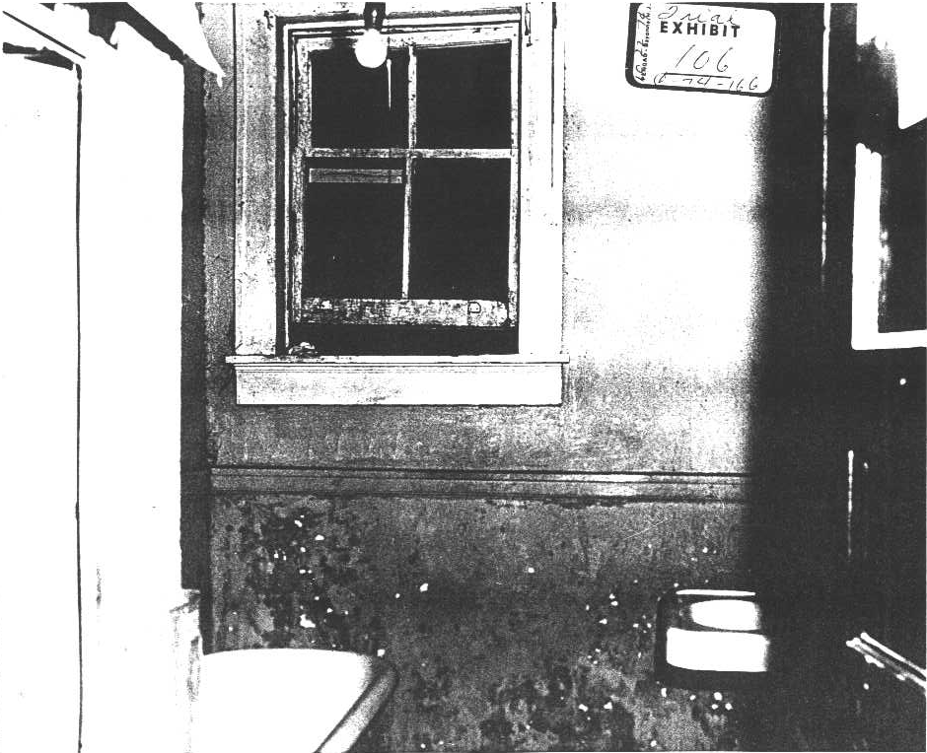
Exhibit 115 was taken after that half of the windowsill was sawed out. It shows what Posner referred to as most likely a palm print. It also shows encrustations in the tub that lead to the belief that it was not used for taking baths. In this picture the window appears to be open.
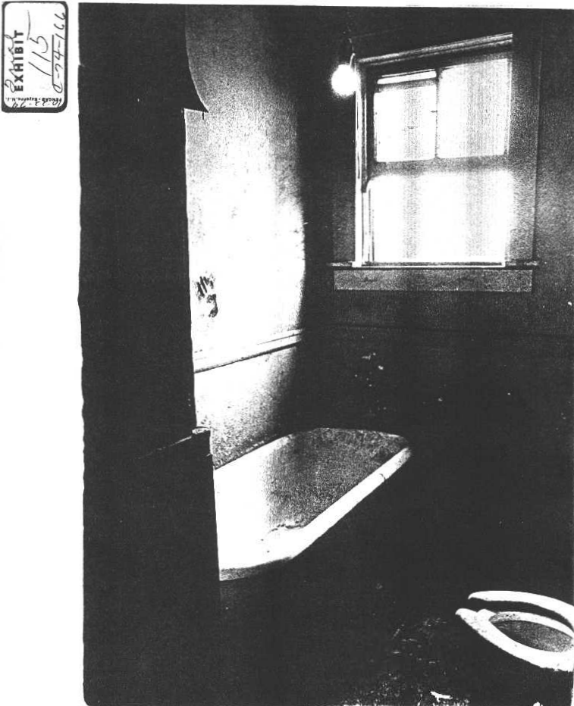
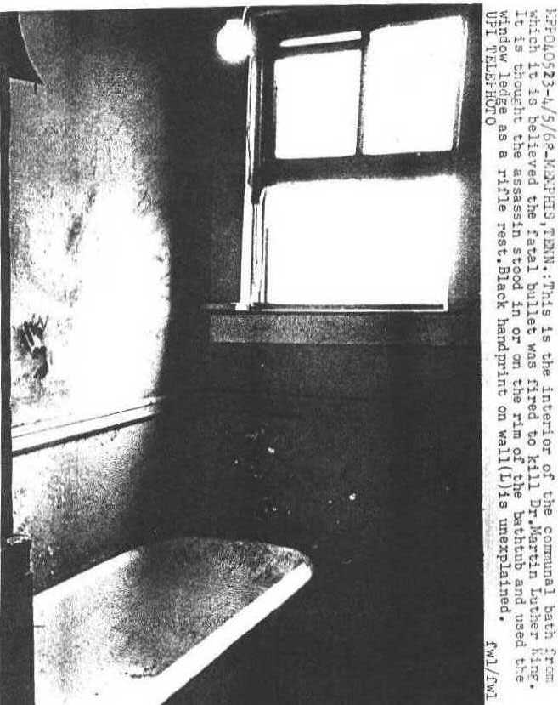
Next is the UPI picture that is dated April 5 and in which the sill has been removed and the window is wide open. This picture also shows that palm print and those thick encrustations. It appears in both of these pictures that at some point and for some reason, it was necessary to block that window open because a block was visible against the left side as the picture is looked at, apparently nailed in place.

At the time of the shooting, from the news pictures taken immediately after it and from Memphis police reports, that window was open only three inches.
In a teletype rated as URGENT and sent at 5:01 AM the morning (or thirteen hours later), after the assassination, the Memphis FBI told headquarters (on the fourth of four pages) that:

ON ARRIVAL INVESTIGATING OFFICERS, BATHROOM WINDOW OBSERVED TO BE OPEN APPROXIMATELY THREE INCHES.

(This copy of this teletype, from 44-38861 file, no serial number. That indicates it is part of a larger record of which I made a copy on receipt and did not include the serial number. It is also in the Memphis MURKIN file. In some instances, having made these duplicate copies of the records I got in CA 75-1996 for the future use as I first read those records, when they were separated from first pages on which the serial numbers are written it is not now possible to cite those serial numbers. Where that is true, other available FBI identifications of them will be used.)
While it may seem to be getting like a refrain to report that this information was in at least two of the FBI files Posner claims were his sources, here, as in other repetitions, the fact is that he ignored crucial evidence that is in those files because ignoring that evidence is essential to his dishonesty in his dishonest book. Repetition again records the fact of his deliberate dishonesty and of the fact that if he had gone over those records himself instead of accepting what the FBI fed him he would have known this information. It has great importance in his and in the official explanation of the crime.
It refutes them, proves them impossible.
From the police reports and from those contemporaneous news pictures, that window was not open wide enough to enable use of a rifle with a telescopic sight because it is atop the rifle and the wooden bottom of the window would have blocked any view through it. This is especially true because in both the official and the Posner stories the muzzle rested in the dent that was in about the middle of that sill and the shot was downhill, more downhill than in the medical examiner’s reconstruction for his autopsy report, as we see. With the shot downhill, the butt end of the rifle would have had to have been raised and that would have raised the telescopic sight more and made blocking of vision through it even more certain.
The three-inch opening of that window would not have permitted sighting that rifle for the shooting was so perfect that one shot was fatal.
The distance from where King stood was estimated but the city engineer and conveyed to the FBI. The Memphis FBI relayed the results in an FD 302 report to headquarters dated April 30 (May have been in Serial 920). It says the distance “from the rear [or inside] bathroom sill to the point where Dr. KING was standing was 207.02 feet.” It does not indicate with this pretended precision in measurement whether the distance was to the front of the back of King’s feet and whether the right of left foot or somehow both.
The angle downhill was computed based on the bullet's entry into King’s “body at a point 59 inches above the right heel with the head positioned to correspond with the path of the missile.”
For this to be possible that bullet had to change course by almost ninety degrees the instant it hit King.
It was well known and established beyond question that King was bent over the balcony railing when he was hit. That is the only way it could be expected that a bullet hitting him in the jaw could wind up below the back of his left clavicle or shoulder blade. Computation based on his standing erect flattens the angle of a shot from that bathroom considerably. The FBI’s report states, “Every effort was made to ensure accuracy.” This basic mistake in all computations that meant or could have meant anything reflects the “effort” and the “accuracy.”
In Posner’s account it was Inspector Zachary who first noticed this windowsill indentation (page 35). That is as unlikely as Zachary’s sworn testimony at the voir dire (transcript, page 49) that it was he who found that package outside of Canipe’s. Aside from the fact that Canipe was first, among the police Zachary was far from the first. Besides Ghormely, then a sheriff’s lieutenant being the one who first radioed in a report on the finding of the package there were a number of police who saw it and a black policeman was ordered by one to stand guard over it before Zachary got there from downtown headquarters, where he was at the time of the shooting.
With the rifle and the box and other evidence Memphis sent by hand to FBI headquarters the night the assassination was its memo of April 4 in which it said what it was sending was "material" that was "recovered by Inspector N. E. Zachary" who, obviously, is not the one who “recovered” what was taken possession of so much earlier.
In the report of the OPR lawyer James F. Walker of his phone conversation on September 15, 1976, at 8:20 P.M. with "Nevelyn E. Zachary,” Zachary confirmed that he was at the time of the assassination “in his office when a call came in reporting” the shooting at the Lorraine. When later he was at the Lorraine, “a deputy sheriff advised him that a bundle containing a rifle had been discovered . . . in front of Canipe’s . . . He does not know which officer discovered the bundle," and then when he heard “Ghormely mentioned “he said he thought that was the one.!”
Could there have been a better basis for Zachary swearing that he found the bundle, for using that to get Ray extradited, and to swear it to the court in the voir dire?
(If Posner had done his own work in those OPR records he claims as a source he would have seen this.)
The city engineer’s “accuracy” and that of Zachary illustrate the problem faced in presenting a truthful and accurate account.
Whoever first saw that windowsill dent, officially the late-coming Zachary is credited with it and although it is certain that many police and even some reporters saw it earlier, it became, immediately, the basis for the non-conspiracy theory (which is hardly even a theory) of the assassination. Totally impossible as it so obviously was. It became that immediately and that never changed. It was alleged in the extradition and it was alleged, in the voir dire.
Canale referred to the muzzle leaving "microscopic " markings on that window sill but the FBI was not able to connect any “marks” with the rifle. As a glance at the pictures of rough surface of the wood makes obvious.
Impossible as it so obviously was, all that followed was an elaborate charade based on it. For example, on April 6, the FBI in Memphis wrote headquarters, “laboratory requested to examine board to ascertain any possibility of breech powder burns or any other identifiable markings that may be made by the weapon in question. Possibility that recoil marks may appear on board” (44-38861-487).
What the Memphis FBI asked for, knowing that it had nor real evidence relating to how the crime was committed, does not exist. It was not possible.
This same serial includes handwritten Lab notes and drawings, including of the board. While no dimensions are given, from the drawing it appears that the dent was in approximately the middle of the edge of the board, as sawed out, and on the edge away from the inside. Along side this sketch is written, “No gunpowder particles found.” (Nothing else was, either, other than dirt and “chipped white paint.”)
Anxious to be helpful, the Lab reported under the date of April 11 that the board, meaning than windowsill, had a dent “which could have been produced by a light blow from the muzzle of a weapon such as the Remington rifle . . . but insufficient marks for identification were left on the board dues to the physical nature of the wood.” The Lab did conjecture that the “marks” are “of the type which could be produced by the side of the barrel at the muzzle.” Or, the assassin was standing, on the vertical wall, and was horizontal to the ground when he was fired.
The Lab has none of this inappropriate and entirely impossible conjecture. In its report it concludes that “No gunpowder or gunpowder residues were found on” that board and that “No wood, paint, aluminum or other foreign materials was found on the rifle barrel nor were any other significant marks found on the rifle barrel.”
(That takes care of Posner’s story, that the muzzle of the rifle was used to push that screen out so the rifle could be fire through the opening with that screen not there. He would have known his version was not possible – if he had done his own work in these FBI records.)
The Lab did not delay clueing Memphis in. It teletyped a report the day after getting that board, on April 7. Its teletype, which also reported on other examinations from 44-38861, lost most of its serial number in being Xeroxed. The number begins with “9.” The teletyped reports include the same language. It confirms that on the muzzle there is no indication that it was used to push the screen out and that it bore no evidence of having been in contact with wood or paint or aluminum. That should have been enough to end this cruel fiction but in the absence of anything else did not as “NO GUNPOWDER OR RESIDUE FOUND ON BOARD.” If any weapon had been discharged there would have been a “residue” as a result.
Handwritten Lab notations and comments are included along with sketches in what was disclosed to me in that lawsuit  and is in Posner’s claimed sources.
Also part of that made-up bathroom story and defying possibility is the Posner version that Ray made his package up, put the contents of that box, including the rifle, in it, and then fled the flophouse from that bathroom. Another of those claimed sources of his, what he cites as "MURKIN" and is 44-38861 in which it is serial 518, itemizes what the FBI says was in that box. What is listed was hand delivered by Memphis FBI agent Robert Fitzpatrick at about 5:15 A.M. the morning after the assassination. In the FBI record each of this these items has a "Q" number given it, representing to be questioned, but they are not included in this listing of the contents of that Browning box:

Rifle box for Browning .243 Winchester caliber rifle, Serial Number 4744Z5; .30-06 Springfield caliber Remington “Gamemaster” slide-action rifle, Model 760, Serial Number 461476, with Redfield telescope sight, Serial Number A17350, with clip; .30-06 Springfield caliber Remington-Peters cartridge case; Nine .30-06 Springfield caliber cartridges (five Remington-Peters and four R-A-55) in Peters cartridge box, Index Number 3033; Large green and brown cloth; “Banner” binoculars (Bushnell) 7 X 35, Serial number DQ408664 (allegedly in zipper bag when recovered); zipper bag; Needle-nose pliers and tack hammer; Box of “Band-aid Sheer Strips;” Georgia-Alabama Standard Oil map; “Commercial Appeal” Memphis newspaper, first section only, issue of April 4, 1968; Standard Oil map of United States; partial roll of toilet paper; binocular case with instruction booklet, lens cloth and guarantee card; binocular box (cardboard); “Gillette Travel Kit” purchased at Oliver Rexall Store, Whitehaven, price $1.89, with razor, lotion shaving cream in dispenser; gray paper sack bearing marking “York Arms Co.” with receipt dated 4-4-68 in amount of $41.55; white and yellow towel; white handkerchief; tube of Colgate toothpaste; pair of black socks; seven-ounce can of ''Right Guard" deodorant; Channel Master radio; Bottle of “Bufferin;” elastic belt; Tube of "Brylcream;" Bottle of One-A-Day" vitamins; small bar of "Cashmere Bouquet" soap; Hairbrush; bar of "Dial" soaps bath size; tube of “Head and Shoulders" shampoo; can of brown “Kiwi” shoe polish; can of "Palmolive Rapid Shave" shaving cream; maroon button (in sack with beer); black button (in sack with beer); toothbrush, "Pepsodent;” safety razor, without blade; plastic bottle of "Mennen Afta" lotion; small bar of "Cameo" toilet soap; small bar of "Cashmere Bouquet” soap, bearing advertisement of Friendship Inn; two bobby pins; two cans of "Schlitz" beer, pull tab; plastic "six-pack" carrying device; brown paper sack (containing beer); small brown paper sack, empty; key; toothpick; metal ring; two coat hangers; two links from ''Adjust-O'' watchband; maroon button.

All of this, in the Posner version, Ray packed up in that bathroom, within seconds, then wrapped it in a bedspread, and he was still out of that bathroom and going down that long hall before Stephens, as soon as he heard the shot, could get to the door of his apartment, which was next to that bathroom, and allegedly see the disappearing man going down the hallway.
There was also clothing left in the room Ray had rented and the FBI made careful examination of it, too.
We return to some of this clothing soon.
These Lab reports also make it clear, despite the repetitious Posner smart-aleckry, that Ray was not alone. That in itself does not prove there had been a conspiracy but it does prove that, with this as with just about all else, Posner cannot be believed without visible confirmation, what does depend on his word.
Memphis called to headquarters attention in submitting them on April 6 that the “men’s shorts” it was sending had “a waist band of approximately 23½ inches.” It also sent a “T-shirt, size 42-44” or “large size.” Obviously, one man did not wear both. Those shorts were much too small for a man whose chest was "large size” (44-38861-487).
In the previously quoted April 7 headquarters report on the windowsill and what related to it, headquarters repeated the obvious to Memphis, “UNDERSHORTS SMALL IN SIZE WHILE T SHIRT IS LARGE.”
All of this is in Posner’s source, what he refers to as “Murkin,” but of it none is in Posner’s book.
Not a word of it!
As always, this provokes the question, is he this dishonest or was he fed what he used by the FBI? Or both?
There was also clothing the Atlanta FBI found in the Mustang and sent to Washington that, where the size is given, could not have fit Ray. Included in that source Posner likes to be able to refer to, “MURKIN,” in 44-38861, Serial 518. What Atlanta sent headquarters for examination by the Lab included: "One rubber shoe, size 7-8½,” and “One pair of size 34 walking shorts,” neither of which Ray could have gotten into, both much too small for him. There are other items of clothing listed but the Atlanta FBI did not give their size.
Memphis and Atlanta both sent clothing that was too small for Ray.
Posner was his characteristic smart-aleck self in his comments about my having quoted newspaper reports accurately in saying that no Ray fingerprints were found on that Mustang. Earlier I reported what Ray had told me, that when he was about half-way from Memphis to Atlanta he stopped in the dark of night and during a rain storm to wipe the car clean of prints to the degree he could. As Posner expressed his pettiness, it could not be conceived that there was another person in that car with Ray (page 238). But the Atlanta FBI found evidence to the contrary, according to requests of the Lab from Memphis and from New Orleans. They requested that the Lab address “material from ashtray” (after which the Lab wrote “cigarette butt (Taryton) and ashes” and with regard to “5 transparent lifts from 66 Mustang” under “Result of examination.” FBI fingerprint expert George Bonebrake wrote “Latents of no value” (which means only that they were not Ray’s prints. It does not mean they could not be identified nor is there any indication any effort was made to identify them. In the Atlanta FBI’s request it listed a latent print from the left door handle, one eight inches from the right door "plunger under rear glass,” another on the right door handle, and "Four lifts or latent impressions found on auto rearview mirror."
With no identification of Ray from those prints, they were deemed valueless.
Posner asked no questions. This means that he was satisfied that the FBI made no effort to learn who had been with Ray or when or why. These FBI records recording the finding of fingerprints on that Mustang that were not Ray’s are included in those MURKIN records Posner cites so often but he made no mention of them. He is better at cheap-shot wise-cracks to deceive and mislead the reader and in his endless efforts to defame others.
Wise-cracks, yes; evidence, no -- this in the real Posner of this book.
He was good at finding excuses for his sophomoric cracks but he was not good at asking the questions that needed being asked as, for example about what is most basic in a shooting: the shooting itself.
If he had asked those questions correctly, as a lawyer he knew he should have, he could not have had his book. So his purpose was to have the book he preconceived, not to bring information about the King assassination to light.
One example is the source of the shot. We have seem some of the proof that the shooting of the official story and of Posner's is not possible and we see more an that. The FBI also developed much evidence that the shot was actually fired from behind the row of buildings in which the flophouse was. As I read the records that were disclosed disclosed to me I made a file of copies of those records in which those in the firehouse at the time of the shooting were interviewed. Ten or more all said that the shot seemed to come from the bushes behind those buildings. That file, which could be embarrassing to the FBI if used, is one, that has disappeared and I believe was stolen. That file held a copy of each of those FBI reports quoting someone n the firehouse as saying the shot came from the ground level, behind those buildings.
(The day this was written my friend Dave Wrone, recently retired University of Wisconsin professor of history, used these “subject" files for his own work. He has been familiar with them since they were established and, over the years, has used them. He is familiar with them, in general and with specific files. He found that in addition to mis-filing, of what interested him a half-dozen file folders, which had titles and had held folders, were empty.
(This is not an accusation against Posner, put it does happen that he was, if not the last, he was one of the last who was unknown to me, not a friend of years, who used those subject files, and he is the last I recall who went to the basement with his attaché case. There could well have been others after him but I do not recall any.
(I am clear that after the Oliver Stone movie JFK and the establishing of the Assassination Records Review Board, interest in those files and in the subject in general was less than it has been.)
One record with a brief reference to this that I had filed elsewhere for the other content is 44-38861-682. It includes that those questioned "indicated" that “the shot had probably been fired from the rear of one of the buildings." This can be ambiguous but those interviewed did indicate the belief that the shot came from outside of and back of one of those buildings.
Making sport with what was attributed to Solomon Jones, the driver of the car that was put at King’s disposal, that the shot came from those bushes, Posner does admit in a footnote that, “To Andrew Young, King’s top aide, the sound was a firecracker [Posner deprecating again] and it came from the bushes above the retaining wall . . .” (page 31).
There is no mention in Posner's book of all those others who said the shot came from the area of bushes behind those buildings yet all those FBI reports are in the MURKIN records Posner cites as one of his sources.
There was official fudging about the shooting by all elements of all involved governments. Although it made no difference, with the deal set, with Foreman determined to put Ray in jail for the rest of his life, there was much disinformation at the voir dire, as there had been before then. For example, at the evidentiary hearing of 1974, Jim Lesar questioned the medical examiner, Dr. Jerry Thomas Francisco. Francisco admitted that in the affidavit he executed for use in getting Ray extradited, brought back to the United States, he described what he removed from King’s body as a “bullet”:

Q. Now, you removed the missile from Dr. King's body, did you not?
A . That is correct.
Q. You described it here as a bullet. Is that the best description of it? Could you describe what you removed from Dr. King?
- It was a bullet.
- Was it an entire bullet, completely intact?
- You mean was there any element of metal missing?
Q. Yes.
A. Oh, yes.
Q. How much?
A. I had no way of measuring how much was missing, because the bullet had passed through several fragments of bone and had left fragments throughout (pages 343-4).

Rather than recovering an intact bullet from King’s body, which is what his affidavit stated, Francisco admitted that, as it is designed to do, that bullet had come apart and had left fragments throughout where it had passed through King’s body.
But there is no reference in any record I recall to the recovering of those fragments for the required scientific testing of them.
We have seen that with King bent over it was alleged that the bullet hit him fifty-nine inches up, which had among other effects, the effect of reducing the downward angle of the shot if it had come from that bathroom. Under Lesar’s questioning Francisco admitted that the angle through the body was not measured but “was roughly thirty to forty-five degrees” (page 35). Lesar then questioned Francisco on the conjectured point from which the bullet came:

Q. Now, that trajectory would have to be based on a fixed point of entry on Dr. King, wouldn't it?
A. I am sorry. I don't understand the question.
Q. It seems you could not fix the origin of the bullet unless you are able to determine with certainty the height with which the bullet entered Dr. King in relation to the bathroom window, or whatever point the bullet was fired from?
A. I think I know the question you are trying to ask, but may I rephrase your question?
Q. Certainly.
A. You are trying to say, is it possible for me to say that a bullet came from a bathroom window to the exclusion of any other point on the face of the globe, right?
Q. All right. You answer your question.
A. No, it is not possible for me to say that (page 246),

This after admitting that his autopsy report is based on King being erect, as he was not when he was shot!
This and so much more like it. In Posner’s claimed sources  and not in Posner’s book.

