Chapter 22

King Assassination As Not Accounted For By Gerald Posner

With the shystering of this shyster Posner, who has built an international name and fame for himself by his shystering, there is always the question of honesty, always the question, does he quote his sources fairly, do they say what he says they say. Or, does he make up and attribute to them what they did not say and he needs for the case he is phonying up -- without which he has no book and what goes with it, fame and fortune.
Then there is the question of the dependability of the sources he chooses. With some, this can involve honesty, with some, the agency policy with which they have to live, with some, haste or simple error, especially with those who did not, in the rush of events, stop to make notes but hurried along with what they believed was their duty.
There can be and there are honest mistakes but it is also beyond question that on this matter all mistakes were not honest.
Posner's are not, as we see, going back to his account of Canipe and his seeing that package and what else Posner attributes to him. We repeat some of that as we get into more of this kind of personal and professional dishonesty without which Posner would not have his book and the fame and fortune that came with it.
We quote Posner from his page 34, first about Canipe, after he heard that “thud”

. . . heard a thud outside. He looked to the front of the store and immediately saw a white man in a dark suit walking south on the sidewalk -- the direction in which Willard would have had to go retrieve his Mustang. After hesitating a moment, Canipe walked outside, looked in both directions, and saw a white compact car, with only the driver inside, speed away from the curb. . . .

“Willard” is the name Ray used at the flophouse, but all else Posner says about him is made up. There is no basis for it and that is why Posner has to make it up. As he does here. Ray was not there, could not have been there from the evidence that Posner ignores, but in his terms, this man he says Canipe said (which really means the FBI said that he saw), could not have been Ray so Posner phonies up his case . such as it is, and to phony it up he has to make his "evidence” up. As he does in:

Willard's escape in the Mustang preceded the arrival on South Main of two officers from TACT 10 by it matter of seconds. The two approached the rooming house from opposite directions after having first gone toward the Lorraine. Canipe saw one of them, Lieutenant J. E. Ghormley, walking rapidly toward him, a revolver drawn.

I have repeatedly noted that Posner avoids giving the actual source of just about all, other than the earlier sycophantic books that he uses as sources, and that, aside from questions of honesty, this is also pettiness on his part. I exposed him in Case Open, he was unable to make any response to anything I said, so he does not like me for exposing him and he gets his petty vengeance in this petty way. In his own mind, anyway. But because it is my own work I have some familiarity with it. It was I who rescued the FBI’s MURKIN records and many others Posner did not use from their official oblivion. I made them available and when the federal agencies are compelled to disclose they all are also compelled to duplicate what they are compelled to disclose in their public reading rooms.
This is how Posner had access (even if he did not do his own work in them) to the FBI records he can’t even cite correctly,
He also makes slight reference to what he does not describe accurately, what the United States government produced in England to get Ray extradited. That was still classified “SECRET” when it was disclosed to me under compulsion of the federal district court in my FOIA lawsuit to get it, CA 718-70.
Posner uses, but does not make the use he should have, of the transcripts of the evidentiary hearing for Ray in federal district court in Memphis in 1974. I did the investigating that led to that hearing and I did the investigating for the two weeks of that hearing. I located and questioned witnesses and other things like that. Witnesses we used at the hearing and some we did not call as witnesses then. Among those we did not call but would have had Ray gotten the trial he should have had is Canipe. And about him and what Posner attributes to him Posner simply lies, as we see from what Posner says he cites.
Part of what Posner says the official records say is what they do say, some he makes up and in making it up he lies. His lies are essential to his having his book because they are essential to his phonying up the case of Ray's guilt without which, nobody caring much about Ray other than as the assassin, Posner has no book.
Canipe was interviewed by Memphis FBI agent Franklin L. Johnson the day after the assassination, on April 5, 1968. That report is in the Memphis MURKIN file, 44-1987, in Subfile D of that large file. In a sense, because Canipe did not read and sign it, the report is what Johnson says. It may or may not be accurate about what it says Canipe said. One part of it that Posner uses is the first paragraph of its second page:

When Mr. CANIPE looked north on Main Street he saw a Deputy Sheriff walking rapidly on the sidewalk on the east side of Main, approaching Mr. CANIPE, this Deputy having his revolver draw. Mr. CANIPE, concluding that something unusual had just occurred, immediately stepped back Into his store. This Deputy proceeded south on the sidewalk past his store, not stopping. A short time later after other officers had arrived, he saw this same Deputy and talked to him. He does not know him name.

This is clear enough on Canipe saying that he saw one deputy and that deputy was coming from the north. But Posner, who lies in saying that it was only a "matter of seconds" after Ray's escape in a screeching Mustang, lies also in saying that, as we saw, he has two deputies he refers to as ''officers'' coming from different directions, one from the north, one from the south. Posner names one only, Ghormley, and he gives as his source the FBI report (on page 350) we have just quoted which says no such thing – says the opposite -- and does not mention Ghormley.
To refer to this and to what we have not yet come to as other than lying is to be unfair to the reader to whom, given the importance of the subject, it is necessary to be clear and not to mince words or understate too much.
In the FBI interview, as Posner does not say, Canipe told the FBI that the one deputy he saw, the one not named by Posner when he did name Ghormley, the one, who must have been Dollahite, (and in the Posner fiction should have seen “Willard”) walked past his store, paying no attention to that package which had part of a rifle sticking out of it – the package that was so large and so visible and was right on the sidewalk. While it may be believed that the deputy, knowing that King had been shot, would pay no attention to the very visible rifle in a so large a package (the rifle alone was well over three feet long), it seems more reasonable to believe that the deputy paid no attention to that package because he knew it had been reported.
In any event, Posner is further unfaithful to the report he uses as a source in not reporting that the deputy paid no attention to that package with the rifle in it visible.
Although you would never know it from what Posner writes, Dollahite was also interviewed by the FBI, by the same agent who interviewed Canipe, and as Posner’s reader has no way of knowing, that interview is also in Memphis MURKIN 44-1987 and for one who knows Posner, it is not surprising that this interview report that Posner suppresses -- is in the very same file from which Posner cites his Canipe interview, Subfile D!
DolIahite said that after he heard the shot he jumped down onto Mulberry Street to run to the Lorraine. He went to underneath where Johnson says King’s body was lying, on the second floor balcony. As Dollahite left the driveway ''he dropped his firearm and had to stop briefly to pick the firearm up, checking it briefly, and then continuing. After going to the scene near where the body was lying and determining other officers were converging on the scene, he left. He went north on Mulberry to Huling Street. He was joined by an officer named MALEY. They looked around as they hurried west on Huling. Before, they got to Main Street, Maley “stopped at that point to observe.” What he wanted to observe and Dollahite did not, Johnson does not say. Then Johnson does say this about Dollahite and what he saw (and did not see): “Upon reaching Main Street and turning south,” which would have been toward Canipe’s, Johnson's words about what Dollahite told him are ''he saw no pedestrian traffic whatsoever."
Which means no policeman or deputy sheriff, no Ghormley in particular, and explicitly enough this says that Posner lied in making it up that the two “officers” were going in opposite directions in front of Canipe's or on Main Street at the same time.
Still before he got to Canipe's, Dollahite "came to Jim’s Grill, a restaurant at 418 South Main Street. The door was standing open. He stepped inside, looked around . . . briefly and announced to all present that no one should leave that restaurant until the police had arrived and approved their leaving . . . It was when he left, closing the door, that he proceeded south. Then ''he observed some items lying in the doorway to Canipe's Amusement Company" but "at the time he had no idea as to the significance of those items." He did not stop, but kept hurrying south, past Canipe's, and soon he saw ''officers . . . coming from the direction of the fire station." It was next to the heavy equipment parking lot that was next to Canipe’s. Dollahite also said that those officers coming toward him “would have been in a position to see anyone running or any other suspicious activity in the general area.”
Not one reported seeing “Willard” or that Mustang.
Dollahite said more about there not being anyone there for him to see:

Patrolman Dollahite advised that he is positive that after he arrived on Main Street, and until the officers had given their approval, no person left the area on foot. He is equally positive that no vehicle sped away from the area around Canipe Amusement Company after he arrived on Main Street. He stated that the only time he was not in a position to observe the activity in the 400 block of South Main after he first arrived there was during the time he stepped into Jim’s Grill . . .

If Posner did his own work then he knew about these records and he decided to suppress them. If he did not do his own work, if the FBI fed him what he used, the FBI was not, obviously, going, to feed Posner what tended to undermine the FBI’s story, which was its instant vision, its instant belief without any investigation, that Ray was the lone King assassin.
The OPR is another of Posner's claimed sources. It interviewed Dollahite. Its report on that interview is consistent with the FBI’s report but it adds one fact that disputes what Posner attributed to Canipe:

Dollahite said he got a glimpse of an individual (later identified as Guy W. Canipe) who stepped out of a doorway on Main Street and quickly went back inside that building.

Or, Canipe was not out of his store nearly as long as Posner says.
On the car that could not have been Ray’s in any event pulling away from a parking space near Canipe's, Canipe was quite specific in saying it was either "a Valiant or a Comet" and not a Mustang and in stating that he heard no tires ''screech.” When he saw it is not stated. Dollahite saw none.
When I interviewed Canipe, he was even more forceful on this. He told me on two different occasions that, and this is a paraphrase but close to what he said, “Anybody says that I said I heard tires screech is a liar,” The first time Jim Lesar was with me. The second time it was Les Payne, then minority affairs reporter for Newsday.
In using Posner’s claimed source, the FBI Canipe interview, it is apparent that Posner lied and lied deliberately, lied as was essential for his book and for the preconception of that book, that Ray was the lone King assassin.
It is likewise apparent that what Posner has that is false is not false by accident. He just made it up because he needed it for the book he was making up.
Ghormley presented a problem to Posner that we do get to but from Dollahite, the “other'' deputy was who was not “other” and who Posner does not name, it is explicit and without question, he saw nobody at all  and that includes Ghormley  and no car, Mustang or other.
With this brazen Posner lying about what he had to lie about, we do more than learn a little more about Posner. It serves to take us from the King assassination, as Posner accounts for it, to what the official, the actual evidence really is.
What the actual evidence must do, as we saw earlier, for there to be any case at all against Ray (which also means if there is to be a book for Posner that is not fiction), begins with placing Ray in Memphis at the time of the crime because, if he was not in Memphis at the time of the assassination, he could hardly have been the assassin.
Ray was in Memphis but the prosecution could not prove it. Knowing this, knowing that the statement used to extradite him was false, Ray was, with me and with others, open about his being in Memphis then and what he did when the time of the day that started to get critical in the story of the assassination. Posner is a bit vague about the time of the proof he knew the prosecution had but would not use. It had to do with Ray's purchase of a pair of binoculars at the York Arms Company, which was several blocks on the downtown side or north of the flophouse. Posner says it was “about a half hour after Willard had checked into the rooming house. Ray told me, as I recall, that it was about four o'clock that afternoon. The salesman was Ralph Carpenter. Posner made their conversation up (page 27).
Then in his footnote Posner is honest. He has been talking about Stephens and Anschutz having seen the man they did not know at the flophouse and about how vague the Stephens “identification” was, Anschutz not making any identification. Posner's honest footnote on Carpenter is:

If the tenants in the rooming house left a lot to be desired as witnesses, the FBI and Memphis police did not have much more help from Ralph Carpenter, who ended up in a mental institution a couple of months after the assassination.

For this, in his typical incorrect citation of the headquarters MURKIN records, Posner has “MURKIN 4442-4500, section 57, p, 133.” Aside from the fact that the FBI does not include its title or acronym when it cites its own records, thus it would have had this citation to “44-38861.” The actual Posner citation is to at least seventy-nine different documents with his gibberish of “4442-4500.”
Each of those numbers represents a serial. A serial can include many documents and it can run to many pages. In the JFK assassination records they run up to, with many close to or more than about a thousand pages. I do not recall any that long in the King records but what is clear is that Posner does not know how to cite these FBI records. That still raises questions about whether he did his own work in them or was hand-fed by the FBI, which gave him what it wanted him to use and did not give him what it did not want used. Posner’s record in his book is consistent with this.
So, Carpenter could not, be used to place Ray in Memphis. If he had been, he could have placed Ray there about two hours before the assassination. (Much longer in the Posner story.) Ray could have been in Mississippi or Arkansas in minutes and he could have gone quite a distance in two hours. Placing him in Memphis two hours before the crime, while it would have placed him in the city, which the prosecution was not able to do after the morning time he checked out of the New Rebel motel, did not place him in a position to have been the King assassin.
To try to do that Tennessee and Washington had to use "Bourbon Charlie," and both did, knowing that he had already stated publicly that Ray was not the man he claimed to have seen! (When he was so drunk he knew nothing at all of what transpired then and several hours later did not know why he and his common-law wife were sitting, outside the district attorney general's office.)
As stated earlier and as the MURKIN records Posner so conveniently overlook state explicitly, the FBI prepared an affidavit in which Stephens would have had a sort-of identification of Ray to be used to extradite Ray, but the Justice Department did not like it. The Department's Civil Rights Division prepared one that also did not meet with approval. Then it prepared the one that was used after “Bourbon Charlie” signed it.
If, as I believe, this false swearing is perjury, then those who, knowing it was false, prepared it for him to swear to suborned his perjury. Both are crimes that are felonies and it was by these felonies alone that Ray was extradited from England. That also was in violation of the extradition treaty between the countries. It was on this perjury alone that Ray would have been prosecuted. It also was on this perjury alone that the voir dire technical plea of guilty that Foreman coerced Ray to agree to was based.
In short, “Bourbon Charlie'' was basic to all charges, all efforts, and all behind those efforts knew that the affidavit he signed was false, perjurious.
Posner did not have to go through all those MURKIN pages to learn this. He saw the pertinent excerpt and on the same Frame-Up page as is the pertinent excerpt from the Robert Frazier FBI affidavit also used in the extradition, also basic and also not truthful. Both appear in Frame-Up, page 506, in facsimile.
Both, having been used in the extradition, were among the records the reluctant disclosure of which, by Joseph Cella of the Department's criminal division, I go into in Chapter 17 of Frame-Up, “Getting the Truth” (pages 398ff). They were literally, as stated earlier, all those pages used in public in Great Britain, in the British court and then available to the media, still classified in the United States and its Department of Justice as “SECRET.”
The real reason they were still classified, the real reason I had to sue to get to see them, is that they were phony as a three-dollar bill and the government knew it!
If they had not been, if the government, any element of any government, had had any case at all against Ray, it would have been anxious to give him the trial he never had and to make that proof public in that trial. It is because there is no proof against Ray at all that he died without ever being tried, that the State of Tennessee blocked his efforts to get a liver replacement which he needed to survive so he could continue his efforts to get a trial.
In what the Department of Justice put in the affidavit it prepared for Stephens to swear to it was careful not to state that even if it was true, as it was not and could not have been, the only time Stephens could have had any view of a face was in the brief second or two required to make an abrupt, ninety-degree, right-angle turn at the end of the hallway the considerable length of which is not stated in the affidavit the government prepared for Stephens to sign:

9. Right after the shot, I heard through a broken pane in my kitchen window a lot of voices yelling and hollering across the street from my building near the Lorraine Motel. I looked out my window toward the noise and I saw a lot of people milling around near the motel. Then I went to my door and opened it. I would say that about a minute, not more, passed between my hearing the shot and when I opened the door. First, I looked toward the bathroom and I saw that the door was open and it was empty. Then I went to the banister and looked the other way. When I did, I saw a man running near the end of the hallway. I have put an “O” mark on the floor plan, Exhibit 1, to show about where he was when I saw him. He was carrying a bundle in his right hand. From what I could see, the bundle was at least three or four feet long and six or eight inches thick. The bundle appeared to be wrapped in what looked like newspaper. The man turned left toward the stairs when he reached the and of the hallway. Although I did not get a long look at him before he turned left, I think it was the same man I saw earlier with Mrs. Brewer looking at Room 5-B. The man running down the hall had on a dark suit, the same as the man I saw earlier.

We include this official "floor plan" even though it is dishonest, dishonest by intent.
It does reflect that the flophouse was the second floors of two adjacent buildings. There was a gap, also visible in the pictures used at the hearing, that separated the two buildings by several feet. But according, to this “floor plan” the only rooms that had any windows at all, for all the outside wall space, were the one Ray rented, the Stephens apartment and that communal bathroom!
The other fifteen rooms had not a single window! Yet each and every one of them had an outside wall!
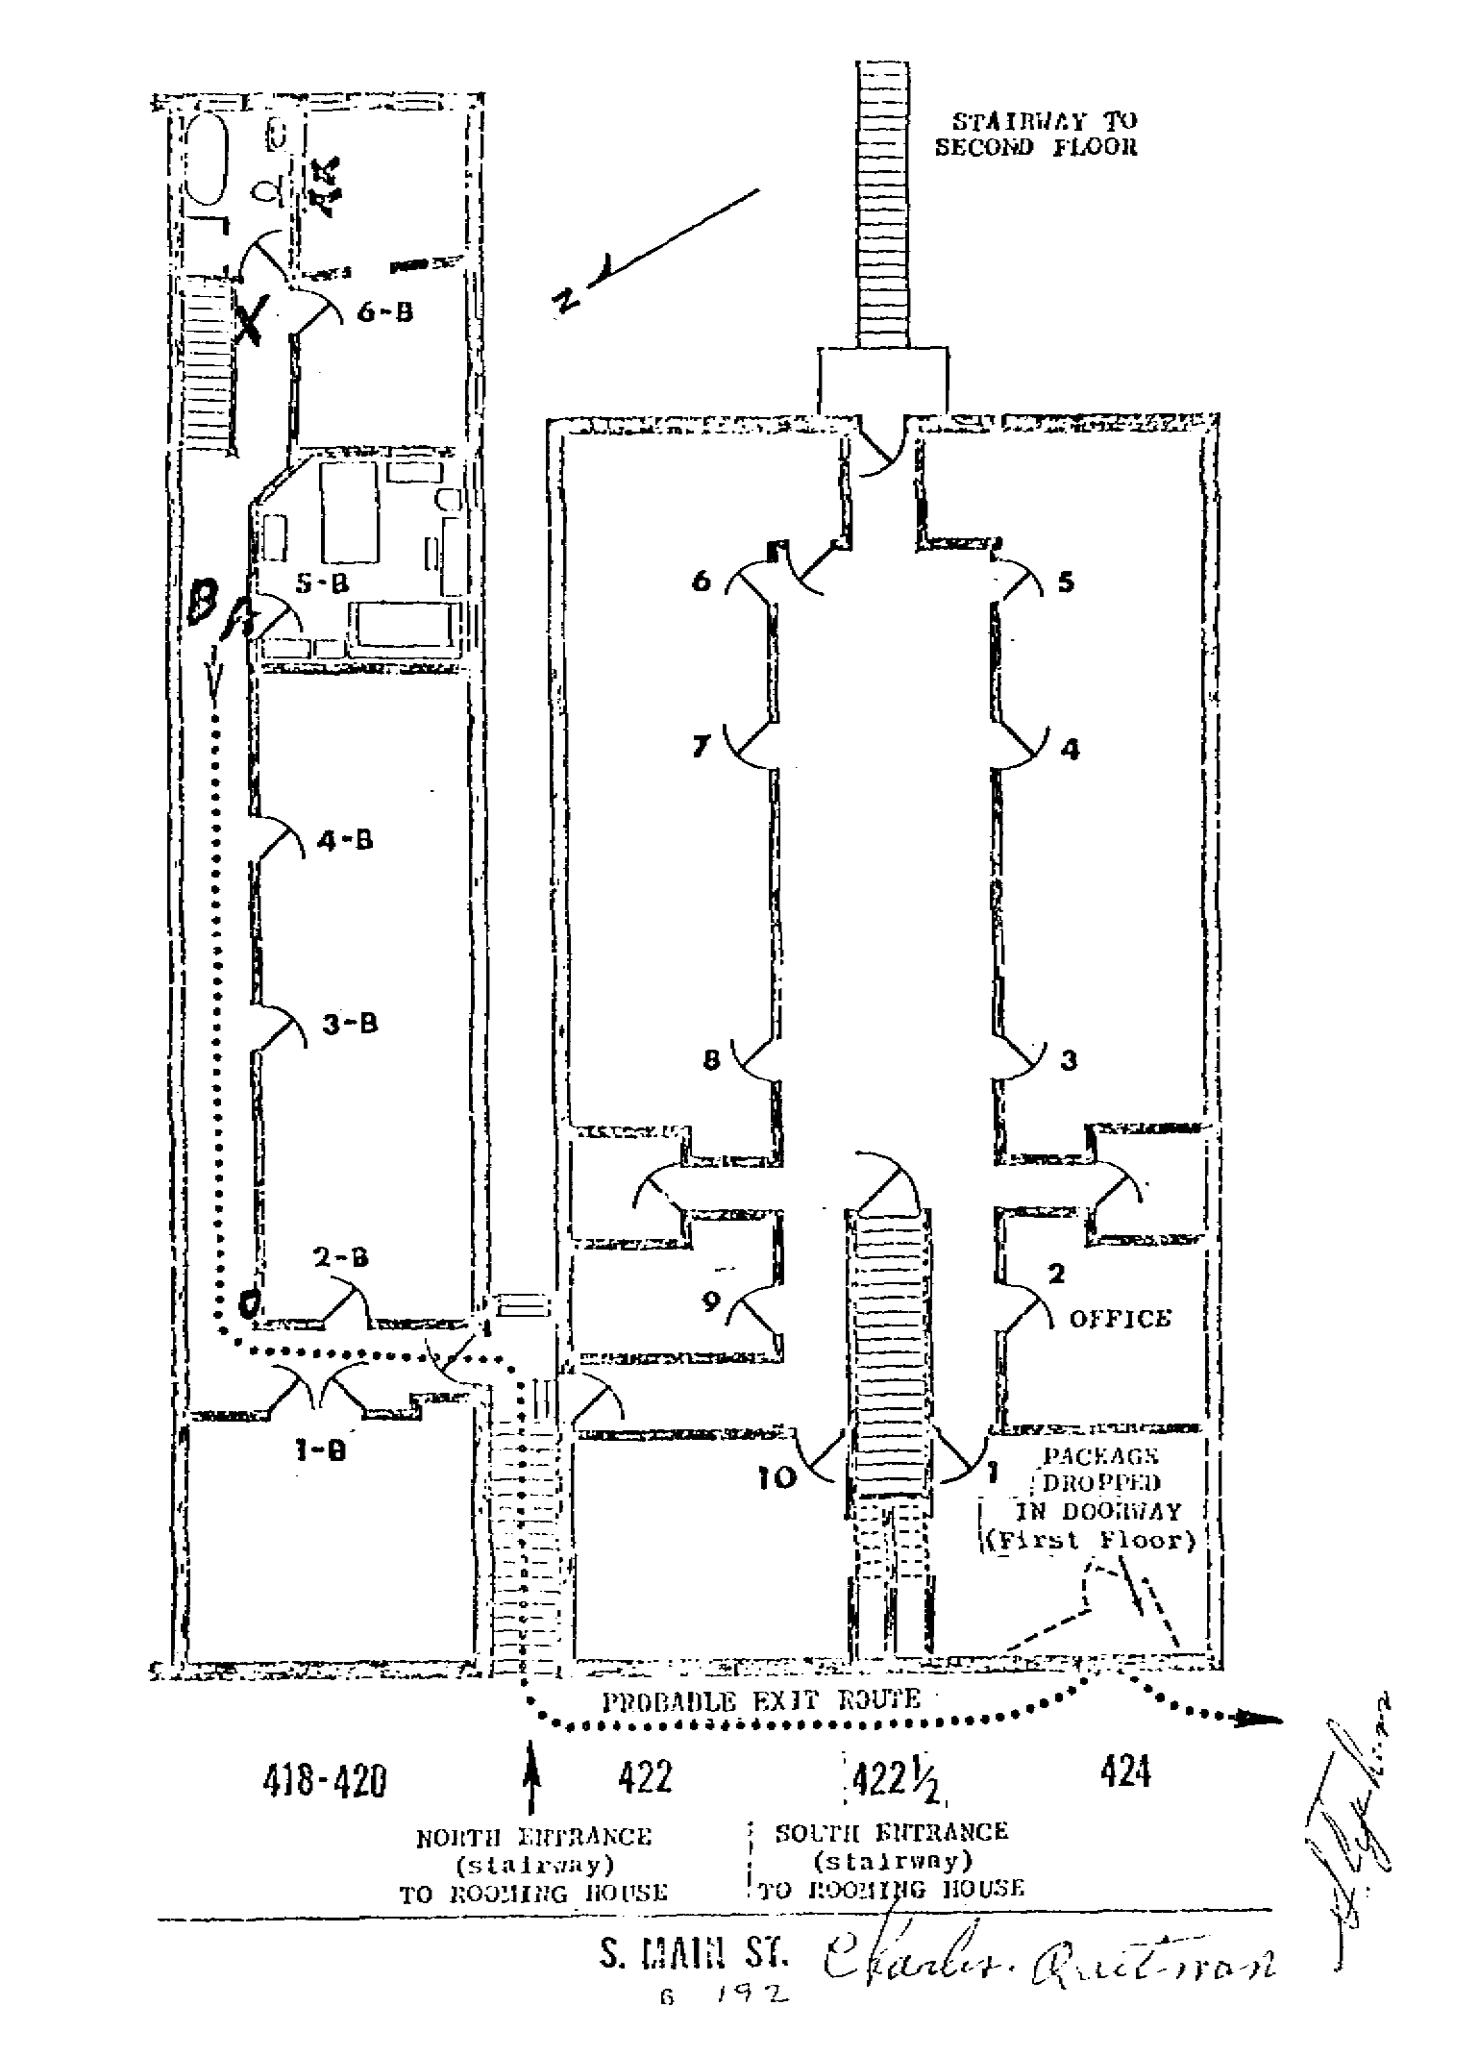

This also was not accidental carelessness. It was to hide the fact that under the best of conditions visibility for Stephens would have been poor and that day he did not suffer the best of conditions!
The hallway he says he saw that man going down did not have an outside wall. That wall was the partition between two buildings. The only light that was ever in that hallway other than the little that could have come if the bathroom or another door had been open was from a small, bare electric bulb in perhaps the middle of that long hallway. Fortunately misfiled and thus not stolen is a partial set of official photographs placed in evidence during the 1974 evidentiary hearing. One marked “Trial Exhibit 109 C 74-166,” taken from the bathroom end looking toward the end that has the abrupt, sharp turn, shows that bulb was burned out.
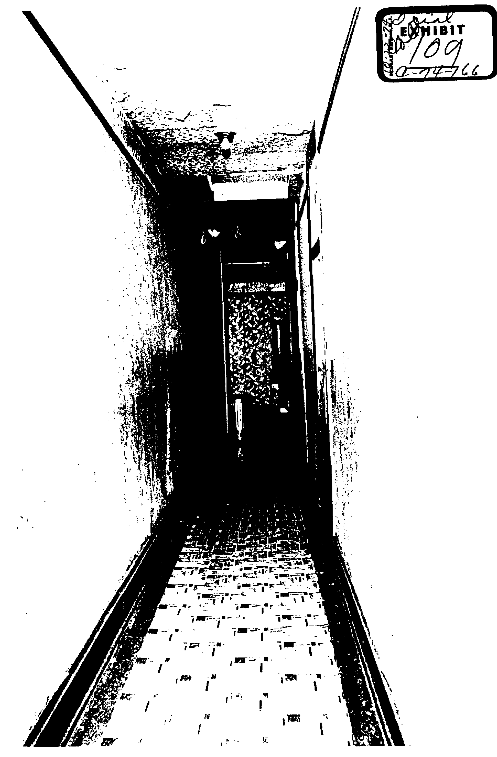Or, there was no illumination at all in that hallway that day!
(The bulb was also burned out when I was there and took pictures without flash that was used to hide the truth in these official pictures.
This, "floor plan" is also dishonest in its failure to show any space between the sloping back end of that old bathtub and that wall.
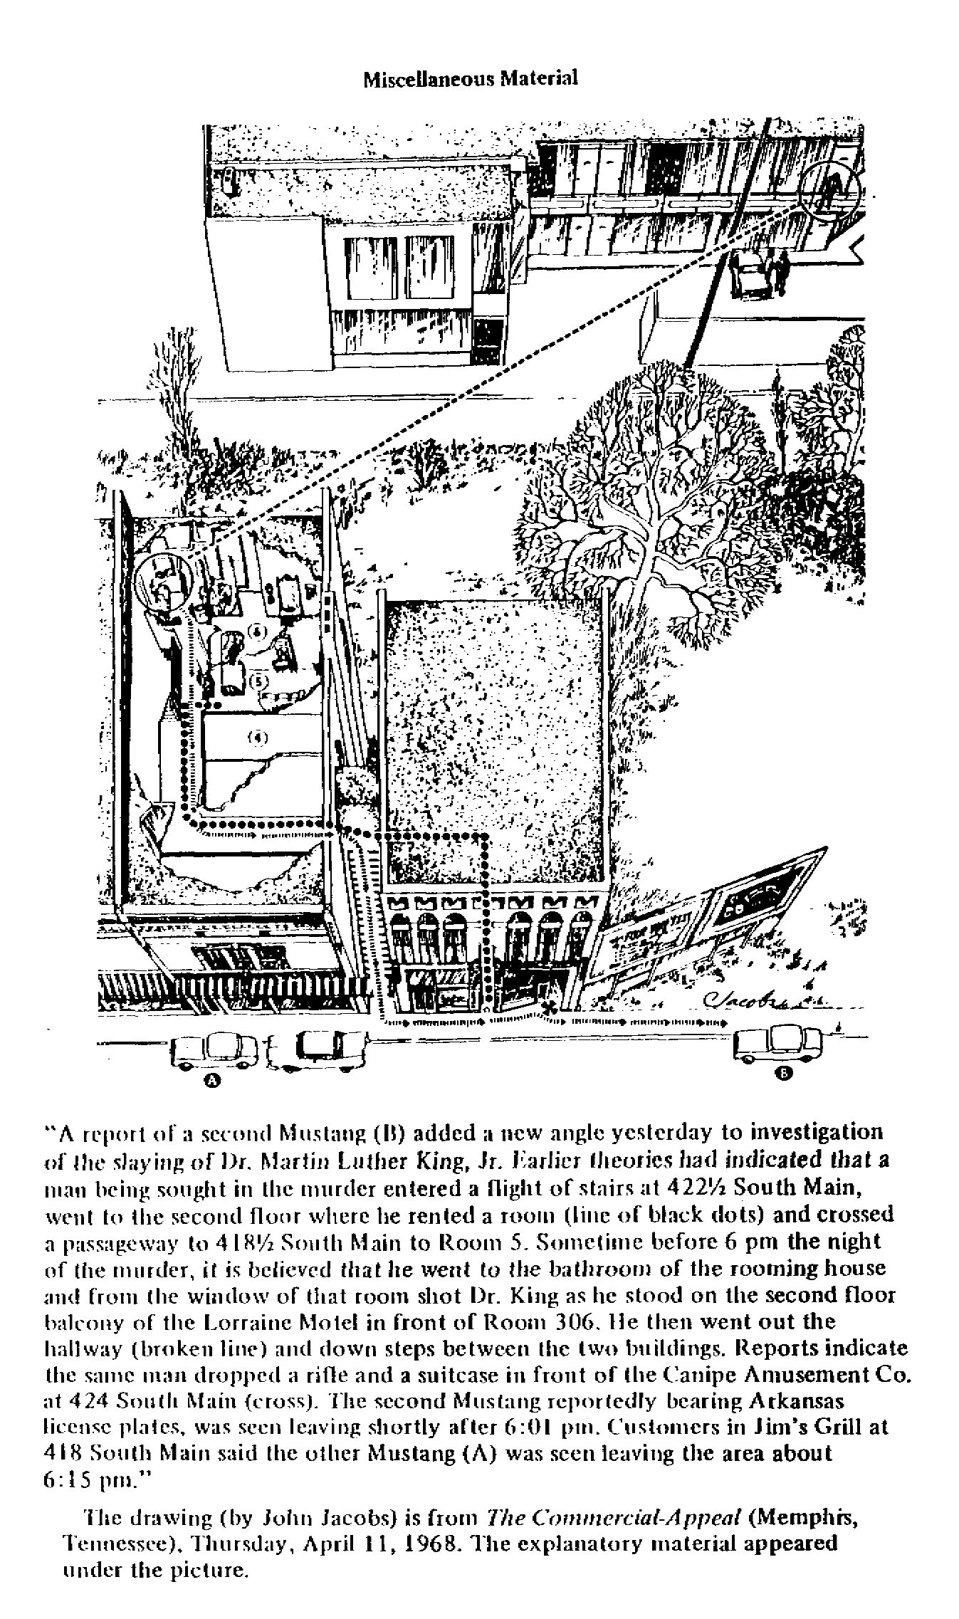
It is honest in placing that bathroom window up against the closer wall, that to the north. From this floor plan, if it is known where King was standing when he was shot it would be apparent that he could not have been shot with a rifle the muzzle of which rested on the windowsill. We do have a sketch of that area, also from Frame-Up, (page 505), which does make this apparent, much as government did to hide the unarguable fact. There is also what is dishonest in this drawing, which appeared in the Memphis Commercial-Appeal, but there here is no need to go into all of that. Like omitting the fire hydrant that denied the right to park on both sides of it. And, on close examination, moving that unused bathtub away from the inside partition wall it was up against.
The caption underscores Posner’s knowing dishonesty in his cracks about my references to a second Mustang. It includes some of what the newspaper said about that second Mustang, which was all over all the papers.
Then there is what was well-known contemporaneously and was conveniently forgotten by all the media once the FBI proclaimed Ray the assassin and had been caught in England. That is what the lone claimed eyewitness, the one person who could, at least pretendedly, identify Ray. Earlier I reported that I do not now have access to my copy of the transcript I have of the CBS-TV’s special of April, 1976. In it in 1976, CBS-TV, which filmed Stephens on April 18, 1968, showed him looking at the Ray picture as “Galt" at bartending, schools. Stephens told CBS that was not the man he said he saw! CBS-TV sat on that for eight years!
It if had not, if it had used that negative identification when Ray was captured, history would have been different since the and the government would have been forced to, belatedly, at least seem to make an effort to investigate the crime itself.
However, also fortunately misfiled and retrieved by accident, is a copy I was sent of Cy Egan's story in The New York Post of that same day, April 18, 1968. Its lead, its first two paragraphs are:

An FBI photograph of Eric Starvo Galt, prime suspect in the Rev. Dr. Martin Luther King is not a picture of the man who fled a Memphis rooming house after the murder, some witnesses maintained today.
“Unless he was wearing a wig, or had had a face lift or something, its not the man I saw,” said Charles Q. Stevens, a resident of the rooming house from which the killer is believed to have shot King. “The hair is too full and the face is too young.”

“Not the man,” exactly what Stephens told CBS and exactly opposite what the government prepared for him to swear to in the government's subornation of that perjury!
Earlier I referred to Posner’s total lie, that I “personally interviewed dozens of people in the 1970s in the vicinity of the rooming house looking in vain to find support for" what Posner refers to as “Ray's gas station alibi'' (page 233).
In referring to this Posner lie, and he lies as if his life, not just his book, depended on his lies, I stated that I did not interview "dozens” of people in all my investigation of the case and that I interviewed none with regard to this "alibi," not intending any use of that in the evidentiary hearing. Of the very few people who could be referred to as ''in the vicinity of the rooming house I recall interviewing four in all. Canipe is mentioned above. Another is not relevant to this area of the case. The other two were Loyd Jowers, owner of Jim’s Grill, and the cab-driver, James McCraw.
What led me to interview both is what Posner makes no mention of. He certainly makes no mention of having sought to examine the records of the public defender who was appointed by Judge Battle to assist Foreman. Hugh Stanton was then the public defender and his assistant was his son, Hugh Stanton, Jr. Junior was, at the time of the evidentiary hearing, the district attorney general. One of the records we got on discovery from the public defender’s office, headed MEMORANDUM TO INVESTIGATORS says, under JAMES MCCRAW, that he found Stephens "too intoxicated and . . . refused to pick him up because of his drunken condition."
(This, is to say that Foreman knew and his assistant, the public defender and his assistant who did most of his work, his son, all knew that the only person who could be used to allege that Ray was in Memphis at the time of the crime was so drunk nobody could have used him as a witness. Yet Foreman insisted that Ray enter a technical plea of guilt and the others agreed with him, they all kept their mouths closed, and Judge McRae held that no lawyer had any conflict of interest or failed to give Ray effective assistance as his counsel!)
I also interviewed Jowers on this and we used him as a witness at the evidentiary hearing, where his brief testimony was limited to it (Volume IV, pages 332-3). Jowers testified that Stephens, a "regular customer," was in his place "at approximately 4:30” that afternoon and "was, I would say, pretty drunk."
There was no need for any other interviews for the evidentiary hearing and only a shyster like Posner, who is a lawyer and knew we needed no more, could imagine that there was a need for more than I did for that hearing.
So, the record is clear on Stephens: rather than identifying Ray as the man he is quoted by the government as saying he saw, he was unequivocal in saying, on looking at the picture of Ray, that he was not the man.
Posner uses that CBS-TV show on which it aired Stephens looking at that picture and telling CBS Ray was not the man he saw, but Posner makes no mention of this in his book. That can’t be because the FBI did not feed it to him. It could be, of course, because the FBI would not like it, would not like being exposed for preparing a false affidavit for Stephens to swear to and because of the damage any attention to this would have caused the government's made-up and non-existing case that did not solve the crime. It is the real Posner defining himself, as a writer of the most determined dishonesty out to make a buck and a name by corrupting our history all over again.
Posner also knew from Frame-Up (page 506) that the FBI’s ballistic expert, Robert Frazier, filed an affidavit that was both false and did not prove Ray fired that shot. I reproduced the last paragraph of it also in facsimile along with a caption spelling this out, so even a Posner would not have missed it:

6. Because of distortion due to mutilation and insufficient marks of value, I could draw no conclusion as to whether or not the submitted bullet was fired from the submitted rifle.

[signed]
_________________________
ROBERT A. FRAZIER

This excerpt from FBI firearms expert Robert A. Frazier’s affidavit, used in the Ray extradition, then confiscated and suppressed, says what is false, that a bullet was recovered and admits there is no proof it came from the "Ray" rifle (see pp. 225ff).

There were other ways in which, if there had been any reason to suspect it, Frazier could have argued that Ray fired that bullet. For example, by comparing the analysis of what was or could have been recovered with the analysis of the rest of that box of bullets.
Knowing from Frame-Up that it was my FOIA lawsuit (CA 718-70) that brought this Frazier affidavit and all else used in the extradition to light and not being able, because I had published this, to risk ignoring it, Posner does use it (on page 51), and then, pettiness of the real Posner coming out again, he gives this source not for it

16. Affidavit of Robert A. Frazier, June 10, 1968, p. 34, part of 193 Extradition File of James Earl Ray, available from the Department of Justice via a Freedom of Information request: the author's research copy from the David S. Lifton Archives, Los Angeles.

Aside from his snide references to Frame-Up in his text, Posner records that it was a source he used in his bibliography, on page 420.
Or, the one who makes the record for history of who Gerald Posner really is and what he is, is Gerald Posner, the petty little man who, as I wrote earlier without a word from him, has trouble telling the truth even by accident; the man of puerile pettiness, the practicing shyster who is, as The Oxford American Dictionary says, “unscrupulous in professional matters, especially a tricky lawyer.”
Posner on Posner.
Also a beginning of the less than full account that is publicly available in the evidence of the King assassination as it is not accounted for by Gerald Posner.

