Chapter 4
Russo, Student of the Kennedy Administration and Its "Foreign Policy Errors"

Those not familiar with the massive outpouring of books that are, supposedly, about the assassination of President Kennedy, people who believe that publishers see to it that the books they publish are factual and correct, may be surprised to be told that virtually without exception the books that are supposed to be opposed to the official "solution" are seriously flawed and are not infrequently by those who believe they can see what others cannot see, by those who think they understand what others cannot and do not understand -- by those who believe they have special gifts, special insights, special resources and sources - by those so many of whom believe they are Sherlock Holmes returned from the grave.
Gus Russo typifies these people who consider themselves special in some way or ways and remain what they begin, subject-matter ignoramuses. He considers that except where he can misuse it there is no value in the official evidence. In fact, however, as most of these subject-matter ignoramuses who regard themselves as some special kind of expert are not bright enough to realize, it is not possible to write accurately and responsibly about the assassination of the President without solid and detailed knowledge of the established official fact.
There is much legitimate criticism of the official "solution" that is justified. I doubt it anyone has been more critical of it, on the basis of fact, than I have been. That does mean, however, that everything in the official accounting is wrong, that none of it has been established as fact and established as fact as in the courts save that in most instances, it was done without that marvelous machine for establishing truth, without cross examination. There is much in the official assassination records that has been established as truth and it is truth that must be recognized by all who would be honest and responsible in writing about the assassination. That most people who are familiar with these matters are more familiar with the official interpretations of the evidence does not mean that the evidence itself has to have that meaning or that there is no other relevant and dependable evidence in the official records.
I emphasize that this does not mean the official interpretation of that fact or the official representation of it. It means the fact itself not given any special twists or interpretations. No one book can exhaust all the countless illustrations of this but in this manuscript there will be more than enough illustrations to make this clear.
Russo is one of many who begin with the preconception all deny beginning with, that Oswald was the assassin. That was the conclusion of the Warren Report and before that Commission began its work, it was the FBI's conclusion. The FBI through its director, reached that conclusion the afternoon of the assassination, that soon, before it had been possible even to begin an investigation. There was an official formulation of this conclusion five days before the Commission was appointed. That was two days after the assassination, on Sunday, November 24, 1963. It was virtually as soon as Oswald was killed and it was known that any trial could be avoided. A trial is in public, with the media present to report it. A trial means that evidence will have to be produced by the prosecution, evidence that can be examined publicly, evidence that can be cross-examined and refuted by the defense. A trial means public testimony and that can mean public recognition of false testimony and public reaction to it.
In this sense the killing of Oswald meant the killing of any real investigation of the crime itself. It also meant that the proceeding that was the official substitution for a public trial and was entirely in secret.
That Oswald was the assassin is the official assumption that was made before any real investigation had been made or was even possible. The documented details relating to their decisions are in the first chapter of my 1995 book, NEVER AGAIN!
There is an incredibly large mass of official information that is said to be about the assassination but in fact is not. Buried in this information that is not about the assassination is a considerable volume of what is about the assassination. Because the official "investigations" began with the assumption of Oswald's guilt, officialdom had to interpret its information that way or to ignore it and it did both.
The first official information officially was made publicly available was the Warren Report. It was published September 27, 1964. Two months later the Commission's twenty-six volumes of appendices were published. The first fifteen of those volumes are of the testimony taken by the Commission – most of which was taken by a single staff lawyer, with only the court reporter and the witness present and with no member of Commission present. That testimony is all under oath. To a large degree, with a few illustrations, to follow, the Commission ignored its own solid evidence and concluded contrary to the clear meaning, of its own best evidence.
If the proceeding had been like that of a trial there would have bean a lawyer representing a different view present to get that view and supporting evidence in the record. Bu the Commission saw to it that no lawyer could be present and that except in a rare case and that neither the press nor the public could be present when the testimony was taken. By proceeding like a star chamber of the past this Commission was able to get away with holding its hearings, taking its testimony, in the most anti-American way – in total secrecy.
Although the Commission had no authority to classify anything, it classified the transcripts of its proceedings SECRET except where it classified them TOP SECRET. With all its proceedings withheld under a non-existing pretense which in fact became the claim, of "a national security" need to withhold every word of its claimed evidence until it issued its report, not a word of that evidence could be examined, not one of the innumerable lies could be exposed as the lies they were, none of the errors, if errors is what they all were, could be caught and contested, and there was no public basis for questioning a word of what the Commission said in its Report.
Everything that was withheld, kept secret under this fraudulent claim of "national security" to keep it secret is what would. have been public if there had been a trial. We. have no secret trials in this country and it was founded in the belief that there could and should be no secret trials. But the grim fact is that what would have been made public at the trial was, in the absence of any trial, kept secret under the spurious claim that keeping it secret was required for national security.
The media was given copies of the Report that it could not publish for three days, those three days intended to give the media time to master the content, but in fact that massive Report could not be mastered in so short a period of time – it is of more than nine hundred pages – and none of the media had any official information against which to stack and consider what the Report stated.
There was very little unofficial information that could be compared with what the Report said.
When the Commission released those twenty-six large volumes, reporting their content became an impossibility. Those volumes hold an officially estimated ten million words. It is impossible to read and understand them overnight. Very few newspapers, if any, could afford to assign a large pool of reporters to read every word of those volumes. But if any had, it still would have been impossible for one mind to encompass all of it and it would have been extremely difficult if not entirely impossible for any of the media to spot any appreciable volume of what the Commission published that ranged from the dubious to the absolutely impossible.
After the Commission's life ended with the issuance of its Report a few of the staff remained to issue the appended volumes. After they were issued the Commission’s records, all its information, all its files and transcripts, were transferred to The National Archives. As it could process those records for disclosure, the made then available -- to those who could get to its offices in Washington or to those who knew what to ask for, who could give an adequate description of what they wanted -- who could pay twenty-five cents a page for copies. This limited severely the number of people who had or could have questions about he official conclusions and wanted to question them or to examine into the basis for them.
In those days I was at the Archives almost daily. The records were kept in a secure area and had to be requested in advance. Then they were taken to a public reading room, which had a uniformed guard at its door. I recall no day when there was more than a small, a very small number of people, media included, who looked at any of those records.
Then Congress passed the Freedom of Information Act (FOIA). It became effective on July 4, 1967. It started as national policy and as the law that the people have the right to know what their government does. In fact most efforts to obtain and make public assassination information that had been withheld, which means suppressed, were contested vigorously by the government. Aside for using the Act without the need to go to court, which I did, I also took a dozen or more cases to court. Some were stonewalled by the government for as much as a decade. But before health problems required me to abandon any more FOIA lawsuits I had obtained a third of a million pages of government records that had been withheld. The government also disclosed some rather than have their disclosure required by a court. In taking this course the government withheld much of what was in the records it disclosed, secure in the belief that no court was going to reprocess thousands and thousands of pages.
In fact, in one of my earlier FOIA lawsuits, in CA 75-1996, the government’s expert witness, the Department of Justice FOIA appeals agent, testifying for the government, actually testified that all the records disclosed to me in that lawsuit had so many unjustified withholdings in them they required reprocessing. But that court did not order any such reprocessing and that same information remains largely withheld more than twenty-five years later!
However, despite these withholdings, an enormous volume of records did become publicly available. In addition to the Commission’s publication and the voluntary Archives disclosure of Commission files, all that was forced to be disclosed to a litigant by court order became, as they should have become, available to all the people.
By the time I had to suspend FOIA litigation to compel disclosure of what government information that had been withheld – suppressed - the volume of pages that were available was beyond estimating. It was a simply enormous number of pages.
The controversy over and the impact of the Oliver Stone movie, JFK, caused new demands for total disclosure of assassination information. In a 1992 the Congress passed a law which had that intent. Under it a virtually inconceivable volume of supposed assassination information was disclosed. The volume was so great it again was not possible for an individual to encompass all of it or even an appreciable portion of it.
Then there was the official interpretation of what constituted assassination information. As most of the books supposedly are on the assassination are not about it at all, so also is most of the disclosed official assassination information not about the assassination itself. There was much investigating that did not relate to the actual crime and there was much that was based on the assumption of Oswald as the lone assassin. Impossible as it may seem to those who then had not been born or who were too young to understand and the country and the world were told that Oswald was the lone assassin and there was an enormous media campaign to get this believed. With the media acting as an arm of government rather than as the questioner of it, it may not be easy for most people to believe that the government concluded exactly the opposite of its own best, its most probative evidence, and concluded with no evidentiary support at all for its most basic conclusions. Most basic of them was of Oswald's guilt. The actual official evidence acquits him. It proves that he could not have been the assassin. This means that when the government said he was it knew very well that he was not have been the assassin. And more – that he could not have been.
For any writer to be able to comprehend this and more, for any writer to be able to take that information to the people, a simply enormous amount of time and effort is required. More, much more, is required than was or could have been at the time the Commission's files first became accessible at the Archives because a greater volume of supposedly assassination records that is beyond the capability of even the fastest and the wealthiest reader to comprehend is now accessible.
The CIA's Oswald 201 file is referred to above. It is but one of a great number of files and parts of files that are now available. When it was disclosed it was said to consist of a quarter of a million pages. When to what had been disclosed earlier is added the millions of pages that were disclosed under that 1992 Act it is apparent that nobody can possibly read and master all of it and only the very wealthiest can afford to even try to read any appreciable portion of it. Doing that requires living in Washington and going to the Archives building daily, with the daily cost of living accumulating and with the cost of copies, if, as is necessary for writing, copies are bought, climbing rapidly, at twenty-five cents a page.
Making even an appreciable dent in all that paper, most of which has not a thing to do with the crime itself, is close to totally impossible for anyone and I know of nobody who has made the effort. People have been going over some of it and a few of them share what they get with others, but the probability is that most of what was officially described as of assassination information – and is not that at all -- will never be looked at by anyone.
The volume itself denies access.
At the same time there is in this monstrous mass of paper what does have real value as assassination information. Some of this is included in my NEVER AGAIN! I was fortunate in having caring people send me copies because from long before the time of enactment of the 1992 law it was unwise for me to go to Washington and I did not.
However, none of what has been disclosed under the 1992 Act of which I know or about which I have been told refutes anything 1 have published that is based on the Report, or the twenty-six appended volumes, or what I was able to resurrect from the Commission's unpublished files (in which it had some of the most important, most basic information hidden where it would never be looked f or), or what I obtain through all that FOIA litigation, refutes a word about the assassination that I did publish.
It is impossible for me to estimate the cost of the work I did in dollars or in days or in miles traveled or in hours spent in writing, but in all of these and in other reflections of cost it was considerable and the amount of effort is also beyond calculation.
Compare this effort of three decades, an effort of great concentration, of days of great length and little sleep, with what it takes to produce a book like Russo's today and to take twenty years to do it.
And, if there is an examination of the sources Russo credits it is immediately apparent that the scantiest category of his claimed sources is the disclosed official records.
Most by far of his claimed sources have no connection with the assassination or with its investigations.
Names that are important to him in his book are unknown to those of us who have studied the official information. Names like Ayoob, mentioned earlier. Or Wimberly Coer, David Bushong, Emilio Caraballido, Walterio Carbonell, Joe Cavagnaro, Fejoa Arvad, Luis Arrizurieta and Justin Gleichauf, to mention only a few. Not one has anything at all to do with the assassination itself other than in what Russo makes up and pretends has to do with the assassination, but does not.
Russo writes this large book that he presents as a solution to that most subversive of crimes yet he does that in ignorance of the actual official evidence of which he began ignorant and of which after his claimed two decades of effort he remains ignorant. Russo makes on he is one of great detectives of the past, like Sherlock Holmes. In fact he is ignorant about the assassination and he has the ego required or lacks the common sense to understand that before anyone can theorize about or conclude who the assassin was, one must begin with the established facts of the assassination itself. Instead Russo merely assumes that Oswald was the assassin and with that most basic in his book and without his addressing any of the alleged evidence of Oswald's guilt, Russo merely denies that he has any preconception while he bases his book and all his work on that preconception. Which then follows with more of them.
Story books are written that way, and movie scripts, but not responsible works of nonfiction.
(It is obvious that Bancroft, like all the other publishers who have sought to make money from assassination trash they publish, avoided what was once the standard practice with works of nonfiction, competent peer reviews. This manuscript, which will not address most of what would lead a competent peer review to recommend declining the book, will bring more than enough of them to light. In this it makes clear why so much assassination trash could be and was published - because it had no competent peer review.)
The inevitable result is a seriously flawed book, a work of fiction that Russo presents as nonfiction and may even believe is nonfiction. The inevitable result is also a flaunting of Russo's ignorance of the assassination and of the basic and established official facts of the assassination.
The inevitable result is a story he made up. It could have been made up either from the most conspicuous ignorance of the established official fact or with dishonest intent. It is a consciously dishonest book.
Of course, a not inconsiderable ego is required for anyone to believe that he can "solve" a crime while keeping himself steeped in ignorance of it. This Russo does, for all his boasting of his "acclaimed investigative reporting."
Russo begins with another basic assumption and without this added basic assumption he also has no book at all. In his "About the Author," the final page of his book, he presents himself as a "longtime student of the Kennedy presidency and as an authority on "the foreign policy errors" of the Kennedy Presidency. He says on his dust jacket that these alleged foreign-policy errors of the Kennedy administration "set the stage" for his assassination.
There is not a word of truth in any of this.
Russo remains ignorant of the Kennedy administration and of its foreign policies and his book is based on that ignorance, that misrepresentation of the administration's foreign policy. Without it, too, Russo has no book.
Earlier I referred to the fact that his index, which included all sorts of trivia, nonsense and irrelevancy, does not have a listing of the 1962 Cuba missile crisis. Yet without that, without reflecting the tiniest, even the most juvenile understanding of it, Russo bases his book on preconception that the assassination was a Cuban job. This is his revisionism of one of the very earliest so-called "theories" of the assassination, the Castro kickback nonsense that is not even a theory. For it to be a theory there has to be a basis in fact for it and for that, in any formulation of it, including this revisionism of it by Russo, there is no such basis.
But he denies having any such preconception – boasts that he does not.
Russo is also a foreign-policy ignoramus or on that score also he is deliberately dishonest in his book and in his beginning concept for it, a concept that is another of the preconceptions he denies having.
The plain and simple truth is that there was no national leader who was more anxious for Kennedy remain alive than was Castro. Probably next behind Castro in his desire that nothing happen to Kennedy was the Soviet leader, Khruschchev. That addresses another of the earlier assumption myths that are not theories that was presented as a "solution," that the Communists did it. But without understanding of the real, rather than the imagined, Kennedy policies these truths are not easily understood by those who have been subjected to barrages of propaganda to get them not to believe the truth and to believe what is not true.
In simplified form, the solution to the 1962 Cuba missile crisis was the JFK public assurance to Khruschchev that the United States would guarantee Cuba against any invasion. There was also the private assurance that our missiles would be removed from Turkey. Kennedy had ordered their removal earlier and was surprised to learn that his directive had been ignored. (They were out-of-date missiles anyway.) In return for removing his missiles from Cuba, Khuschchev's first demand was that the United States guarantee it would not invade Cuba. When he got no prompt response he made his next demand, for those missiles in Turkey – on his border – to be removed. Khuschchev released that to the press, before the official copy could reach JFK. Once JFK had decided on his response, he also went public with it before Khruschchev had the official copy in hand. (Kennedy could not publicly promise to remove United States missiles from Turkey for domestic political reasons and because they were in Turkey by NATO decision. Removing them required the agreement of both NATO and of Turkey.)
This Kennedy guarantee to Cuba was one that, if Khruschchev had made it, he could not perform on it. He could fight in defense of Cuba but in the course of it. Cuba would be laid waste and a great number of Cubans would have been killed or wounded while homes and other buildings were demolished. However, that promise from the United States was a promise it could keep. It was binding on the United States, it could be lived up to, and it has been for more than three and a half decades.
Besides this, what was meaningful to Castro and to Cuba, there was the assurance that if anything happened to Kennedy, Johnson would become President automatically. Johnson was a known hawk. Kennedy had become a dove. Both Castro and Khruschchev both preferred a dove to a hawk for President. For the USSR that Johnson was a hawk meant increased military expenditures when its economy needed that investment. Trying to keep up with the United States militarily led to the USSR's bankruptcy and its end. As could have been anticipated.
While this is a greatly simplified version it does make clear that neither Castro nor Khruschchev wanted Kennedy's end, and neither did or could have had anything at all to do with his assassination and automatically making Johnson President.
Not only is Russo's book based on the irrational belief that the JFK assassination was a Cuban job, he goes in big for what he says triggered his imagined and impossible Cuban response. He also has the Mafia as the assassins, a concept not original with him, and what he has come largely from Sy Hersh's mistitled The Dark Side of Camelot. (It is really the dark side of Sy Hersh, not the kind of book one would expect from a Pulitzer Prize-winning reporter.) I addressed the Hersh book in my book-length manuscript titled Faking Kennedy: With Hersh-It Journalism. Where Russo rehashes Hersh there is no need to repeat the refutation in the Faking Kennedy manuscript. But on the whole childishly immature notion that the Kennedys had the Mafia try to assassinate Castro. This childishness was officially refuted by the CIA, originally in secret and. then in what it disclosed to me. I repeat what it did disclose to me because it is a definitive refutation of all the childishness of those who should have known better, the Hershes and the Russos in particular. Hersh should have known from his prior experiences and what he had learned in all the years he spent as a reporter. Russo should have learned it because it is a prerequisite for the book he set out to write:

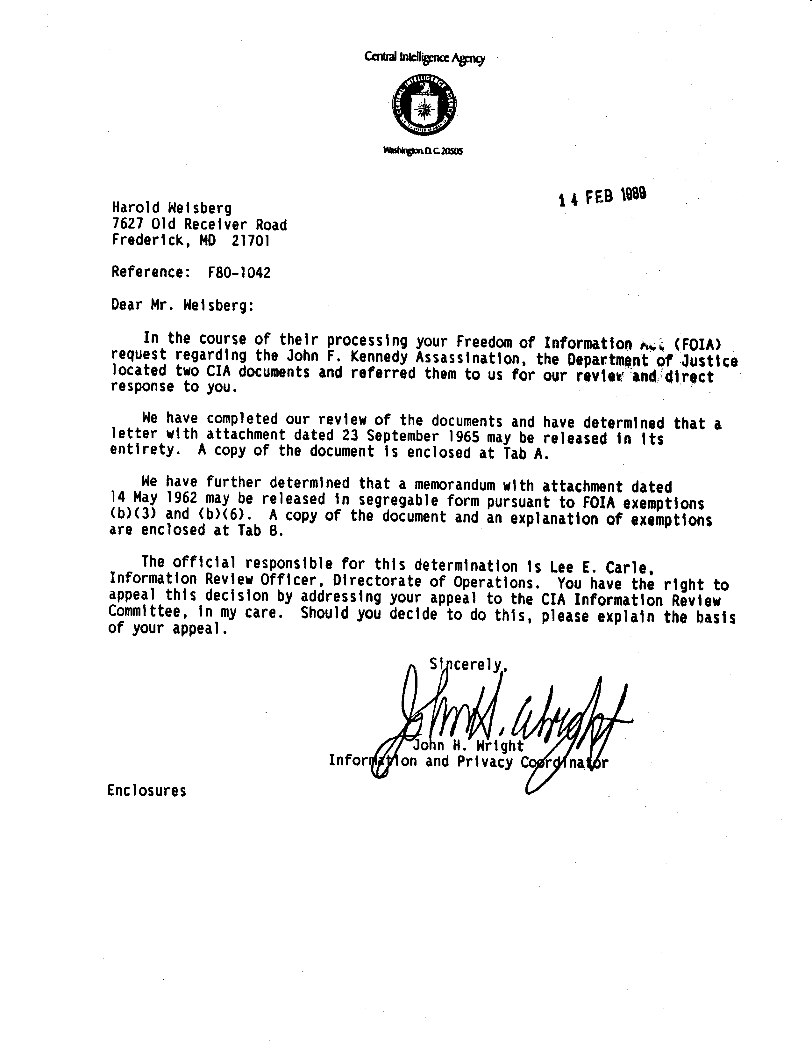
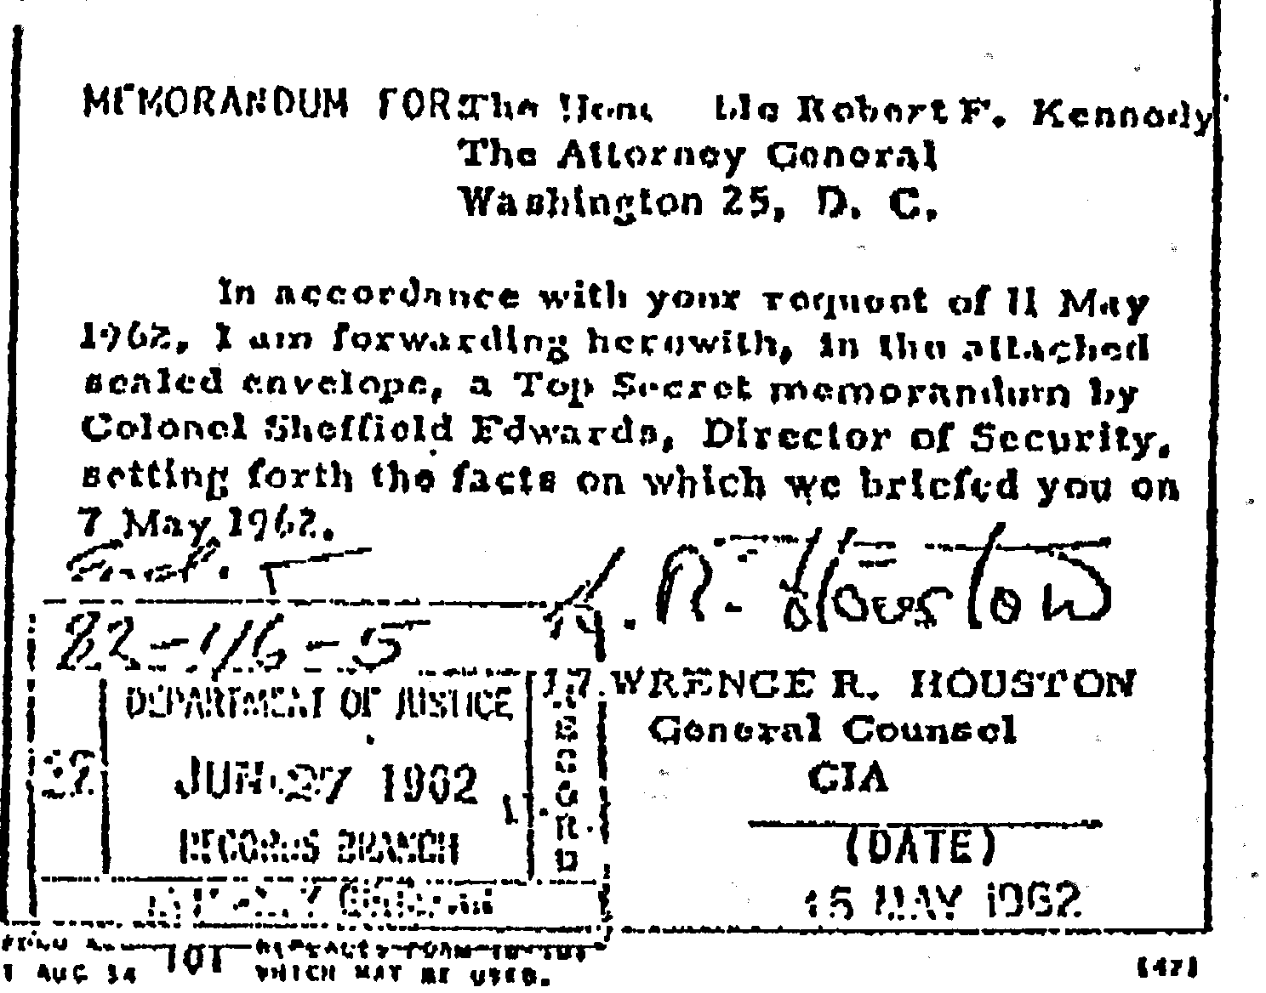

There just is no doubt about it, the attempts to kill Castro were projects of the Eisenhower administration and this one, of August , 1960, not the first, was even before Kennedy was elected. Those plots cannot be attributed to him, as these who seek to commercialize and otherwise exploit the assassination of the President state in their books, which require the misrepresentation for their existence.
Russo in particular.
With regard to what the Kennedys did do, having little choice but to follow the policies set for the Kennedy administration by the Eisenhower administration, the political and economic undermining of the Castro government was the fixed national policy before Kennedy took office. It began before he was elected. He had no choice but to continue it for a while at the least. At the time he was killed he had authorized negotiations with Castro looking toward more normalization in relations. The talks were at the United Nations, where William Attwood, one of Kennedy's ambassadors represented the United States and Carlos Lechuga, the Cuban ambassador to the UN, represented Castro. Both wrote books about it. Attwood's is in the Russo bibliography but Lechuga's is not. We have seen some of the irrelevant trash that Russo regarded as important in his bibliography but the Lechuga version of his negotiations Attwood looking toward normalization of relations was not useful to Ruoso. Indeed it was not because it would have highlighted the ignorance and the stupidity of his baseless argument converted into a book.
Those talks were on Castro's initiative. He would not have gone to the trouble of seeking better relations with Kennedy if he planned to kill him. On this added basis alone it makes no sense at all.
There has been official disclosure of contemporaneous official records. They establish clearly that the Kennedys did not plan to assassinate Castro, did not plan to invade Cuba absent an uprising that had some prospect of succeeding, and that all the official plotting to assassinate Castro was of the Eisenhower administration or by the CIA and was carried on, without any Kennedy authorization, by the CIA. Russo's chums.
The CIA, on its own, even renewed the silly Mafia plot after the disaster of the one reported above. There is no record of any kind and no reason to believe that the Kennedys were even aware of that until later.
But in fact that policy was changed after the October 1962 Cuba missile crisis. The government then, as I reported in my earlier books, began to close down the free-lance, soldier-of-fortune plans to invade Cuba and on other anti-Castro operations.
There has also been official disclosure to go along with what was public knowledge that escaped the attention of this foreign-policy expert and student, which Russo says he is, long-time at that, in his criticism of what he says were the "errors" of the Kennedy foreign policy as related to Cuba. Foreign-policy expert that Russo says he is, he somehow neglected to include in his monument to his own skill as an "investigative reporter" the rather unusual acts and decisions of the Eisenhower administration, particularly in its very last days, just a few days before Kennedy was inaugurated and long after the election that made Kennedy President and ended Eisenhower's administration.
(Some of these official disclosures of official records are cited, quoted and referred to in other writing that I completed before Russo finished his book, particularly in Faking Kennedy: With Hersh-It Journalism, so they are not repeated here. All of this was available to Russo. It was also publicly reported.)
To put it briefly, Eisenhower put in place the Cuban policies that became Kennedy's automatically because they were the policies of the United States government that Kennedy inherited. They were the government's policies before and when Kennedy was inaugurated. They were not, any of them, policies that Kennedy introduced.
The most conspicuous "error" of those days was a clear departure from practice by the Eisenhower administration just a few days before Kennedy was inaugurated. That policy decision caused a strong reaction in this country and, if Kennedy had wanted to change it, he could not have dared even to try. The reaction against it would have been enormous and it would have been fired up even more by those who would have been affected by it and by Republicans and those of right-wing beliefs.
United States interests owned much of Cuba when Castro took power. Some of those United States corporations were engaged in anti-Castro activity. Some were engaged in gouging Cuba to further enrich themselves - to enrich themselves at the cost of Cuban suffering when the Cubans then were a long-suffering people much of whose suffering they blamed on foreign exploitation.
Petroleum fuels all modern economies and much of industry. Cuba imported petroleum. It was refined by United States refinery owners. The price they then charged was extortionate. Cuba was being further milked by the exorbitant cost of refined petroleum. It was refined in Cuba only by a United States refinery.
In order to be able to get essential petroleum products at a reasonable rather than at an extortionate price, Castro did his own importing of the raw petroleum. He bought it on the open international market at much less than he was being charged for it by those who were used to taking advantage of Cuba and Cubans and had come to treat their gouging as a right they possessed. But when the petroleum Castro bought on the open market reached Cuba, the United States owned refinery refused to refine that raw petroleum that Castro had gotten at greatly less than the extortionate price charged by the refinery.
When after the refinery owners refused to reduce the price of refined petroleum and make it comparable with what the price was elsewhere, when they refused to stop gouging Cuba and the Cuban people, Castro nationalized the refining, took it from the United States owners, made it Cuban.
In retaliation Eisenhower did not wait, as was customary, and as would have been a proper response to the election, for Kennedy to become President and for Kennedy to make any decision that he wanted to make.
Eisenhower, about whose foreign policy Russo has not a word to say, certainly not a word of criticism, put all American power behind the American interest who for decades had been bleeding Cuba and Cubans white. Eisenhower took the decision about what to do, if anything, away from Kennedy, who under United States practice should have been the one to decide. Eisenhower broke diplomatic relations with Cuba just a few days before the Eisenhower administration ended and the Kennedy administration began.
Unusual as this was, and some might even refer to it as an "error," which as a matter of traditional United States policy it was, there was not a thing that Kennedy could do about it if he had wanted to. There would have been an enormous reaction against him if Kennedy had begun his administration by restoring relations with Cuba once Eisenhower broke them and that anti-Kennedy reaction would have been further enflamed by other Castro nationalizations of United States interests that were gouging Cuba and Cubans.
Whether or not Castro would have engaged in nationalization of United States interests without what the Eisenhower administration did to him and to Cuba may be a question that has no answer, but the record is that after being in power for a year Castro had not nationalized what was owned by United States interests. Further nationalization was just about the only answer he could make to the unprecedented action of the Eisenhower administration in its support of those who were gouging and long had gouged Cuba and the Cubans. Castro did that and in doing that, tiny Cuba was telling powerful United States that it was an independent country and was not a United States possession. It also was saying that it was not going to be dictated to by the United States.
The Kennedy anti-Castro policies that Russo regards as "errors" and as having kicked back against Kennedy, causing his assassination, were policies that were Eisenhower's policies, were put in place by Eisenhower, were inherited by Kennedy, some of them in the very last days of the Eisenhower administration. Eisenhower put them in place with the intent of fixing those policies on the incoming Kennedy administration. They had the intent of making, of fixing the policies of the Kennedy administration, fixing them rigidly, so rigidly that as a practical matter Kennedy could not change them.
And, as we have seen, the policy of assassinating Castro was of the Eisenhower administration. It was the Eisenhower policy before the election in which the people chose Kennedy to be President, chose Kennedy to decide on and to set national policy, the decision Eisenhower took away from the people and from the choice of the people as in this country the people chose.
This is a very brief encapsulation of what really happened, what was really done, what made United States policy and what made and was intended to make it impossible for Kennedy to have any different policy. It is also a peek at Russo who boasts of being a political scientist.
The domestic political situation may have made it impossible for Kennedy to have a different policy toward Cuba. He may not have wanted a different policy than the one with which Eisenhower saddled him, the policy he could not change – dared not try to change if he had wanted to. But the reality is that in its last, its very last days, the Eisenhower administration took the decision away from the man the people had elected to make those decisions and put in place a policy that as a practical matter no incoming president could do a thing about or would dare try to do a thing about.
During the campaign Kennedy was as anti-Castro as Nixon was but Kennedy was not an exponent of robbing the poorer, the under-developed countries. He espoused his own version of what under Franklin Delano Roosevelt was called the "good neighbor" policy. He called it "The Alliance for Progress." (This is not mentioned in the Russo index. See page 387.) That was not the policy of the outgoing Eisenhower administration and the outgoing Eisenhower administration made it impossible for Kennedy to practice any such policy with the fledgling Castro administration in Cuba, the Castro administration that took over from a long series of governments that were subservient to United States economic interests.
Castro was called a Communist in the United States bat in fact he not only was not a Communist. He was and he had been opposed by the Communists. Castro was a nationalist. But the last-day decisions on policy that were made by the Eisenhower administration which should, under the American system, have let those policy decisions wait f or the successor administration, forced Castro to look elsewhere for the help he so desperately needed as the result of these last-gasp Eisenhower decisions and policy creations.
The Soviet Union was the only place to which he could turn for the help needed for the survival of his government and for the survival of Cuba and of Cubans. With the Cold War the reality, the Cold War interests of the Soviet Union dictated its decision to help Castro and in that to oppose the United States and its policies.
It was only after the Soviet Union rescued Castro and Cuba that the nationalist Castro turned toward it and began to call himself a Communist.
There were "errors" in foreign policy as there always are in any country and under any political system but the "errors" Russo, self-styled foreign-policy expert and self-styled expert on the Kennedy administration that he says he is, in addition to his being what he also says he is, an "acclaimed investigative reporter," in his book of more than six hundred pages in which he argues that Kennedy's policies caused Kennedy's assassination, found none of the foregoing relevant for those whose minds he sought to reach with his book.
Was the Kennedy solution to the 1962 Cuba missile crisis one of those "errors" Russo sees in his foreign policies? Foreign policy is another field in which Russo claims expertise but he does not go into this when he had only six hundred pages to his book. Instead he boasts of it on his dust cover and in his generalized boasting under "About The Author."
Did that - could that have led to Kennedy's assassination?
That, too, is a matter for Russo, expert on both the Kennedy administration and on foreign policy that he claims to be. He says it did.
If Russo became expert on these subjects in his formal education, that must have been in his classes on rock and roll or on boogie-woogie. He did not acquire the expertise he claims and reflects in his book on these matters as part of any college course on foreign policy.

